` MSc Information Technology,   
Department of Computer Science and Information Systems,   
Birkbeck, University of London

Project Report



Centralized Application for NHS, GPs and Patients  
  
Author: Melvir Singh  
Supervisor: Carl Barton

This report is substantially the result of my own work, expressed in my own words, except where explicitly indicated in the text.

Abstract

In this report, I discuss the problem statements and subsequent implementation of MedCentral to solve them. The application was developed from scratch and is a web-based platform that serves Patients, GP Admins and NHS Admins with different feature for each role. This report includes the discussion of implementations of the various components and also includes a full demonstration walkthrough of the developed product. The conclusion of this report is that a prototype of MedCentral has been successfully developed and is ready for trial with actual users of the community. Future features/improvements are also proposed for future programme candidates who would like to further improve MedCentral.

Word Count: 10637

Table of Contents

1. **Introduction 3**

1.1 Recap of Problem Statements 3

1.2 How Med Central tackles those Problems4

1.3 The Approach Taken 5

1.4 Roadmap of Remaining Chapters 5

**2. Background6**

2.1 Comparing with other similar Applications out there 6

**3. System Analysis & Design 7**

3.1 Implemented Use-Cases 8

3.2 Utilized Technology Stack 10

3.3 Deployed Application Architecture 11

3.4 Info Flow (Sequence Diagram) 12

3.5 Model, View, Controller Pattern14

**4. Implementation15**

4.1 Completion status of Application Requirements 15

4.2 Interesting Code Snippets of utilized Technology Stack17

4.3 Application Deployment25

4.4 Application Github Repositories 28

**5. Code Testing 29**

**6. Demonstration 33**

6.1 Patient Role’s Functionalities33

6.2 GP Admin Role’s Functionalities41

6.3 NHS Admin Role’s Functionalities48

**7. Evaluation Findings52**

**8. Critical Evaluation & Conclusion55**

8.1 Recap & Success of solving Problem Statements55

8.2 Lessons Learnt 64

8.3 Proposed Additional Features for future iteration of MedCentral 65

**9. References67**

1. Introduction

1.1. Recap of Problem Statements

The rationale for working on and eventually developing the Med Central application was to solve some problems that my family and I had encountered during our initial settling in period in the UK which includes having to register for a GP for medical issues. We encountered painful administrative delays and pitfalls through those first few weeks. I prioritized this idea over some others that I had as I knew that we were not the first to encounter these delays so there is value in solving them

Thus, I would like to use this opportunity to recap and summarize on those 3 problem areas as I feel it is paramount for readers to understand the foundational reasons for the implementation of MedCentral.

1. Tedious manual processes for all parties (patient and GP)   
  
The first was on the tedious manual processes for all parties. The registrations at the couple of GPs near me were manual forms that had to be downloaded, filled up manually and then either scanned in or physically submitted at the GP clinics. The manual processes extended to the GP Admins as well as there was lots of repetitive work such as manually restitching the different parts of the form should there be any new fields or sections added to the forms. Finally, I also pointed out there was no self-service way that the patient could check on the status. Thus he/she had to call the GPs to check the status, again taking time away that could be spent on the GP Admins core work.

2. Long waiting times for patients to visit their GPs   
  
The second problem area I highlighted was on the long waiting times for GP visits. I pinpointed from my research that a recent study showed that the median waiting time for treatment was 14.4 weeks, significantly higher than the pre-covid median wait of 8.3 weeks back in 2019. (BMA, no date). I also shared my own personal experience where I had to wait up to 3 weeks for a leg injury to see my GP. However, it is important to note it is not anyone’s fault in particular but rather down to the fact that the GPs themselves are being overwhelmed with requests.

3. Information/Data is not being centrally available to be harnessed properly by data experts to bring better value-add and user experience for everyone

Lastly, I shared that information/data being stored disparately were leading to major issues downstream that cannot be identified by laymen. With more companies/industries going towards AI and data-driven decisions, having data stored offline or separately via different GP clinics should not be the way to go in today’s technological age. Research has found that the benefits of data-driven decision making include more confidence in the decisions, being innately more proactive throughout your business and better cost savings. (Tim, 2019)

I shared that the data had to be carefully designed, architected and managed. It becomes much more manageable and sustainable going forward when data management is centralized.

1.2. How Med Central tackles those Problems

MedCentral solves those problems via 3 solutions. These 3 solutions have been implemented as part of the MedCentral product and are highlighted further below.

1. Med Central has been developed to be a centralized web application with consistent interface for NHS, GPs & Patients  
  
Med Central was primarily developed as a web application that could provide a good intuitive and consistent interface for all users of NHS. These include Patients, GP Admins as well as NHS Admins themselves. The web application, which will be shared more of during the demonstration section later on in the report, digitizes the manual forms and processes leading to a much more effective and efficient use of time for all the roles involved. Research shows that by having a consistency interface for all use-cases in Med Central, this goes a long way in helping users to quickly adapt and for the team to add future functionalities and manage change management much quicker. (Hexacta, no date)  
  
2. Med Central allows for secondary GP selection within the registration process that is selected automatically by system algorithm

The next solution within Med Central was the availability of a secondary GP selection during the digital registration process. There is a smart algorithm within the system that selects the GP with the least current load and most current capacity within the patient’s borough. However, it is acknowledged that for this to really succeed, process change is required at NHS to actually allow patients to be technically registered to 2 GP clinics.

3. Med Central stores data centrally/single location

Lastly, Med Central also stores data centrally in a single MongoDB cluster.

I have selected MongoDB as the main data store as DB-Engines have pointed them out as a market leader and one of the most popular non-relational data stores over the last few years. (DB-Engines, 2023)

MongoDB is a well-known industry leader and Mike from DataIdeology also shared that some of the benefits of centralized data management include consistency/quality control, better optimization as well as time and cost savings. (Mike, no date)

However, it still caters for High-Availability/Robustness as the cluster is replicated across different region by the Cloud service deployment which will ensure data is well-protected and secure.

1.3. The Approach Taken

Being a web application, it was necessary to incorporate various technologies for both the frontend and backend to ensure that it was developed and released as an interactive, consistent and robust product. The technology choices as well as the application architecture amongst other diagrams are shared later on in ‘System Design & Analysis’ as part of Chapter 4.

As the timeline was relatively short (less than 8 months) and it was only a 1 man project, I could not go the full way of adopting my preferred Scrum methodology. I utilized a hybrid of Waterfall + Agile throughout the project. The latter allowed me to show regular progress of the application features developed to my supervisor as well as other stakeholders such as my testers.

The major milestones were the proposal phase (1 month), exploration phase (1 month), development of frontend (1.5 months), development of backend (1.5 months) and testing (2 weeks). This project report now follows through the rest and is now the final milestone to be delivered in roughly 1.5 months.

1.4. Roadmap of Remaining Chapters

Chapter 2: Background

Provides a comparison with other similar applications, demonstrating why Med Central is indeed different and novel compared to them, thus having a solid opportunity in the market.

Chapter 3: System Analysis & Design

Shows the different use-cases that Med Central has been developed for. Also covers the actual technologies utilized for the various components of the product. Finally covers the information flow of all 3 roles via a Sequence diagram.

Chapter 4: Implementation

Describes the overall completion status of the requirements. Also shows some code snippets that I have deemed useful for other tech readers. Aspects of deployment of the application is also covered here including for both the developed components as well as the database.

Chapter 5: Code Testing

Describes the level of testing done in the code via Unit Testing. Shows screenshots of test-cases and their completion/success rates.

Chapter 6: Demonstration

Gives a walk-through of the features developed for Patients, GP Admins and NHS Admins and how it helps them achieves their aims within the system. This is especially useful if the reader is unable to run the application themselves (otherwise the README from the respective Github repositories should help).

Chapter 7: Evaluation Findings

Describes the survey results done by a group of testers. The results would show whether the system has been successful in its goal to solve the 3 problem areas specified above.

Chapter 8: Conclusion

Reviews the project, recapping the problem statements and how the system has achieved in solving them. Includes some tests done to evaluate how and to what level the problem statements have been improved. Also provides some personal aspects of lessons learnt and how I would do things differently if I was restarting the project. Caps off the entire report with proposing some additional features for future iterations of Med Central

2. Background

2.1. Comparing with other similar Applications out there

As MedCentral is a brand new product, it is vital to ensure that it has an edge or differential factor over other competitors that have similar products already in the market. As the product owner, I had to make sure that the product would be able to hold its own in a competitive market and that no other company had built something exactly like it. Through my market research, I came by various products, some already launched whilst others in their initial state. However, I only deemed 2 of them to have a possible similar target audience to MedCentral. The rest either had very different features or targeted other problems that patients might have.

Below are the 2 products that I summarized to provide a good sensing of similar products in the market for readers.

Docclocker

Docclocker, which was founded in 2015, basically allows patients to check in from their car and be alerted when to come in. Thus, patients will be able to skip the waiting room and be aware of the expected wait time. Thus, it is mainly being marketed as a time saving tool for both providers and patients. (Docclocker, no date)

However, it is still vastly different from Med Central as the latter focuses on streamlining and digitizing processes of the NHS for Patients. In addition, Docclocker has not been customized for the UK market. It would not be a plug and play for GPs to onboard. When I tried to search for GPs in my own borough, Harrow, there were none on the product. And the product has been launched for almost a decade.

NHS WaitLess

NHS WaitLess, another similar product which was founded in 2019, is marketed as a tool to help reduce load on already overloaded A&Es. (NHS, 2020)

Again, it is different from Med Central as the focus of the latter is on GPs and the day to day care-taking of patients. Although it has been launched for about 3 years, I could not find much news in public provided by NHS whether they planned on improving the features or extend the user-base to GPs as well.

3. System Analysis & Design

Since there was limited time to work on a brand new product from scratch, it was especially important for me to prioritize the high value features that would make MedCentral a success in its initial phase. I did this by segregating features into them either being Core or Additional/Advanced features.  
   
Functional Requirements

|  |  |  |
| --- | --- | --- |
| **Requirement** | **User Role** | **Type of Requirement** |
| **Login to system** | All | Core |
| **Submit Feedback** | All | Core |
| **Submit GP Registration** | Patient | Core |
| **View GP Registration Requests** | Patient | Core |
| **Reply to GP requests for more information** | Patient | Core |
| **Book GP Appointment** | Patient | Additional/Advanced |
| **View GP Appointment Requests** | Patient | Additional/Advanced |
| **View & Update GP Details** | GP Admin | Core |
| **View/Approve/Reject/Request for more information for Patient Registration Requests** | GP Admin | Core |
| **View/Approve/Reject/Request for more information for Patient GP Appointment Requests** | GP Admin | Additional/Advanced |
| **View GP/Patient Feedback** | NHS Admin | Core |
| **View Performance Dashboard** | NHS Admin | Additional/Advanced |

Table 1. Functional Requirements

Non-Functional Requirements

|  |  |  |
| --- | --- | --- |
| **Requirement** | **User Role** | **Type of Requirement** |
| **Stable without major errors** | All | Core |
| **Good Performance without lag** | All | Core |
| **Easy Code Maintainability** | All | Core |
| **Online Code Repository** | All | Core |
| **Deploy key app-infra (ie. DB) in Cloud** | All | Additional/Advanced |
| **Deploy in Docker Containers for scalability** | All | Additional/Advanced |

Table 2. Non-Functional Requirements

3.1. Implemented Use-Cases

Below are the use-cases that have been successfully implemented for all 3 roles in the system – Patients, GP Admins and NHS Admins.   
  
Due to some prior experience I had with the technologies involved, I managed to complete all the Core features and most of the Additional/Advanced features stated above as well. The Additional/Advanced features were Stretch Goals for myself. These are highlighted in purple instead of blue in the Use-Case diagrams below. Reason for the stretch goals are due to wanting to push myself more and coming out of my comfort zone even in the limited project schedule. I achieved that by learning how to set good stretch goals from Project.co. (Project.co, 2023)

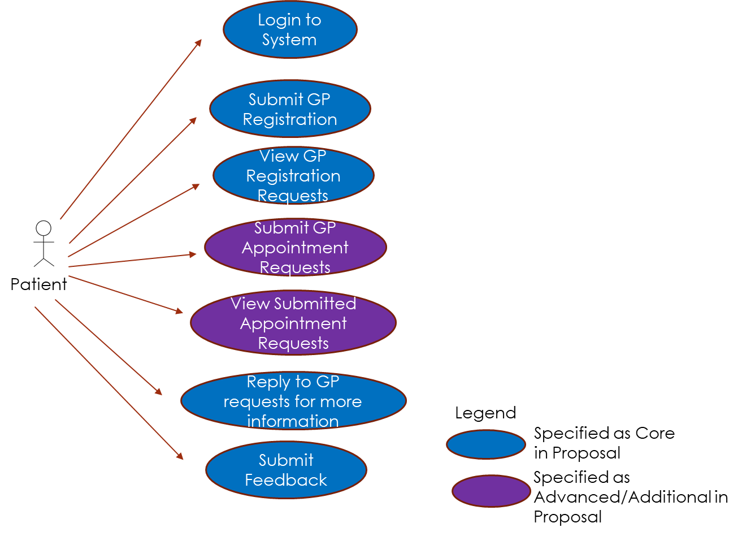  
Figure 1. Implemented Use-Cases for Patient role

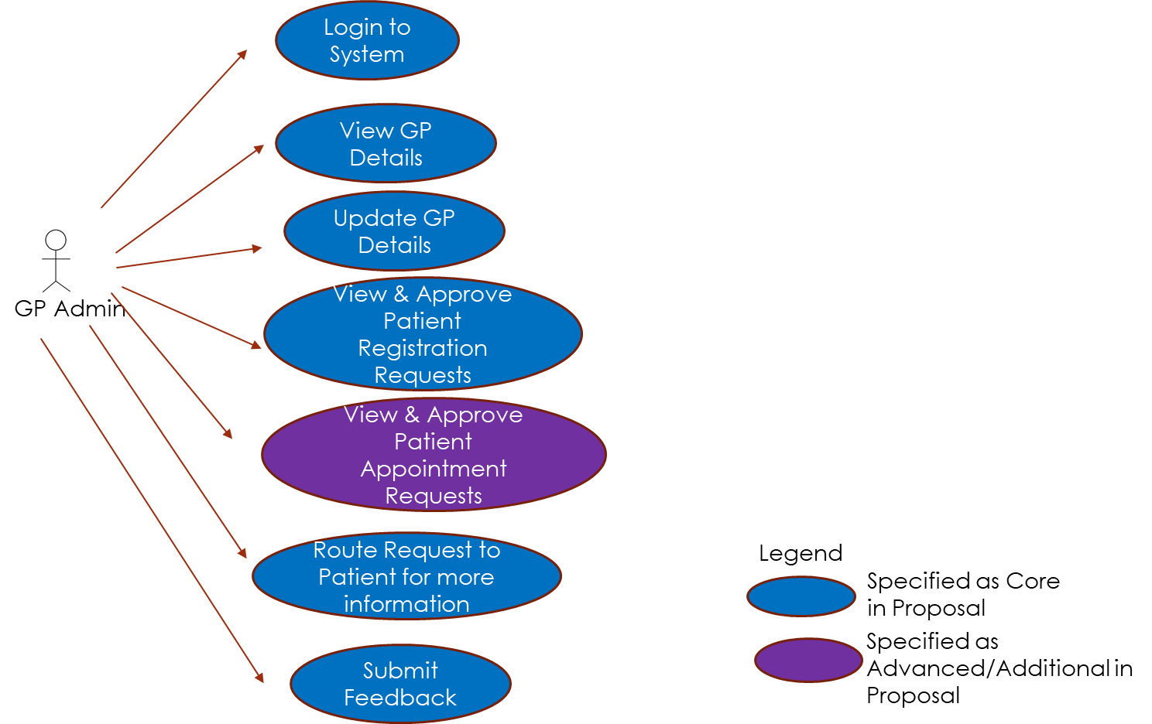  
*Figure 2. Implemented Use-Cases for GP Admin role*

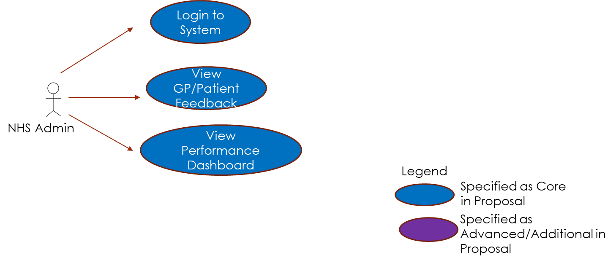  
*Figure 3. Implemented Use-Cases for NHS Admin role*

3.2. Utilized Technology Stack  
  
With my experience testing with Python during the Masters programme, I decided to also incorporate Python as an additional language for Code Testing. Python has lots of good library and resources out of the box for testing which I found useful and easy to test my implemented backend endpoints. I also managed to set up a MongoDB cluster in Cloud from scratch when I previously only envisioned a local copy to save time for development. The experience has been really useful and given me confidence to push for more services in the Cloud for my future developmental projects.

MongoDB Cloud (for DB)

Chrome

HTML5

Java Microservices

MongoDB

Edge

JavaScript

Python – For Code Testing

DataTables

SmartTab

Toast Notification

Technology Specified in Proposal

New Technology not in Proposal

Figure 4. Technology Stack

3.3. Deployed Application Architecture

There were some minor changes on the actual Application Architecture that was used to develop the product. As there were new features worked on such as for Patients to Submit GP Appointment Requests and for GP Admins to either Schedule/Reject the request, an additional microservice called Appointment-MS was required to be planned, designed and developed. This keeps MedCentral product aligned to the true microservice concept of each microservice having their own distinct business domain as their boundaries. This ensures the benefits of microservices are indeed reaped and retained fully. There are various benefits to microservices such as smaller codebase, easier deployment and support, as evidenced by popular industry leader Gitlab. (Gitlab, 2022)

The changes from the proposal have been depicted with a ‘New’ label in the diagram.

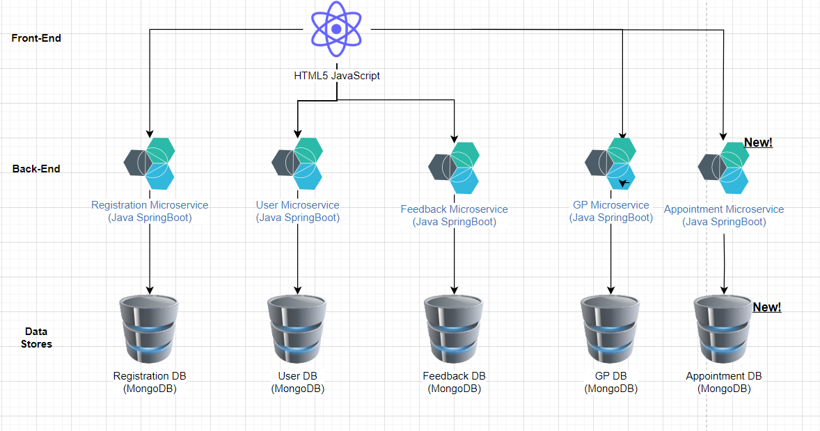

Figure 5. Application Architecture

3.4. Info Flow (Sequence Diagram)

The info flow depicted in Sequence diagrams have also been updated to reflect the actual flow in the final developed application. The changes from the proposal have been depicted with a ‘New’ label in the diagrams.

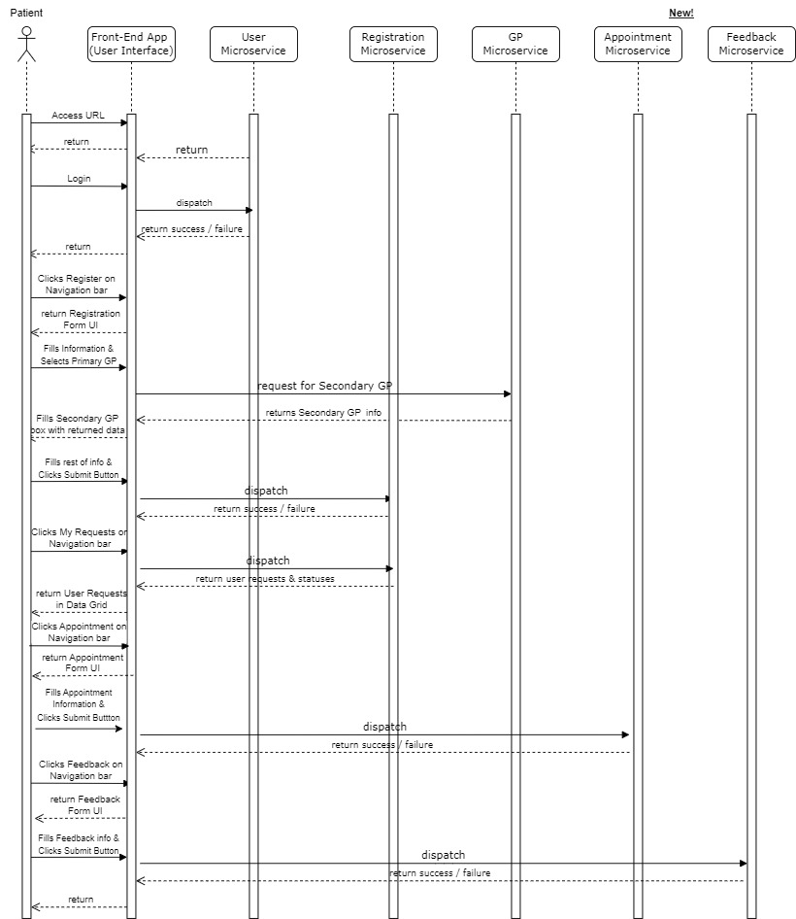

*Figure 6. Patient Sequence Diagram*

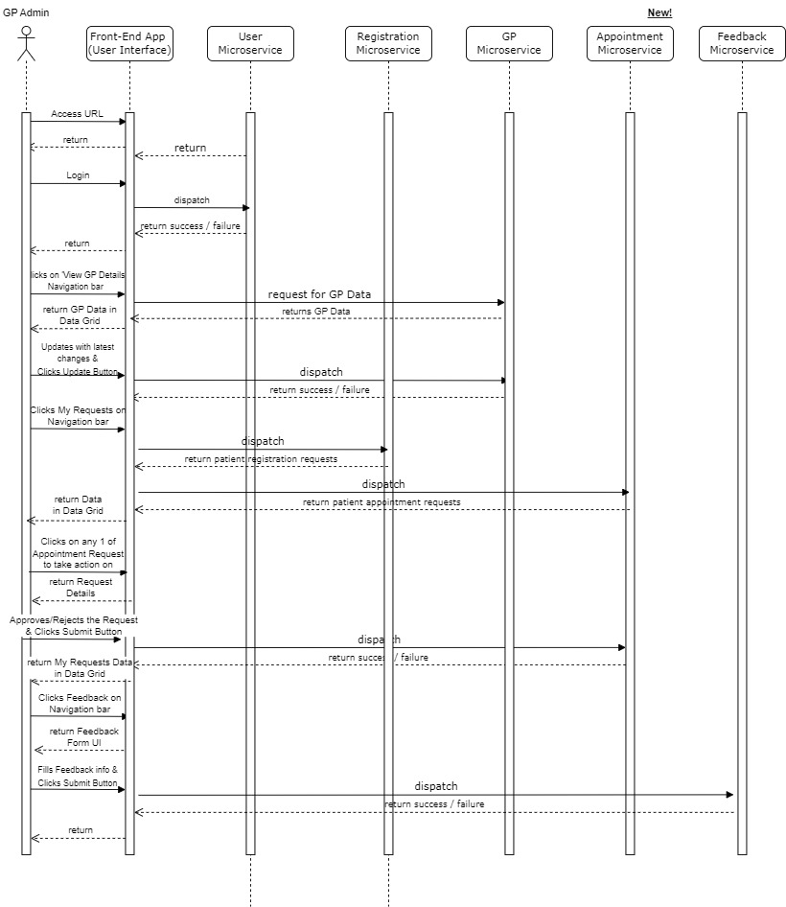  
*Figure 7. GP Admin Sequence Diagram*

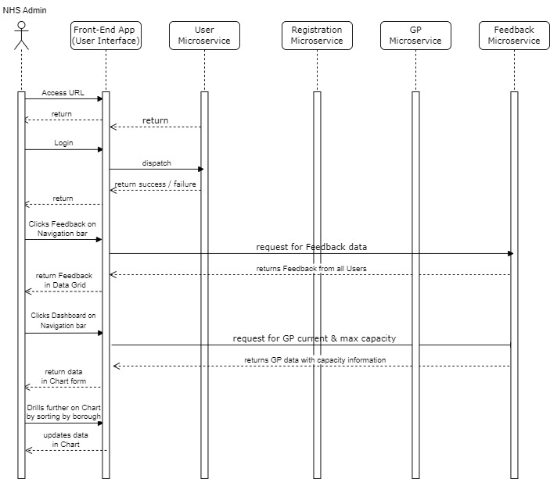

*Figure 8. NHS Admin Sequence Diagram*

3.5. Model, View, Controller Pattern

The main design pattern used in the development of the application was the Model, View, Controller (MVC) pattern. As explained by GeeksforGeeks, the MVC pattern requires that each of the data model, presentation view and control information are separated into different objects and take care of their own control boundary to ensure that the overall components of the application are easily manageable and less dependent on each other for proper functioning. (GeeksforGeeks, no date)

Below is a diagram that very simply depicts how the 3 play their individual roles to ensure a proper functioning application.

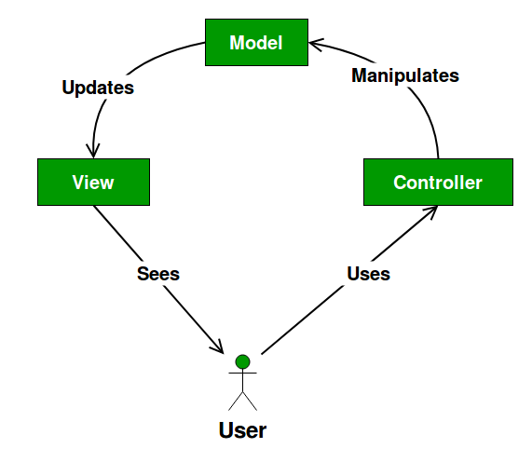

*Figure 9. Model, View, Controller (MVC) Design Pattern used in MedCentral*

4. Implementation

4.1. Completion status of Application Requirements

Below shows the overall completion status of both Functional and Non-Functional Requirements. More comprehensive examples of the former will be presented later in the Demo section and under Sharing Code Snippers for the latter. Although I was working alone, I understood the value of tracking project progress and thus continually tracked the statuses of each task/requirement throughout the project, which is really important for project success as detailed by Sonya. (Sonya, S, 2017)

Functional Requirements

|  |  |  |  |
| --- | --- | --- | --- |
| **Requirement** | **User Role** | **Type of Requirement)** | **Status** |
| **Login to system** | All | Core | Completed |
| **Submit Feedback** | All | Core | Completed |
| **Submit GP Registration** | Patient | Core | Completed |
| **View GP Registration Requests** | Patient | Core | Completed |
| **Reply to GP requests for more information** | Patient | Core | Completed |
| **Book GP Appointment** | Patient | Additional/Advanced | Completed |
| **View GP Appointment Requests** | Patient | Additional/Advanced | Completed |
| **View & Update GP Details** | GP Admin | Core | Completed |
| **View/Approve/Reject/Request for more information for Patient Registration Requests** | GP Admin | Core | Completed |
| **View/Approve/Reject/Request for more information for Patient GP Appointment Requests** | GP Admin | Additional/Advanced | Completed |
| **View GP/Patient Feedback** | NHS Admin | Core | Completed |
| **View Performance Dashboard** | NHS Admin | Additional/Advanced | Completed |

Table 3. Completion Status of Functional Requirements

Non-Functional Requirements

|  |  |  |  |
| --- | --- | --- | --- |
| **Requirement** | **User Role** | **Type of Requirement** | **Status** |
| **Stable without major errors** | All | Core | Completed |
| **Good Performance without lag** | All | Core | Completed |
| **Easy Code Maintainability** | All | Core | Completed |
| **Online Code Repository** | All | Core | Completed |
| **Deploy key app-infra (ie. DB) in Cloud** | All | Additional/Advanced | Completed |
| **Deploy in Docker Containers for scalability** | All | Additional/Advanced | Not Completed |

Table 4. Completion Status of Non-Functional Requirements

As seen from the table, all the Core features were completed fully. All of the Additional/Advanced features bar 1 (Docker Containers) were completed successfully as well.

4.2. Interesting Code Snippets of utilized Technology Stack

Ensuring ease of Code Maintainability

I prioritized having good maintainable code as I have had bad experience in the past of having an application with really huge code being messy and unmainable that made it very difficult to grow the application. Furthermore, Google shared on a DevOps study that showed that the ability of teams to maintain their code effectively was one of a number of technical practises that had positive contribution to success with continuous delivery of products. (Google, no date)

1. Utilizing similar and consistent naming conventions across both Frontend and Backend services

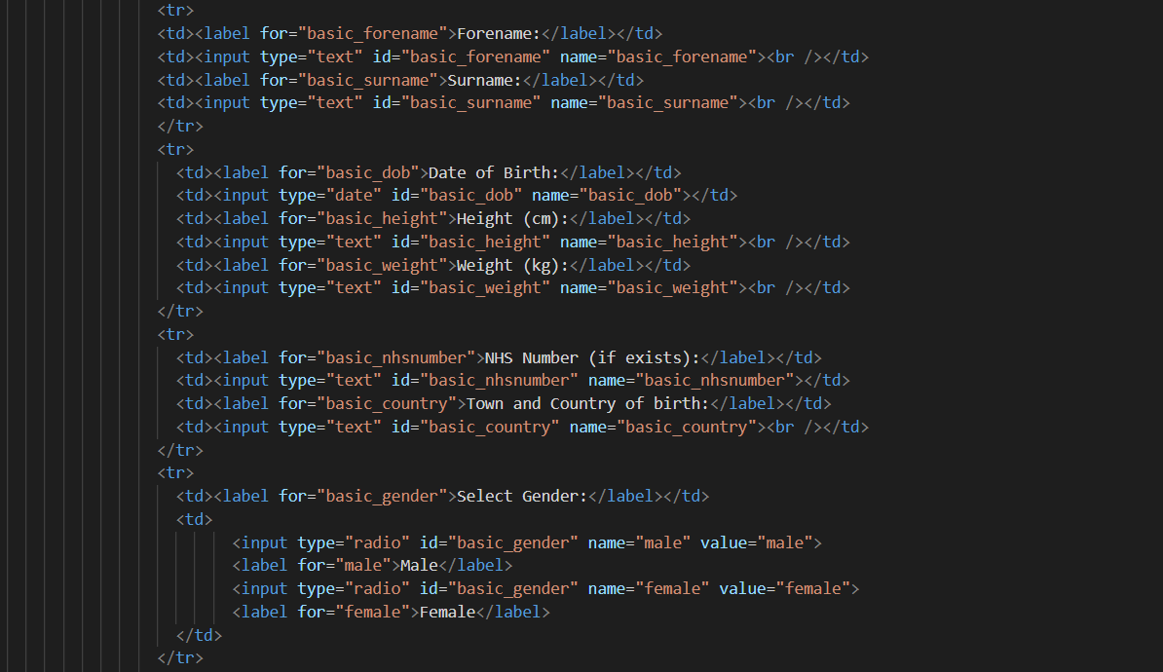*Figure 10. Screenshot of consistent naming conventions for Frontend*

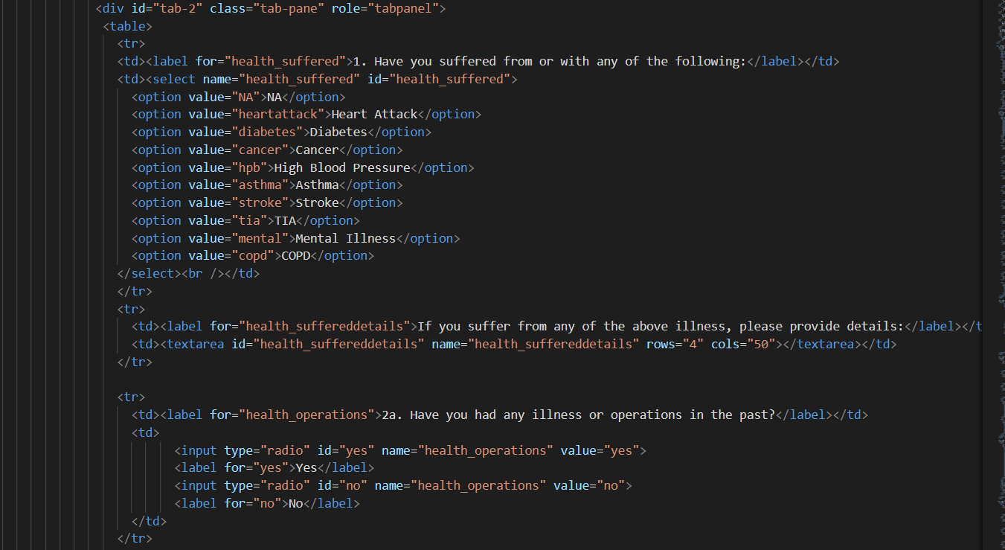  
*Figure 11. Screenshot of consistent naming conventions for Frontend continued*

The above 2 screenshots of the Register GP UI for the shows the standardized naming conventions on the Frontends. The variable names are set as [name of tab on page]_[name of field]. This ensures that even when the Frontend grows to have more tabs and many more fields, it is easy for the developers to maintain the code as they know the referencing point.

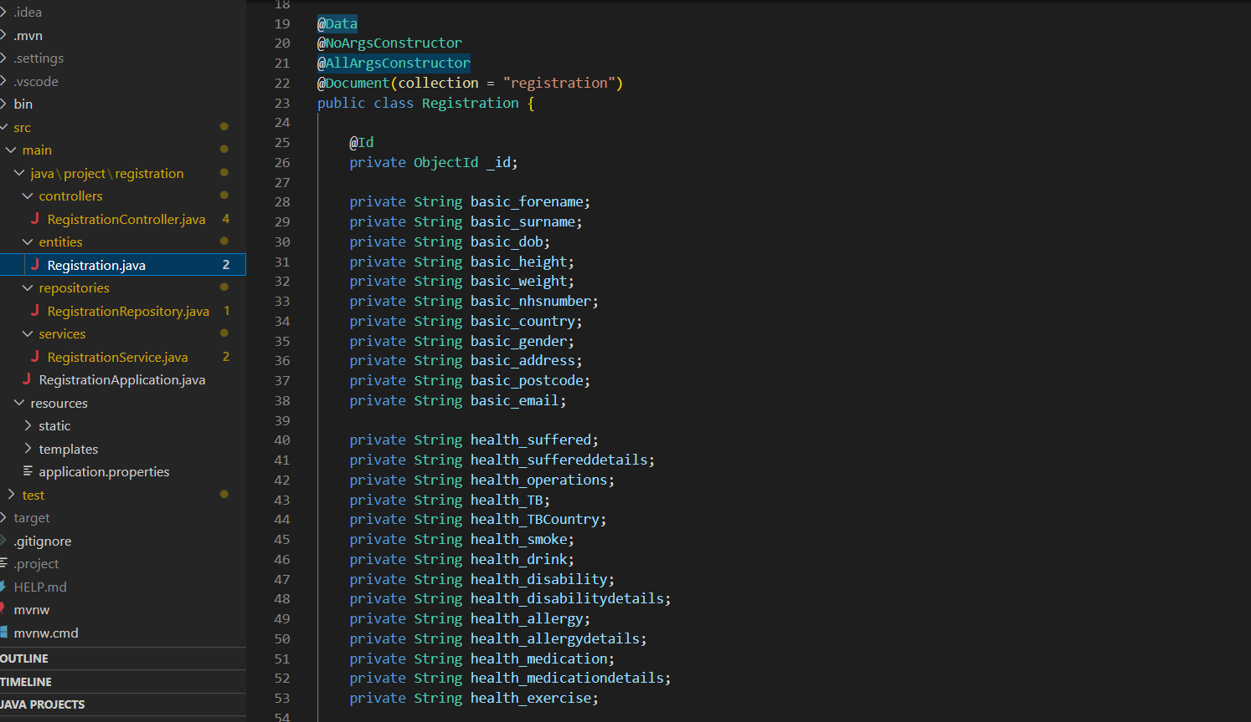   
*Figure 12. Screenshot of consistent naming conventions for Backend*

Similarly for the Backend, the above screenshot shows the Registration entity that retrieves and sends data to the databases.

1. Ensuring as little duplicate code, ensuring more code reusability for efficient development

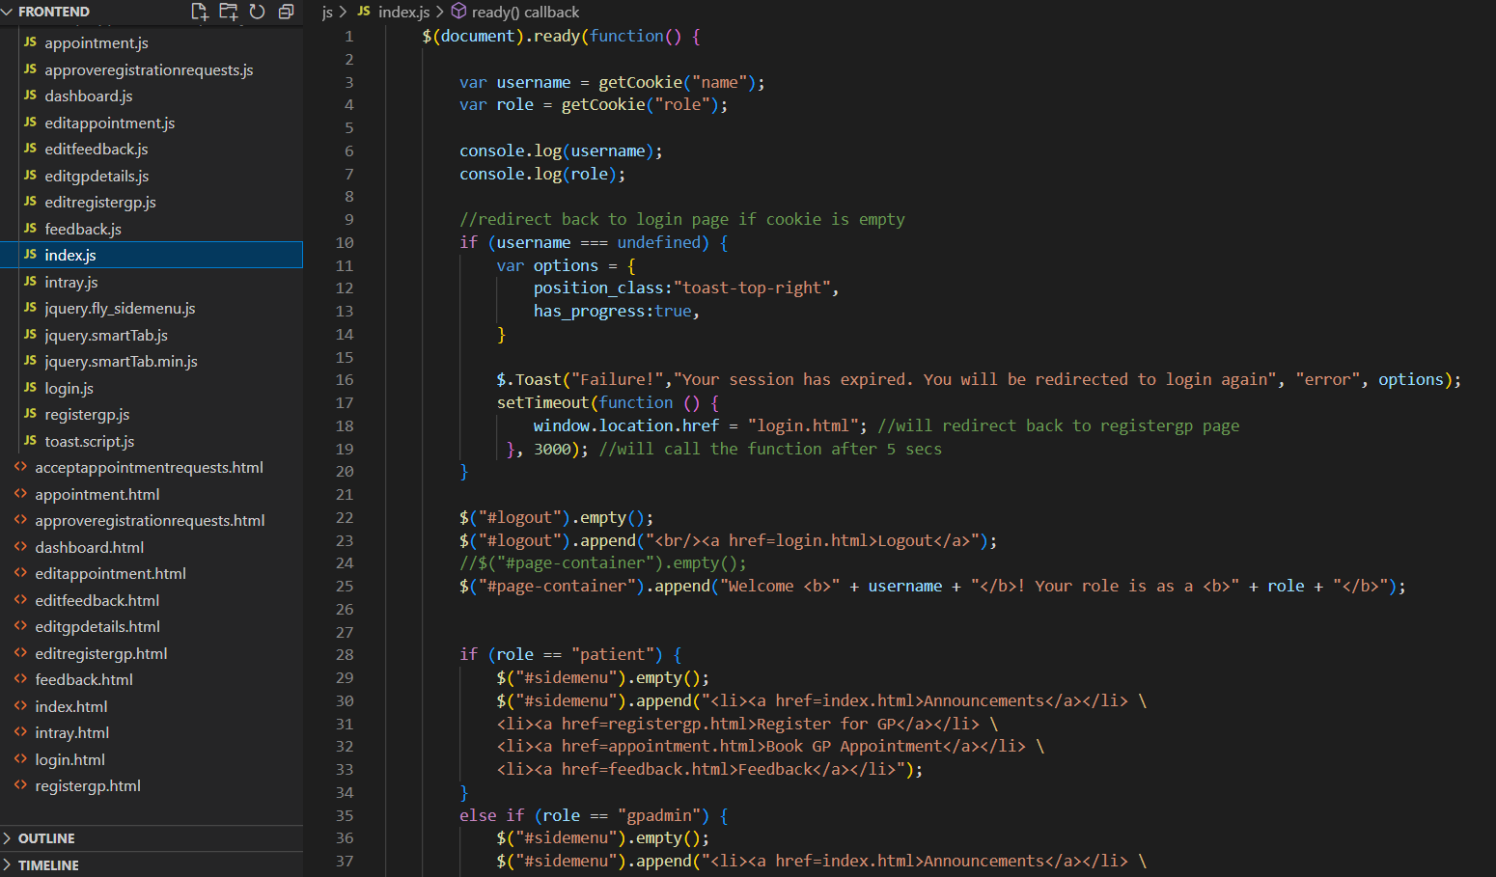  
*Figure 13. Screenshot of code reusability based on navigation bar example*

The above screenshot shows general functionalities such as filling up the navigation bar based on the different user roles being done in a standardized js page in index.js.

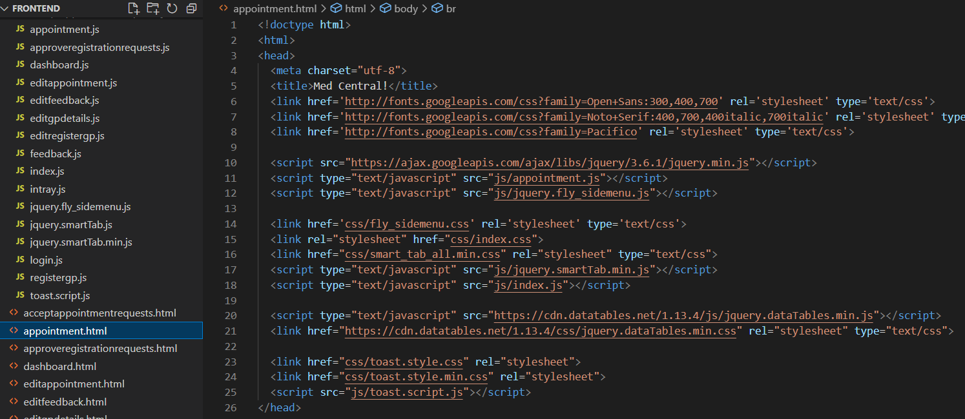  
*Figure 14. Screenshot of code reusability based on navigation bar example continued*

From the above screenshot, one can see that the index.js is then imported into the different pages, this example showing how it is injected into the Appointment UI.

This ensures that code is not unnecessarily duplicated across the different pages which will otherwise lead to a bloated application and possible degradation in performance.

1. Utilizing reliable industry tested frameworks that make code more efficient and readable

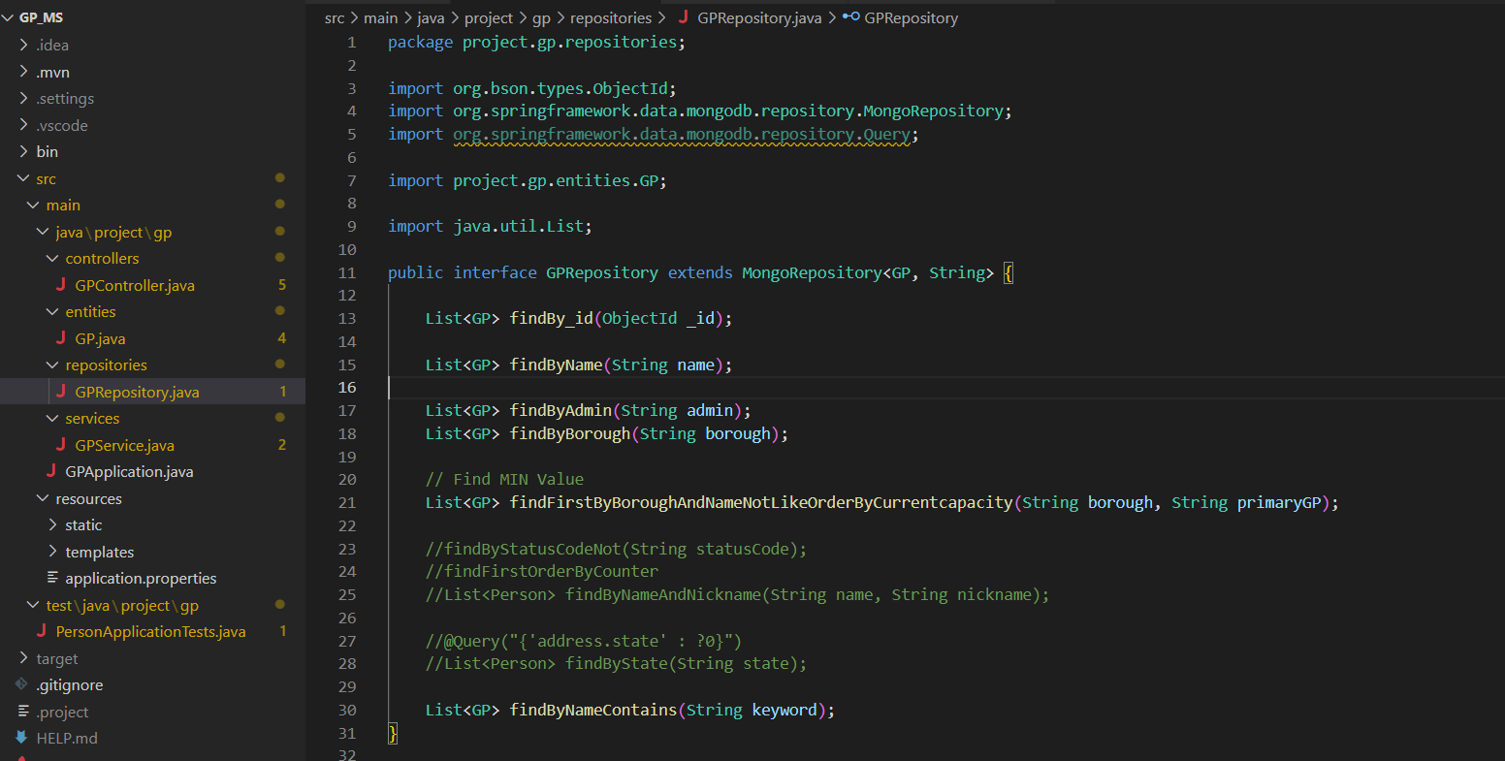  
*Figure 15. Screenshot of SpringBoot library in use for Database method*

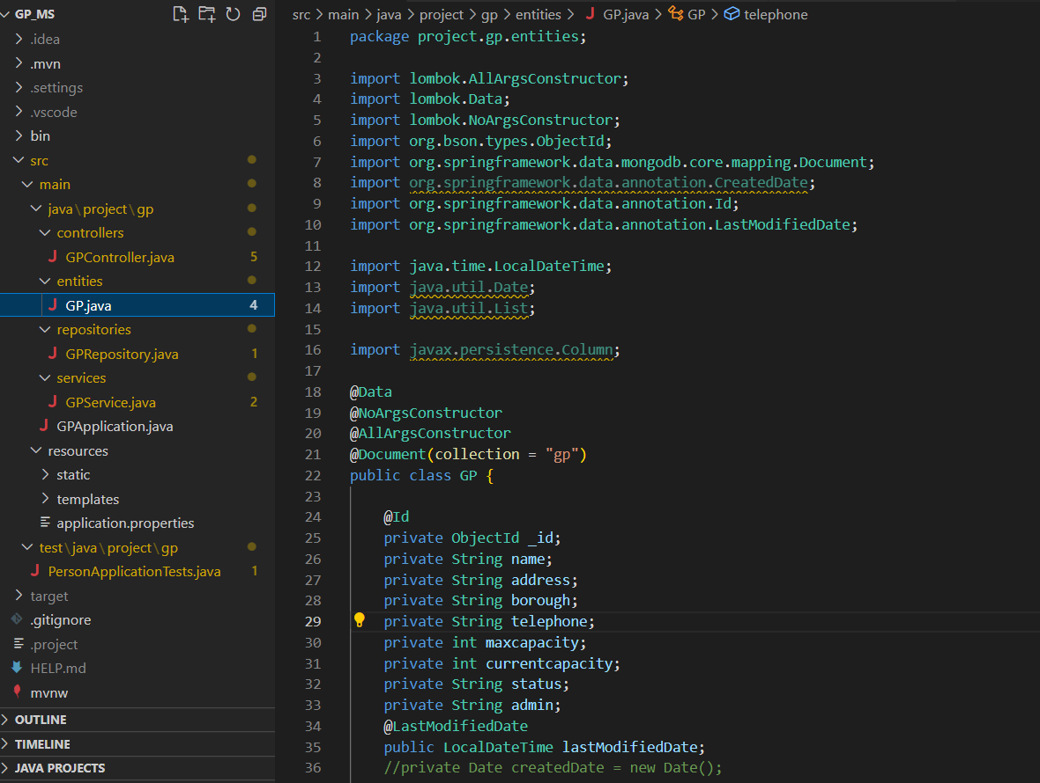  
*Figure 16. Screenshot of SpringBoot library in use for GP class*

The above 2 screenshots of the GP Backend service shows how utilizing a good framework such as SpringBoot can make coding much more efficient and readable. By developing well, it will allow developers to build good robust microservices as mentioned by Spring themselves. (Spring, no date)

From the entity class, there are no getter and setters that are typically required as boilerplate code. SpringBoot allows for importing of Lombok library which does this completely transparently for the developers leading to less code to be written.

Similarly, the GPRespository screenshot shows that common database methods such as retrieving and updating are automatically available in SpringBoot. Only when the developer requires customized fields to be written do they need to write that specific function (in the above example of findByAdmin or findByBorough). Even in such a case, with the correct variable name, SpringBoot knows how to automatically pull the data without the developer having to write the query out.

Adhering to proper industry code standards

Another practise that I made sure of was to adhere to proper industry standards. As I would be going back to industry to do software development after completing my programme, it would be really helpful to have that mindset. Catarina shares that, ideally, with code standards, the entire team’s source code should look like it was written by a single developer. (Catarina, G, 2022)

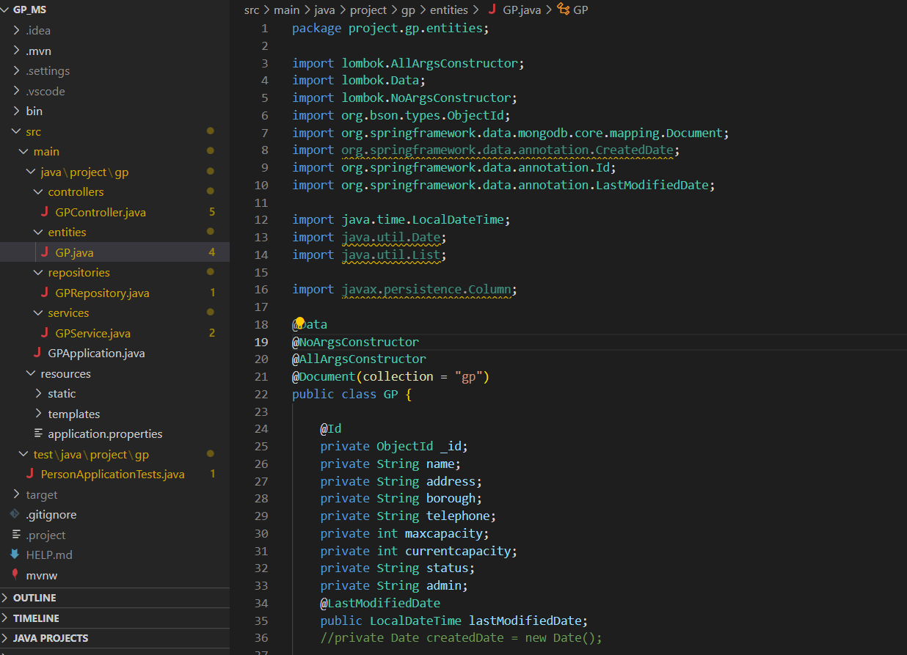  
*Figure 17. Screenshot showing adherence to industry code standards for Entity class*

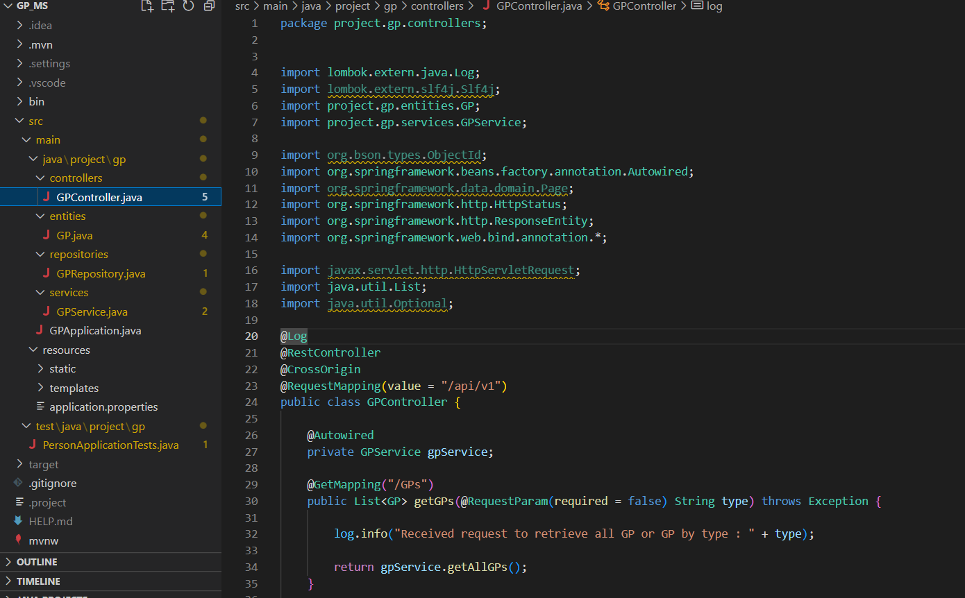  
*Figure 18. Screenshot showing adherence to industry code standards for Controller class*

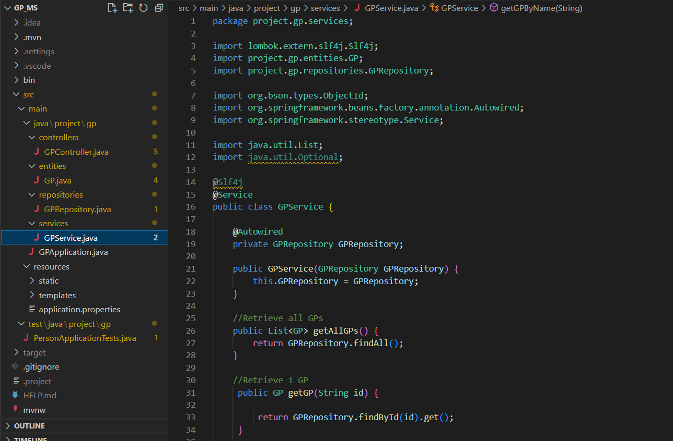  
*Figure 19. Screenshot showing adherence to industry code standards for Service class*

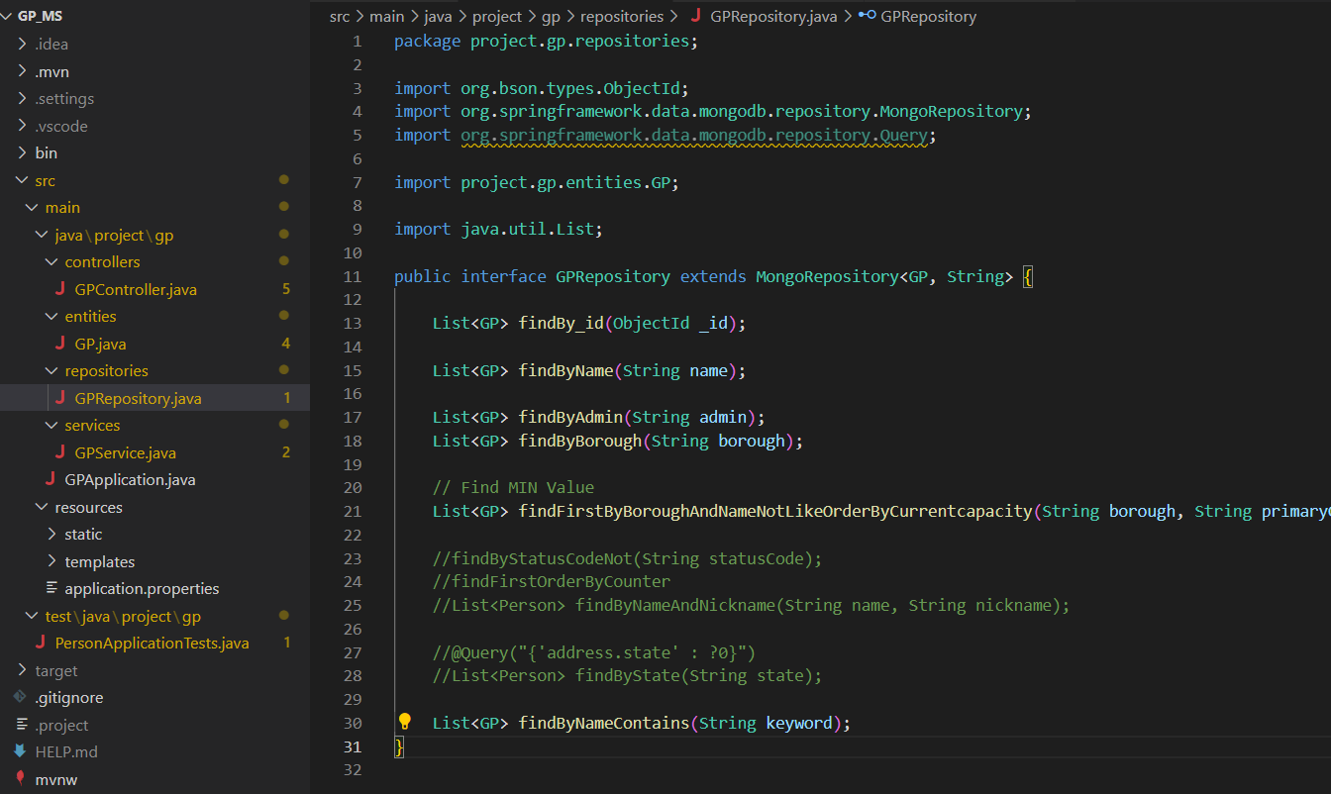  
*Figure 20. Screenshot showing adherence to industry code standards for Repository class*

The above 4 screenshots of the GP Backend service shows how the code is structured consistently across 4 components  
(1) Entity class – Containing defined variables necessary for the model

(2) Controller class – Defines the REST calls and are the first point of entry whenever a call is made to the service

(3) Service class – Brain in which all logic processing is done and communicates with the Repository & Controller classes to send data to/from

(4) Repository class – Defines methods and functions necessary for retrieving and sending data to the database

Rationale for breaking it up into these components are to adhere to industry standards and so that the code remains predictable to both current and new developers who might join the team in the future.

Implement code versioning to ensure sustainable feature rollout

Finally, code versioning was another standard I managed to add into the product code. Versioning is critical to ensure that the product remains backwards compatible until all customers/users have been moved to the latest version.

Versioning is well known to be a crucial part of API design, giving developers ability to improve APIs without breaking older versions. (Marwen, A, 2018)

  
*Figure 21. Screenshot showing code versioning in application*

In addition, the above screenshot also shows how versioning is maintained in the code base. The line ‘RequestMapping(value = /api/v1)’ is where the magic happens as the below methods will be catered only if the frontend route service calls to v1. If an upgraded feature is required, a new RequestMapping can be defined for /api/v2 and then newer customers or calls can be routed to that whilst older customers can remain on v1 until full testing has be done to ensure that the v1 feature can be decommissioned safely.

4.3. Application Deployment

Application code

The application code comprises of the Frontend and the Backend.

The Backend technology is utilizing SpringBoot which is native Java. Thus, there are 2 ways of running the Backend services. Firstly, to directly run ‘mvn spring-boot:run’ in testing stage which will automatically restart the service when code changes are made. Secondly, to run the compiled java package ‘java -jar gp_ms’ in the example of the GP microservice. The latter works as maven automatically packages and compiles into a working jar artifact if the maven build or install command is run.

Since the Frontend technology includes native HTML and JavaScript, it has to be run in a web server. The web server that I am using to run it is called the XAMP tool. XAMP was chosen as it allows for easy localhost testing by providing a main server out of the box. (Javatpoint, no date)

The screenshot below shows that starting and stopping the Apache web server is done by GUI which makes it very convenient and simple.

## **Components of XAMPP**

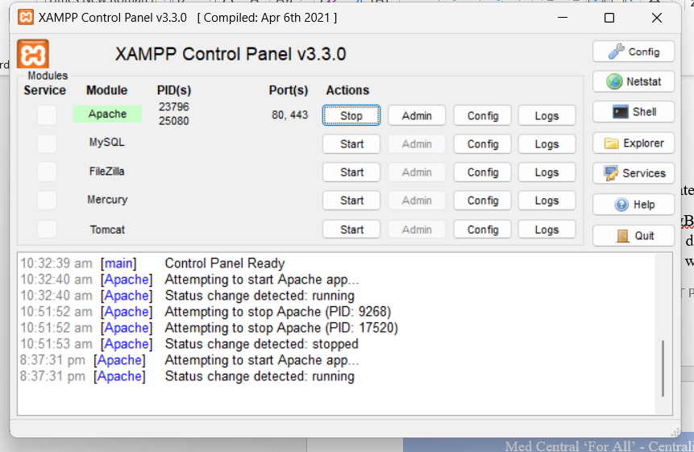  
*Figure 22. Screenshot showing XAMPP web server status*

Both the Frontend and Backend services are run locally currently. Perhaps a future iteration or improvement could be to package them into docker containers and run them on a cloud. To mitigate possible loss of code, I have consistently committed the code base regularly to the Github repository. Github was chosen to be my code repository as it is in industry leader and makes version control really easy to manage and sustain. (Alexandre, O, 2021)

The screenshot below shows the different repositories (1:1 to the different services) as well as the commit history.

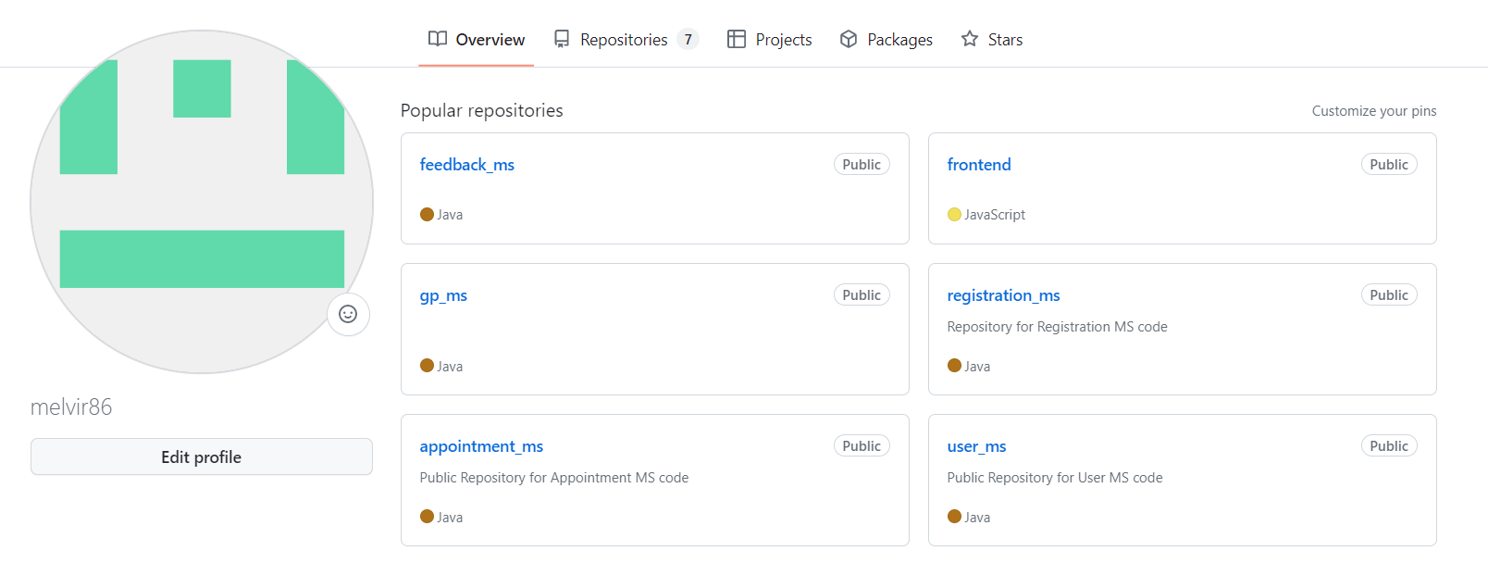  
*Figure 23. Screenshot showing Github repositories of MedCentral*

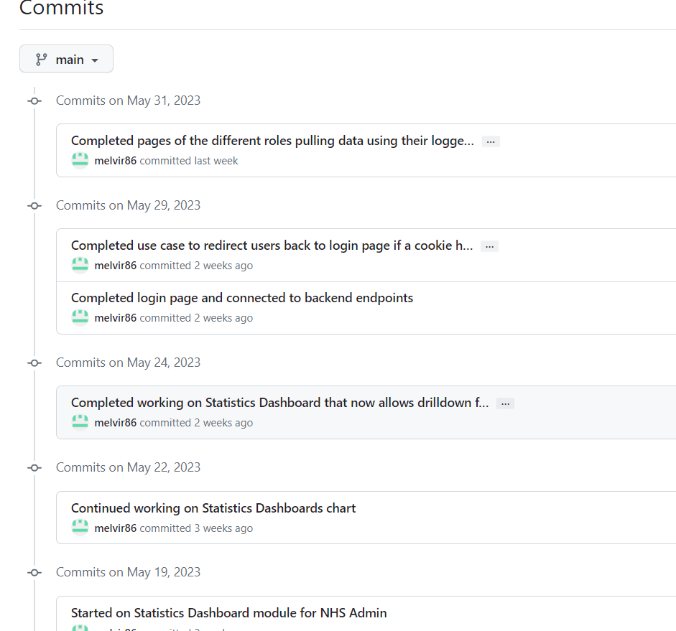  
*Figure 24. Screenshot showing Github commit history of MedCentral*

Application middleware

The main application middleware comprises of the Database server. The Database technology I am utilizing for the project is MongoDB. MongoDB has been the market leader over the last few years so I really wanted experience of working with it. (DB-Engines, 2023) As the data is always the most critical aspect and has to be kept available and secure, I have utilized a cloud repo instead of hosting it locally. I am using the official free cloud service by MongoDB called Mongo Atlas. It is really easy to use and more importantly deploys and replicates your database cluster and its data across a few different locations to ensure high availability. Below is a screenshot showing the database deployment.

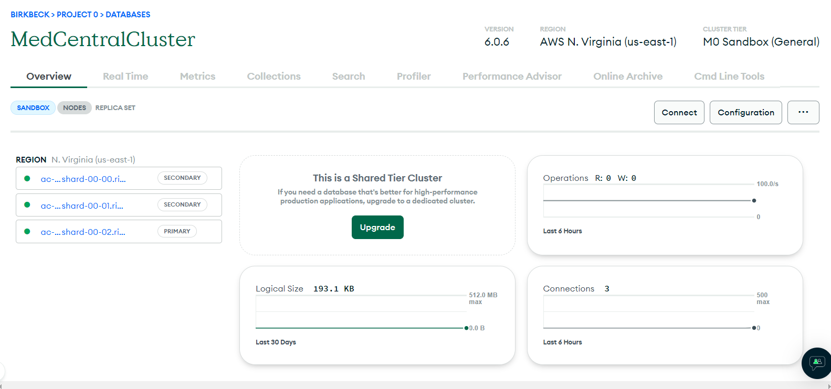  
*Figure 25. Screenshot showing Database deployment in cloud for MedCentral*

4.4. Application Github Repositories

Below is a table summarizing the various Github repositories used to develop and maintain the project. As far as possible, since it is a one man development team, lean code structure and a single branch is utilized for better working efficiency.

|  |  |  |  |
| --- | --- | --- | --- |
| Application | Branches | Rationale | URL |
| Frontend | Main | Used to store code used by the Frontend of MedCentral | [melvir86/frontend (github.com)](https://github.com/melvir86/frontend) |
| Registration-MS | Main | Used to store code used by the Registration Microservice of MedCentral | [melvir86/registration_ms: Repository for Registration MS code (github.com)](https://github.com/melvir86/registration_ms) |
| Appointment-MS | Main | Used to store code used by the Appointment Microservice of MedCentral | [melvir86/appointment_ms: Public Repository for Appointment MS code (github.com)](https://github.com/melvir86/appointment_ms) |
| Feedback-MS | Main | Used to store code used by the Feedback Microservice of MedCentral | [melvir86/feedback_ms (github.com)](https://github.com/melvir86/feedback_ms) |
| User-MS | Main | Used to store code used by the User Microservice of MedCentral | [melvir86/user_ms: Public Repository for User MS code (github.com)](https://github.com/melvir86/user_ms) |
| Registration-MS | Main | Used to store code used by the Registration Microservice of MedCentral | [melvir86/registration_ms: Repository for Registration MS code (github.com)](https://github.com/melvir86/registration_ms) |
| GP-MS | Main | Used to store code used by the GP Microservice of MedCentral | [melvir86/gp_ms (github.com)](https://github.com/melvir86/gp_ms) |
| Testing | Main | Used to store testing code that tests the various backend endpoints of MedCentral | [melvir86/testing (github.com)](https://github.com/melvir86/testing) |

Table 5. GitHub Repositories of MedCentral

As I was not made aware early on when I started development that we had to utilize the school’s provided repository to code and commit instead, thus to meet requirements, I have just copied over the final contents of the above mentioned repositories to it. Since there was only 1 repository provided and I am utilizing the microservice architecture, I have instead used branches to denote the different microservices. It is not ideal, but it allows me to submit code for marking. I have provided more information in the respective README files in the repository. My school’s provided repository is set private at <https://github.com/Birkbeck/msc-project-source-code-files-22-23-melvir86>

5. Code Testing

After most of the microservices and frontend had been developed, I moved on to the testing phase. Testing is absolutely critical in any tech product and cannot be left as an after-thought, after deployment or delivery for example. The drawback of doing so could mean that your customers run into errors while using the application that developers might not have caught during the routine development work.

It might sound counter-intuitive but testing actually saves time and money. Research has been done showing bugs and the cost of fixing them at a later stage of the product lifecycle is more expensive. In short, the earlier a defect is detected, the lower the overall cost of its correction. (Fortegrp, 2020)

Testing is not purely about just writing the test code. Thought process has to go into starting from writing the test plan. This includes building test cases, developing an escalation procedure, conducting the actual tests and verifying the results. (Fortegrp, 2017)

Since MedCentral has basically Create, Read, Update and Delete (CRUD) functions of each core User Feature, I revolved my test plans around them. Below shows a table summarizing the various test cases written for each microservice. Although they are largely similar, there are various differences as not every microservice contains all of CRUD that the frontend calls to display information to the client (user).

|  |  |  |
| --- | --- | --- |
| Microservice | Test Cases (Testing APIs) | Rationale for Testing |
| User-MS | test_getAllUsers() | To ensure Application Admin can retrieve all Users information for use |
| test_loginUser(user) | To ensure that login to the Application works correctly |
| Registration-MS | test_getAllRegistrations() | To ensure that Application Admin can retrieve all Registrations information for use |
| test_getRegistration(id) | To ensure that a specific Registration information could be pulled by passing in its ID |
| test_getRegistrationByUser(user) | To ensure that Registrations of users could be pulled by passing in their ID |
| test_getRegistrationByGPs(gp) | To ensure that Registrations to GPs could be pulled by passing in their ID |
| test_updateRegistrationInformation(id) | To ensure that Registration information could be updated by passing in its new data and its ID |
| test_createNewRegistration() | To ensure that new Registration information could be created successfully |
| Appointment-MS | test_getAllAppointments() | To ensure that Application Admin can retrieve all Appointments information for use |
| test_getAppointment(id) | To ensure that a specific Appointment information could be pulled by passing in its ID |
| test_getAppointmentsByUser(user) | To ensure that Appointments of users could be pulled by passing in their ID |
| test_getAppointmentsByGPs(gp) | To ensure that Appointments to GPs could be pulled by passing in their ID |
| test_updateAppointmentInformation(id) | To ensure that Appointment information could be updated by passing in its new data and its ID |
| test_createAppointment() | To ensure that new Appointment information could be created successfully |
| GP-MS | test_getAllGPs() | To ensure that Application Admin can retrieve information on all GPs |
| test_getGPByAdmin(gpadmin) | To ensure that a specific GP information could be pulled by passing in its GPAdmin incharge |
| test_getGPByName(gp) | To ensure that GP information could be pulled by passing in the GP ID |
| test_getGPByBorough(borough) | To ensure that GPs can be pulled by boroughs to aid statistics module |
| test_getGPByLeastCurrentCapacity ByBorough(primary GP) | To ensure that system selects the correct Secondary GP option during patient registration feature |
| test_updateGPInformation(gp) | To ensure that GP information can be updated successfully |
| Feedback-MS | test_getAllFeedbacks() | To ensure that Application Admin can retrieve all Feedback information for use |
| test_getFeedback(id) | To ensure that a specific Feedback information could be pulled by passing in its ID |
| test_getFeedbacksByUser(user) | To ensure that Feedback of users could be pulled by passing in their ID |
| test_updateFeedbackInformation(id) | To ensure that Feedback information could be updated by passing in its new data and its ID |
| test_createNewFeedback() | To ensure that new Feedback can be created successfully |

Table 6. Test Cases/Functions on all MedCentral’s Microservices

Testing code was written in Python for 2 reasons. Firstly, it was to utilize knowledge imparted to us during the entire postgrad as most of the programming modules used Python. It was important for me to put into practise what I had learnt and excelled in during the postgrad. Secondly, the abundant libraries in Python meant test code could be easily written. Below are some screenshots of testing done on the Feedback microservices that could aid better understanding.  
  
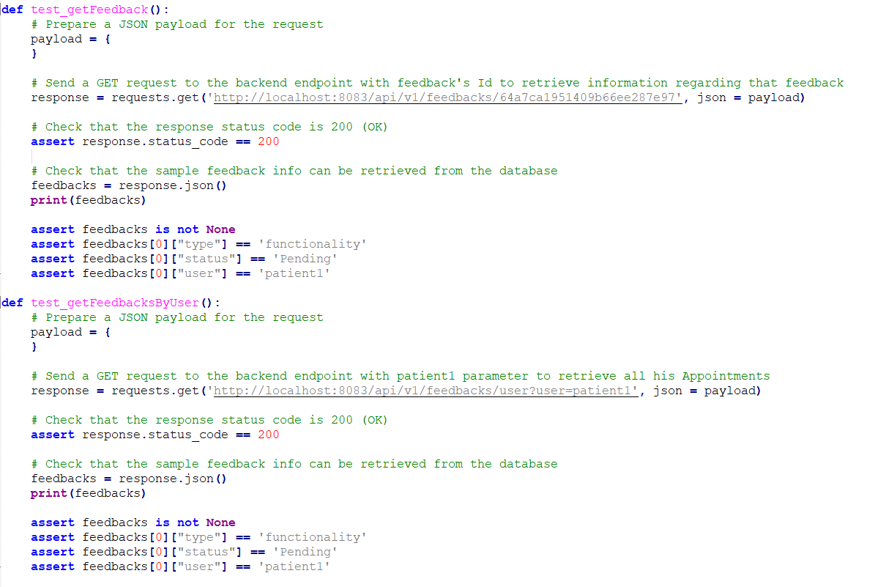

*Figure 26. Screenshot showing 2 functions of Feedback-MS being tested and the return data being verified*

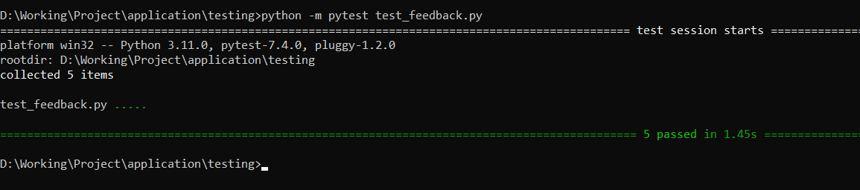  
*Figure 27. Screenshot showing all 5 test cases on Feedback-MS passing successfully*

6. Demonstration

This section does a walkthrough of the different role’s functionalities available within the application.

Since the application is run locally, this is the URL to access it 🡪 <http://localhost/frontend/login.html>

6.1. Patient Role’s Functionalities

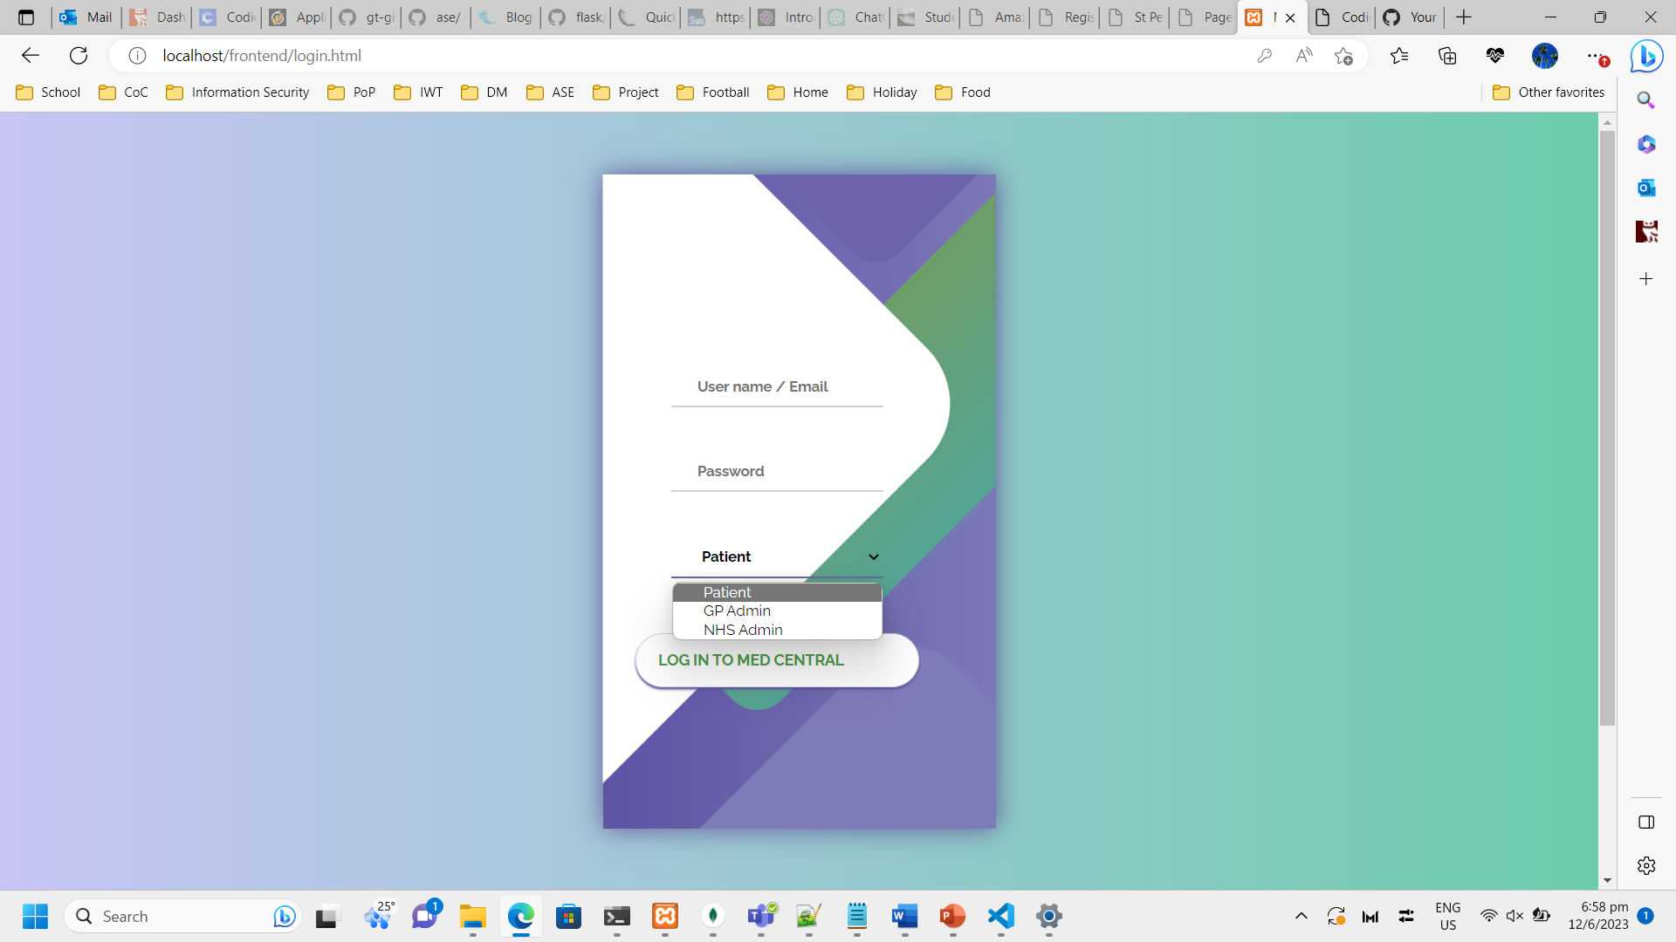  
*Figure 28. Screenshot showing Patient Role Login page*

Description: Login page for all users of the application. Login for a test user (patient1 / Password123).

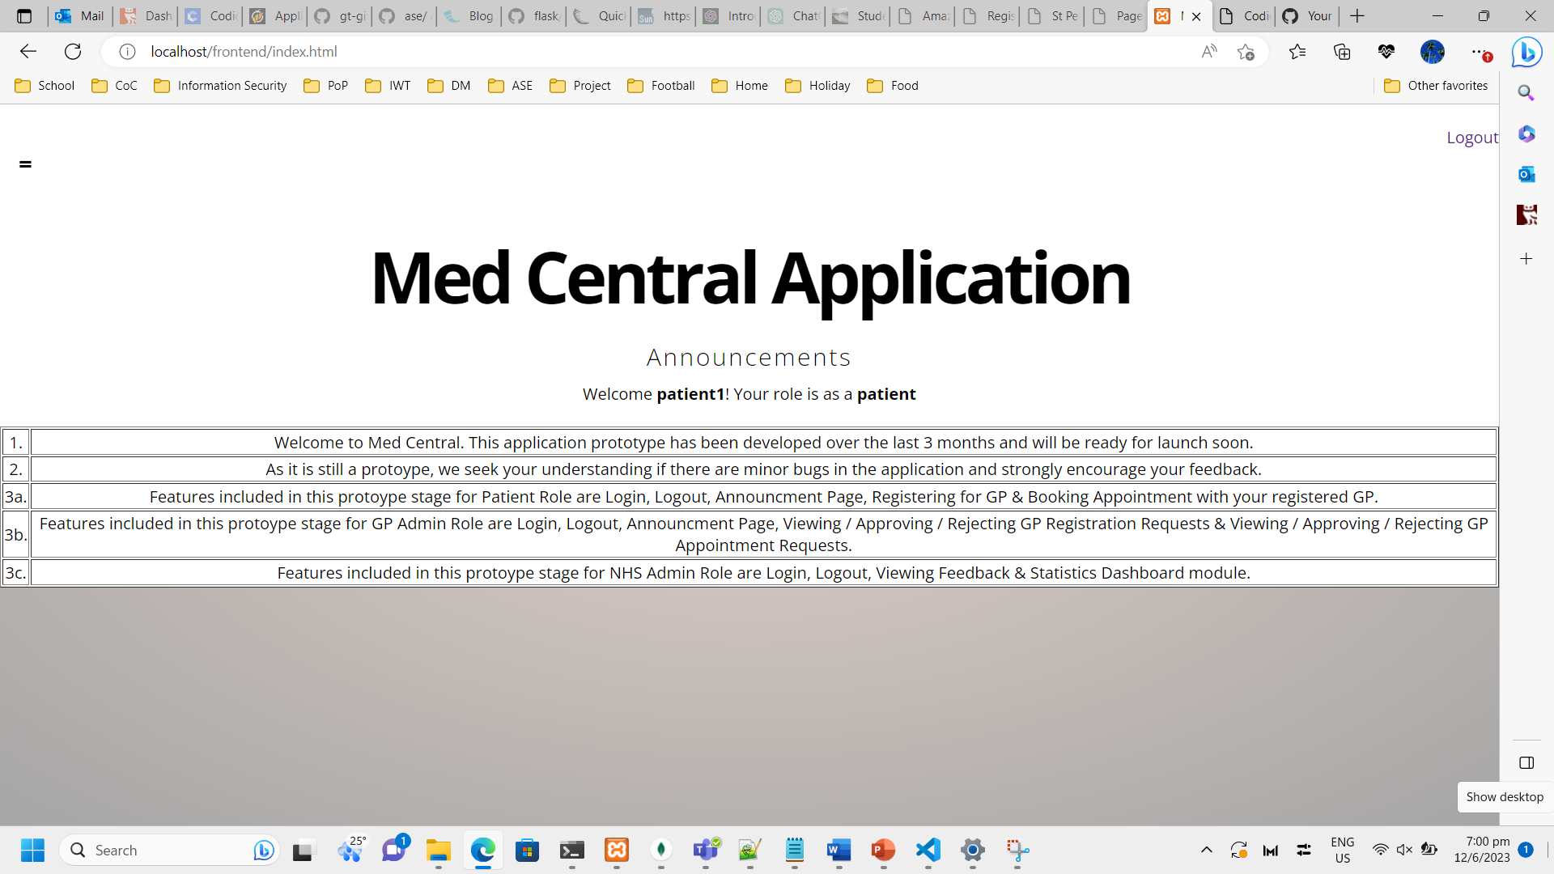  
*Figure 28. Screenshot showing Patient Role Homepage*

Description: Default home/landing page for all users of the application. The name and role of the user is customized to the specific login. The announcements are standard and also allows user to logout his/her session on the top right.

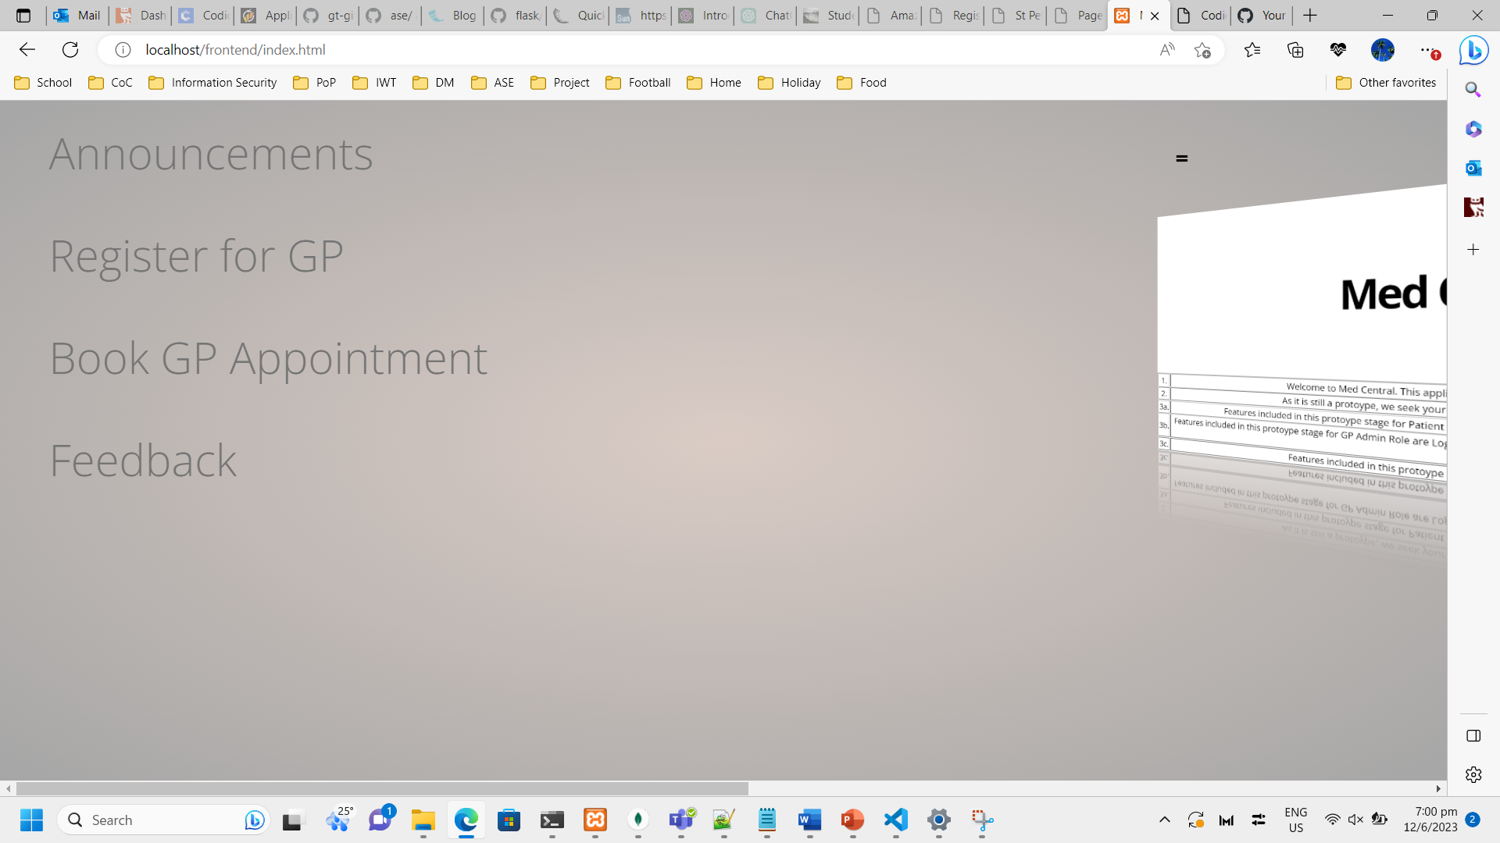  
*Figure 29. Screenshot showing Patient Role Navigation tab*

Description: The navigation tab links are different for each role due to them having specific functionalities. These are the ones available to Patients.

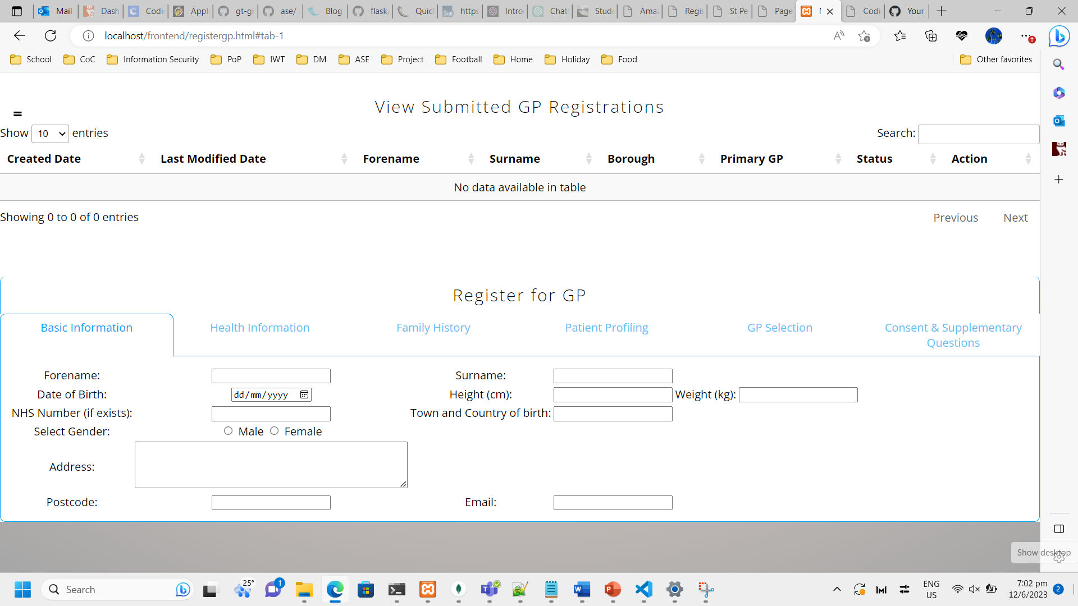  
*Figure 30. Screenshot showing Patient Role GP Registration page*

Description: Page for Registering for GP. The same page also shows the submitted GP registrations on top. This is to enable a single view for the patient instead of requiring multiple clicks.

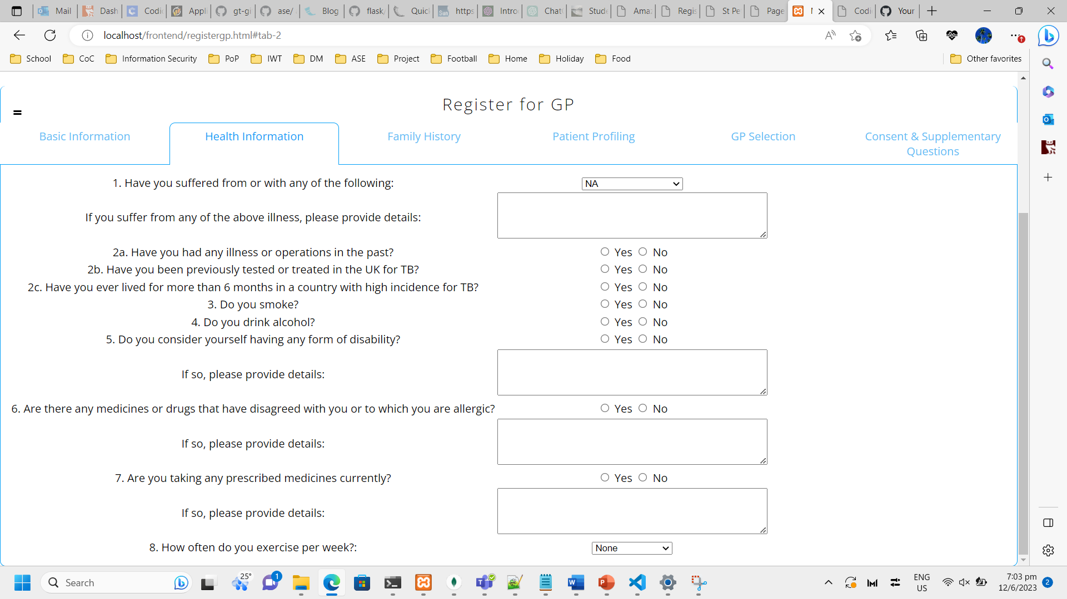  
*Figure 31. Screenshot showing Patient Role GP Registration page’s Health Tab*

Description: Health Information tab for Registering for GP.

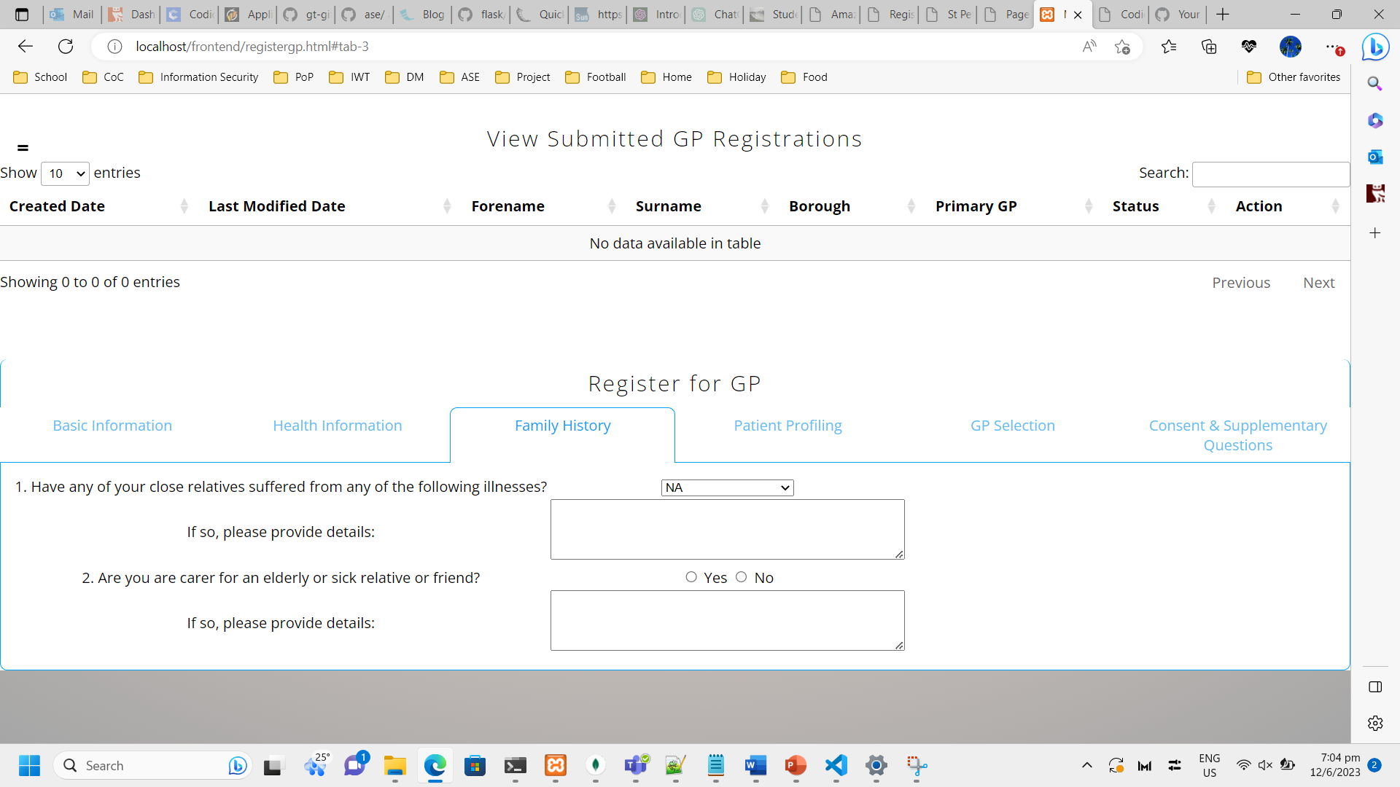  
*Figure 32. Screenshot showing Patient Role GP Registration page’s Family History Tab*

Description: Family History tab for Registering for GP.

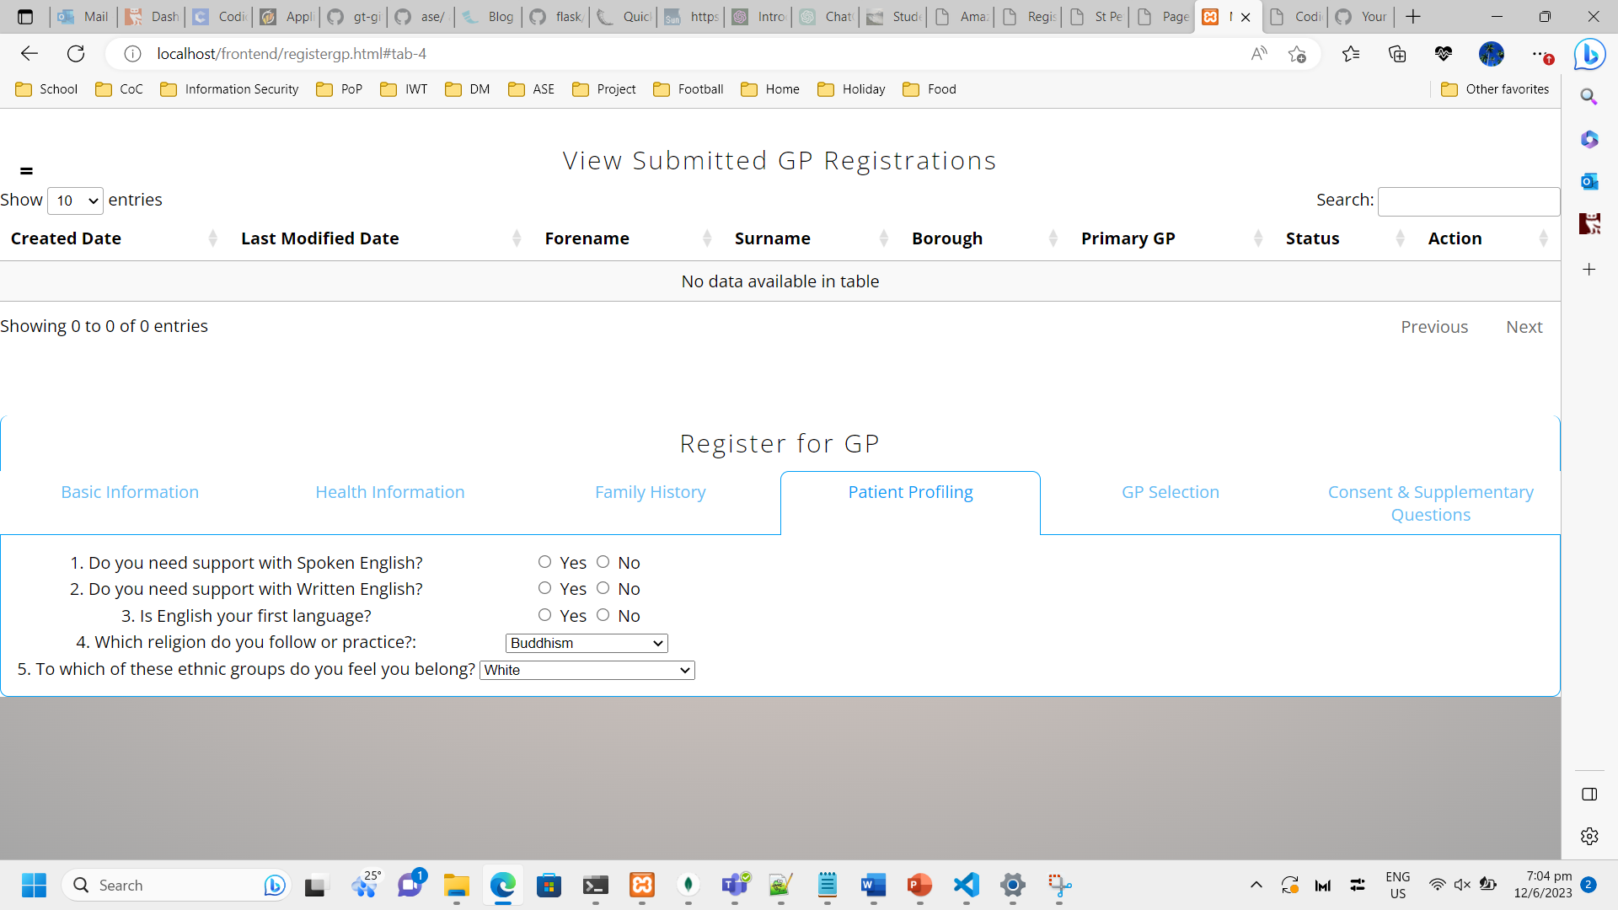  
*Figure 33. Screenshot showing Patient Role GP Registration page’s Patient Profiling Tab*

Description: Patient Profiling tab for Registering for GP.

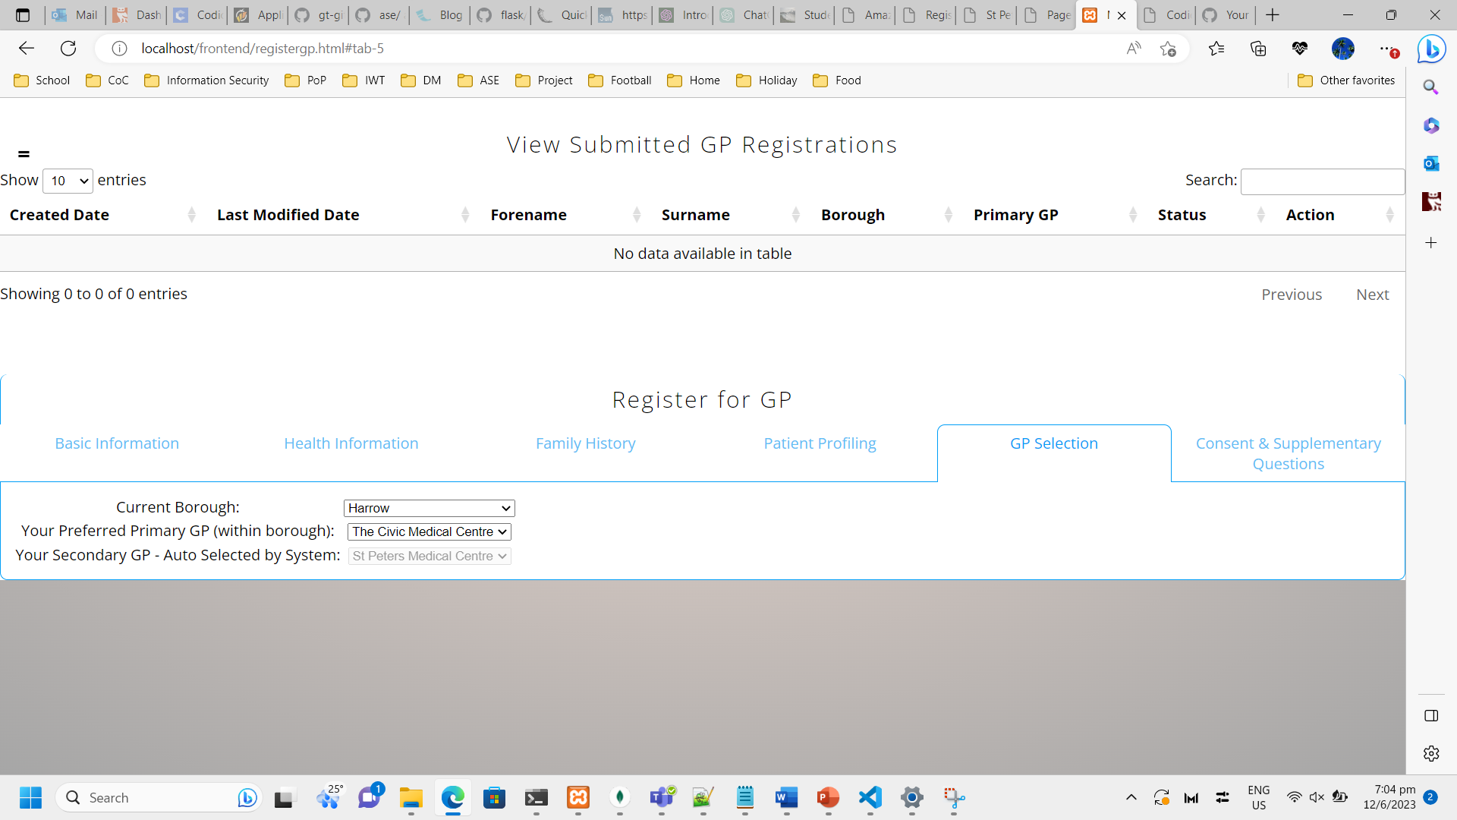  
*Figure 34. Screenshot showing Patient Role GP Registration page’s GP Selection Tab*

Description: GP Selection tab for Registering for GP. The list of GPs are dynamically loaded upon selecting your borough. The Secondary GP is also automatically selected by the system once the Patient selects his/her Primary GP. The algorithm uses least current load within the borough to recommend the Secondary GP.

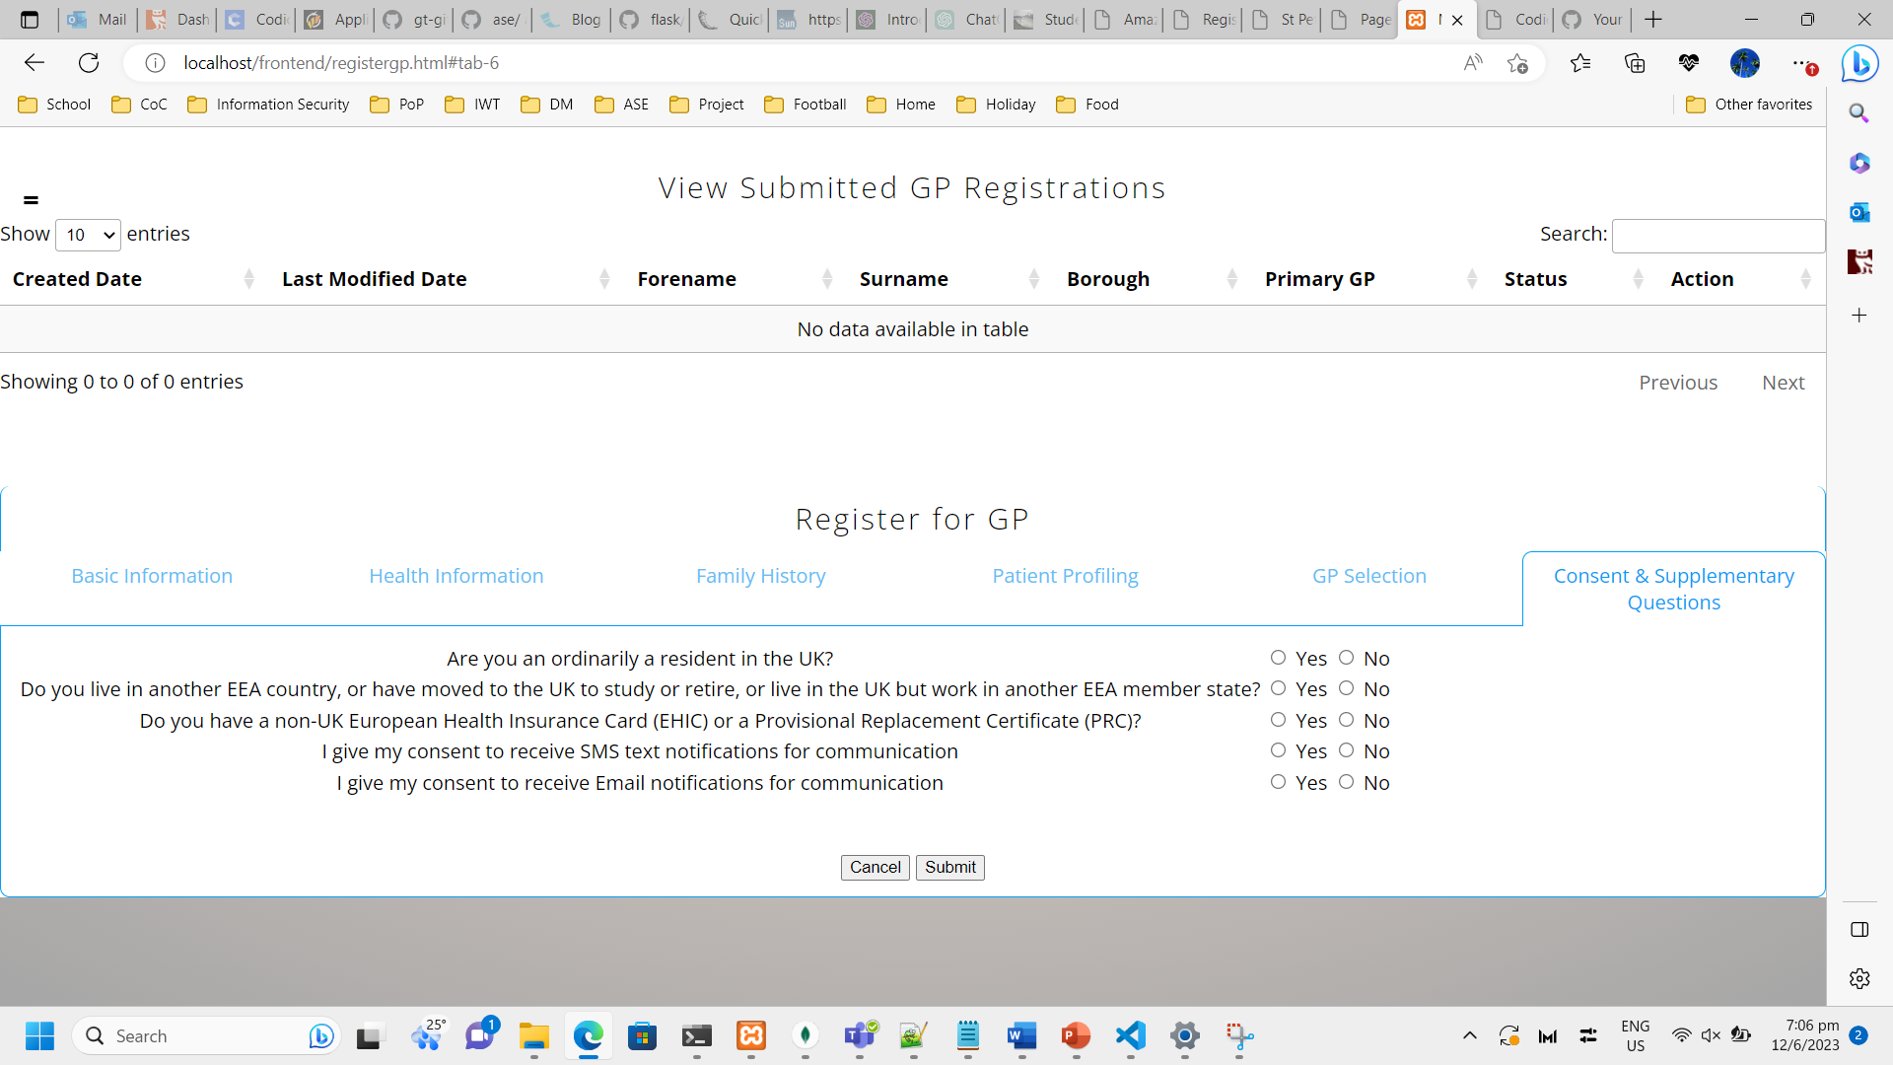  
*Figure 35. Screenshot showing Patient Role GP Registration page’s Consent Tab*

Description: Consent & Supplementary Questions tab for Registering for GP. Also the final tab which allows the Patient to submit the Registration.

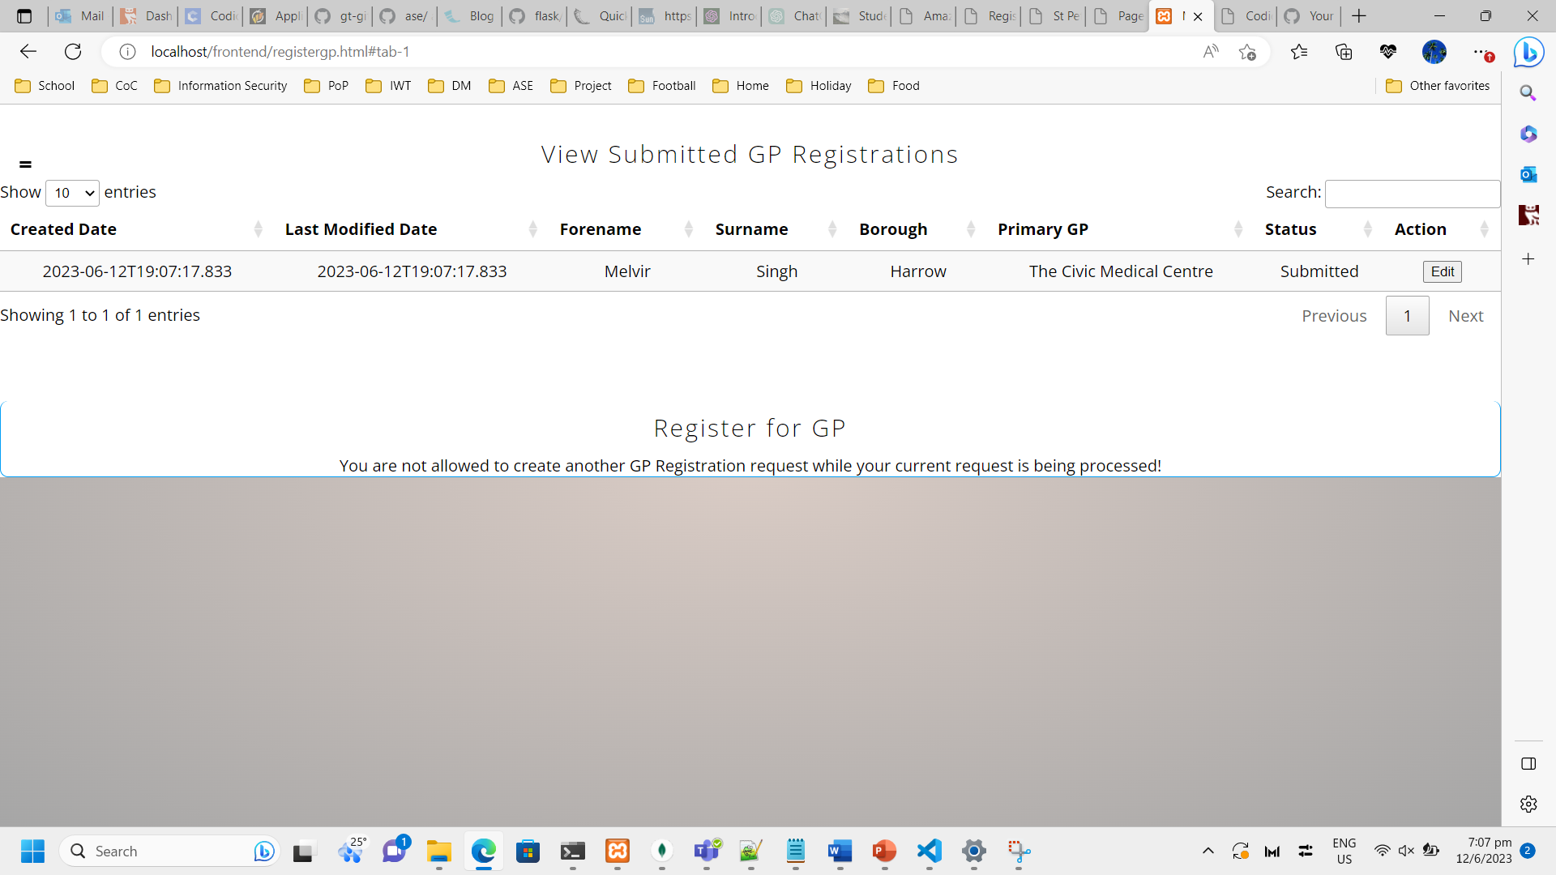  
*Figure 36. Screenshot showing Patient Role View Submitted GP Registration’s page*

Description: Upon submission of GP Registration, the system updates the View GP Registrations table on top with the latest data. The system also blocks the patient from submitting another concurrent registration request. The system allow real-time filtering for the table that is very responsive via the Search textbox on top right.

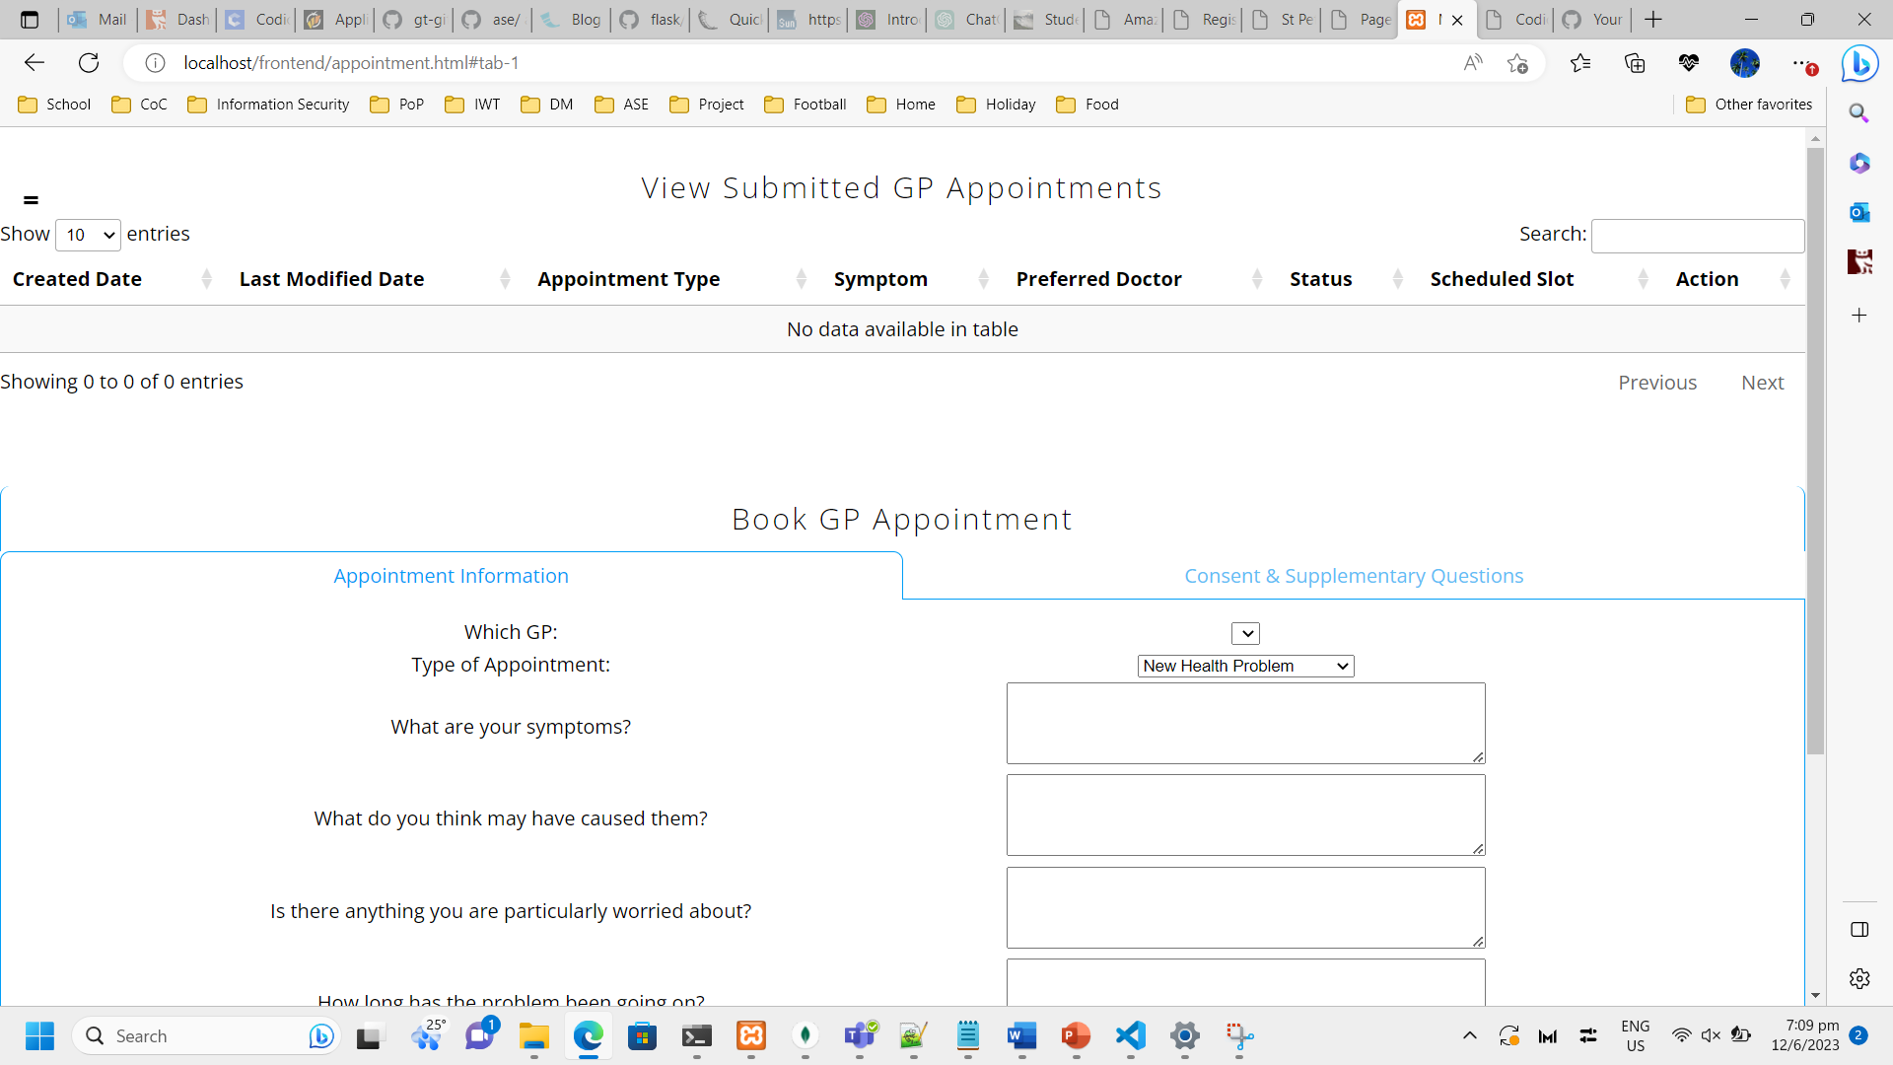  
*Figure 37. Screenshot showing Patient Role View Book GP Appointment page*

Description: Page for Booking GP Appointments. The page is designed with the similar concept (table showing submitted requests on top and form to submit appointments below) and intuitiveness as the GP Registration page to ensure that the patient does not have to re-learn and will understand how to use it immediately.

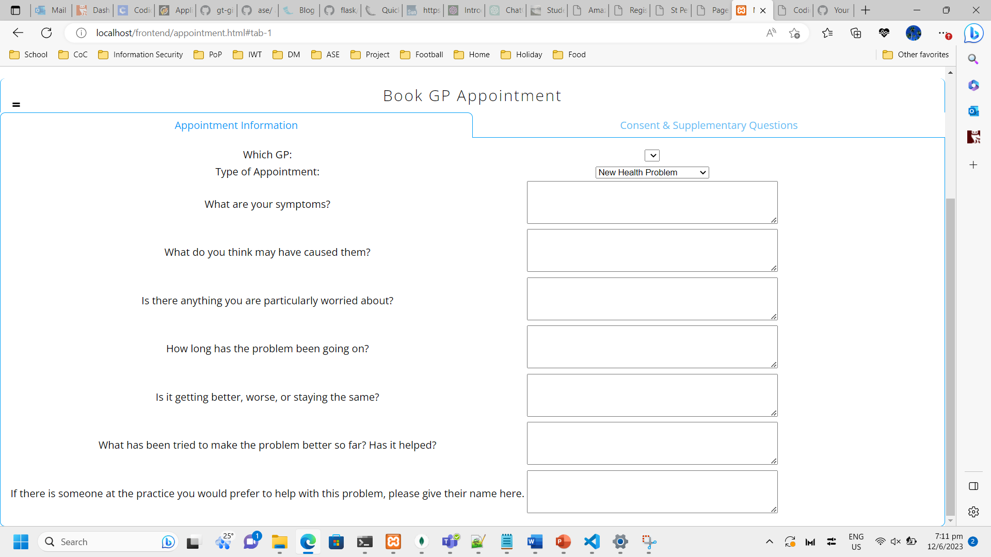  
*Figure 38. Screenshot showing Patient Role View Book GP Appointment page tabs*

Description: Kept it simple with just 2 tabs – Appointment Information & Consent Supplementary Questions. Patient is able to select which GP (primary or secondary) to book appointment for. The dropdown box is empty currently as the Patient does not have any approved GP Registrations yet.

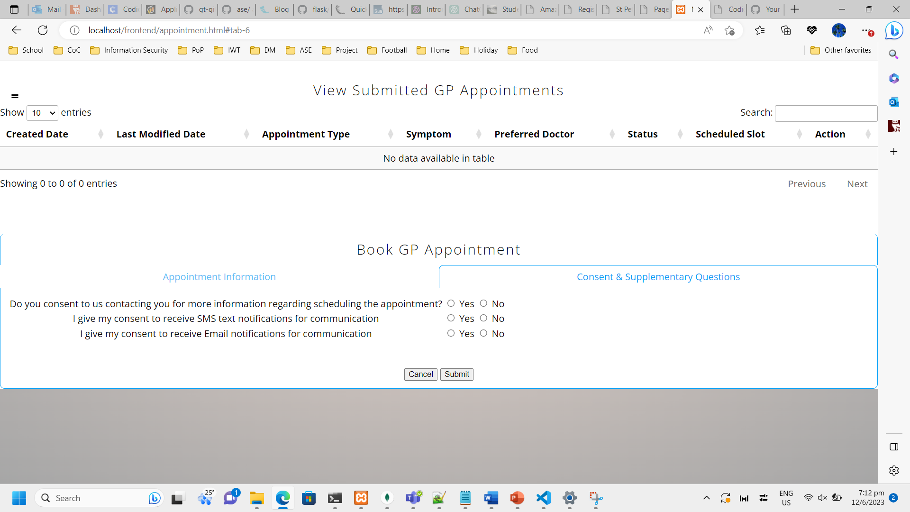  
*Figure 39. Screenshot showing Patient Role Book GP Appointment Consent tab*

Description: Consent & Supplementary Questions tab for Booking GP Appointments. Also allows the Patient to submit the Appointment.

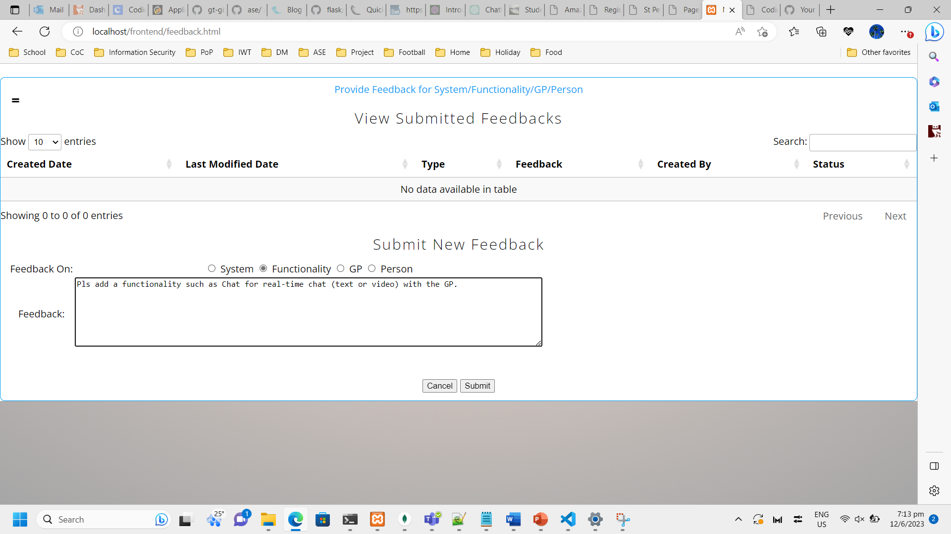  
*Figure 40. Screenshot showing Patient Role Book Feedback page*

Description: Page for Submitting Feedback about system/functionalities/GP or any person in NHS. Similar concept of showing the submitted data in a table on top followed by the actual form below.

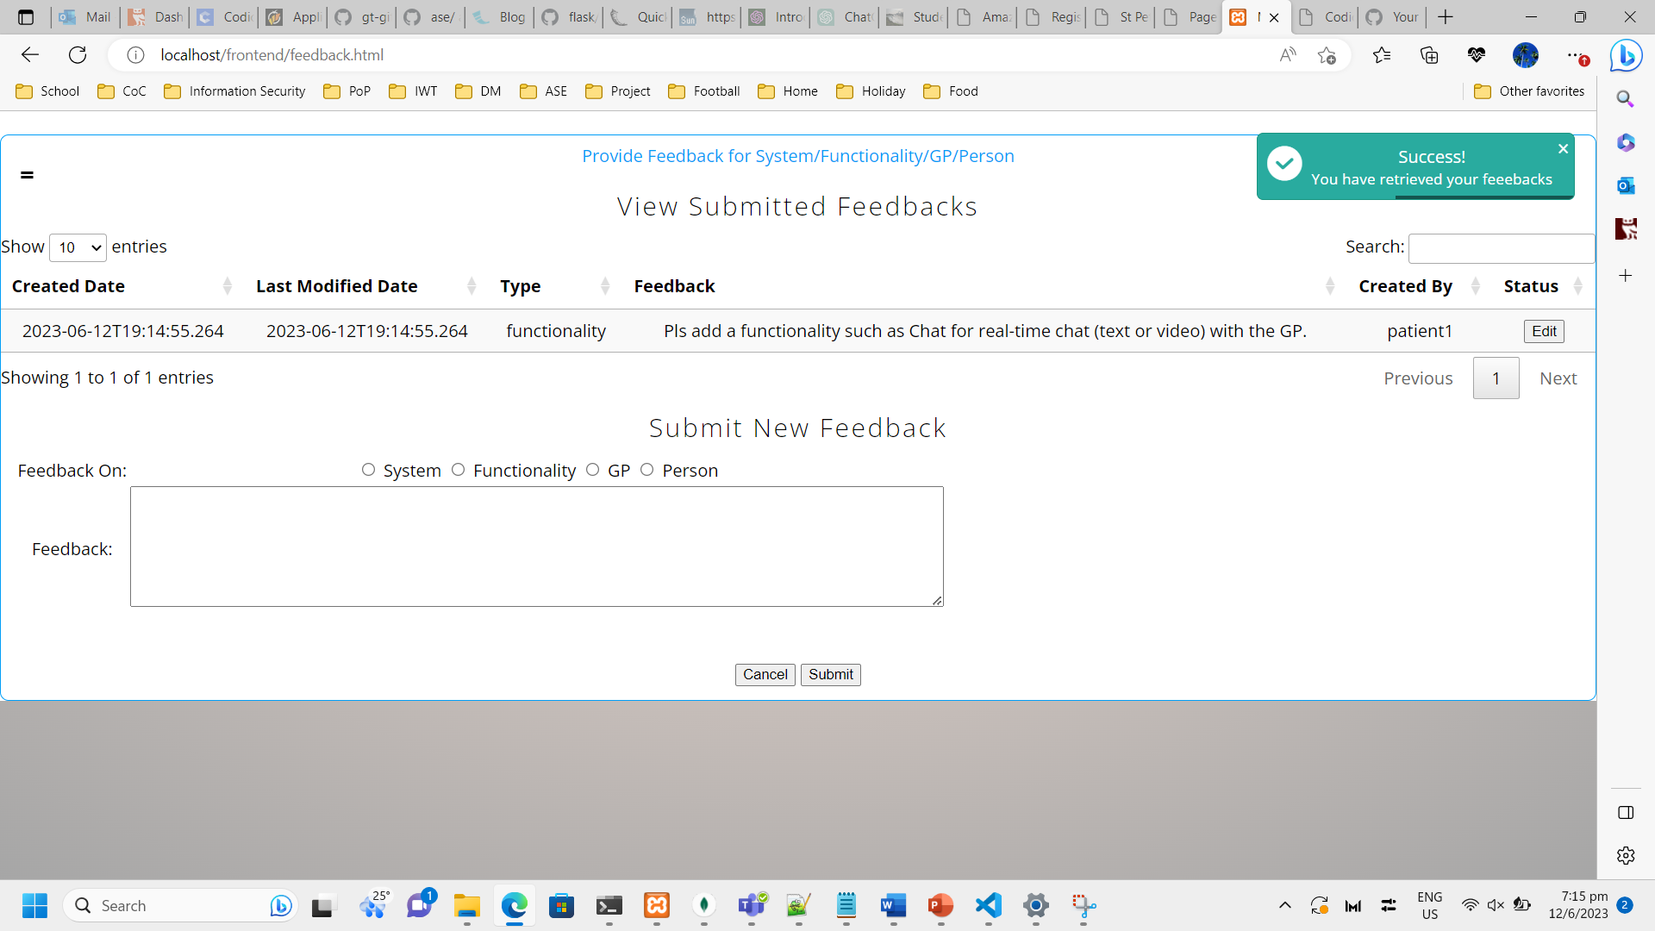  
*Figure 41. Screenshot showing Patient Role View Submitted Feedbacks page*

Description: Upon submission of Feedback, the system updates the View Submitted Feedbacks table on top with the latest data. The system allow real-time filtering for the table that is very responsive via the Search textbox on top right.

6.2. GP Admin Role’s Functionalities

  
*Figure 42. Screenshot showing GP Admin Role Login page*

Description: Login page for all users of the application. Login for a test user (gpadmin1 / Password123).

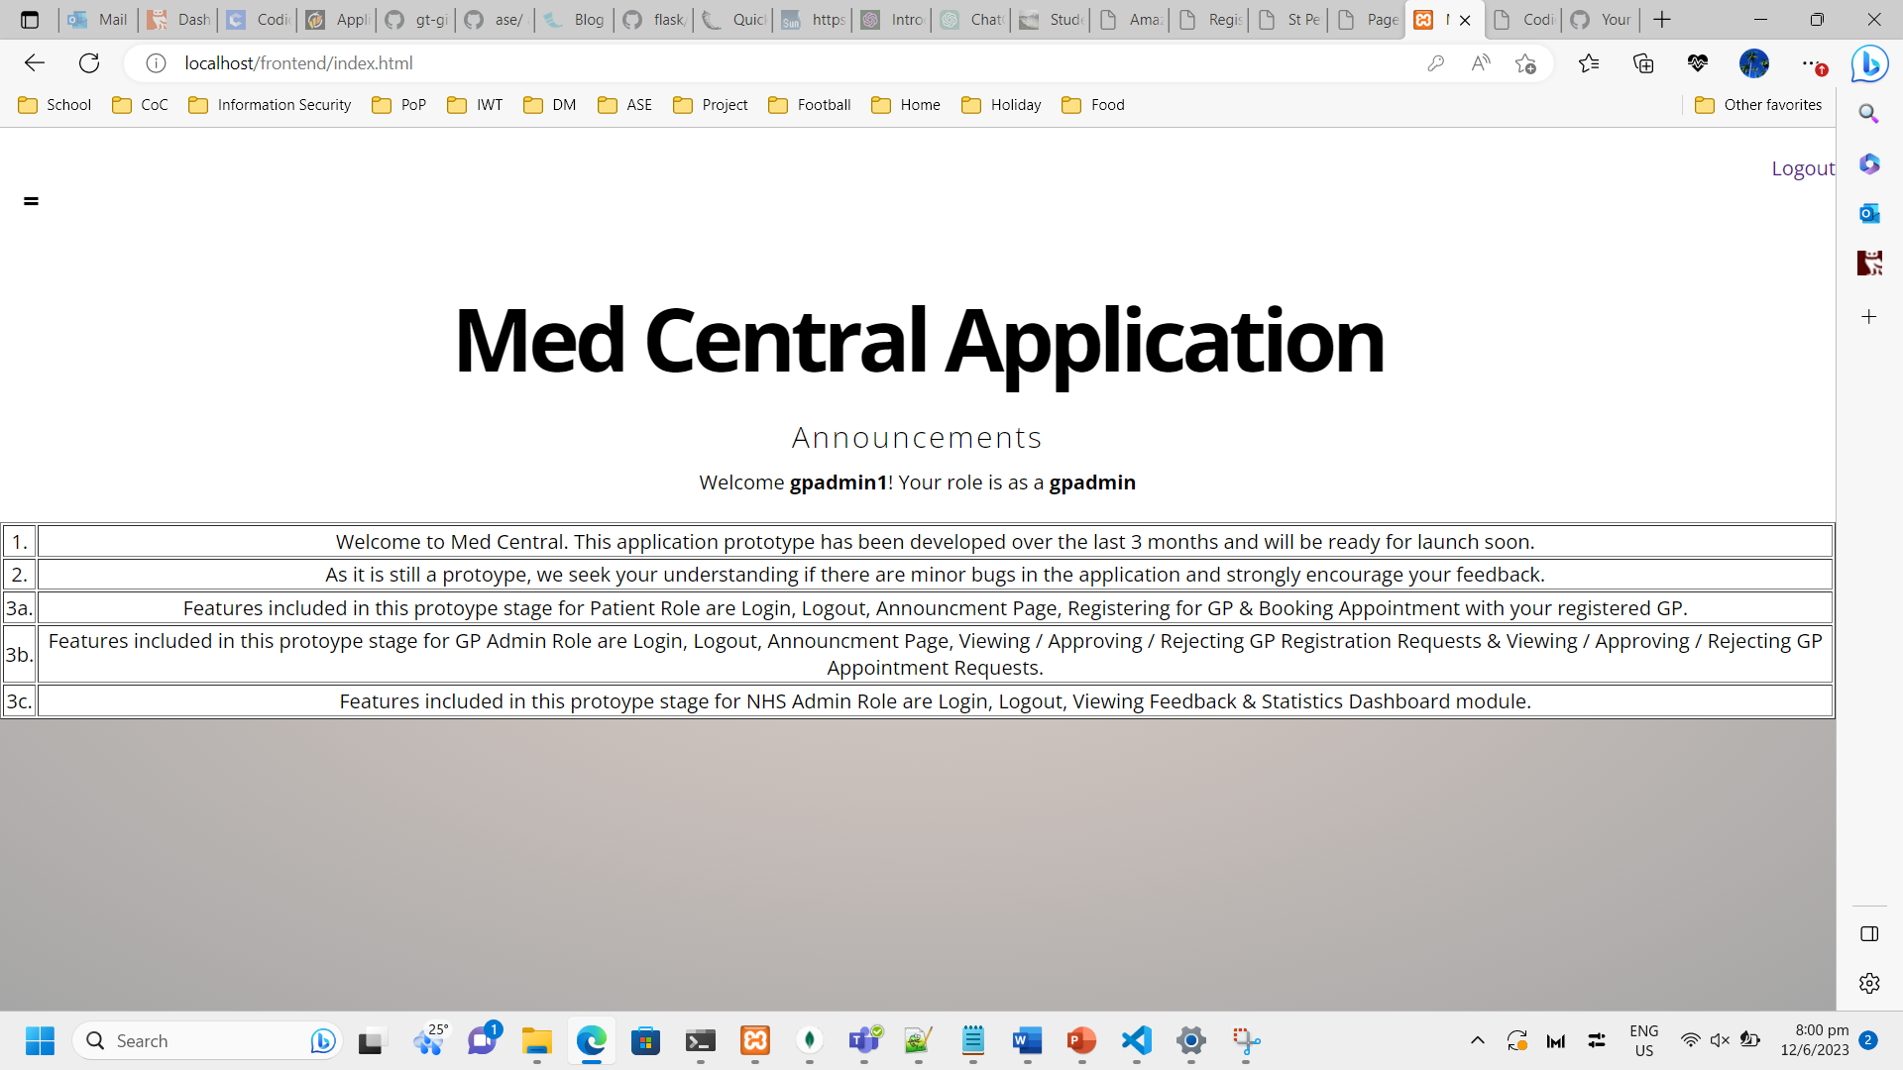  
*Figure 43. Screenshot showing GP Admin Role Homepage*

Description: Default home/landing page for all users of the application. The name and role of the user is customized to the specific login. The announcements are standard and also allows user to logout his/her session on the top right.

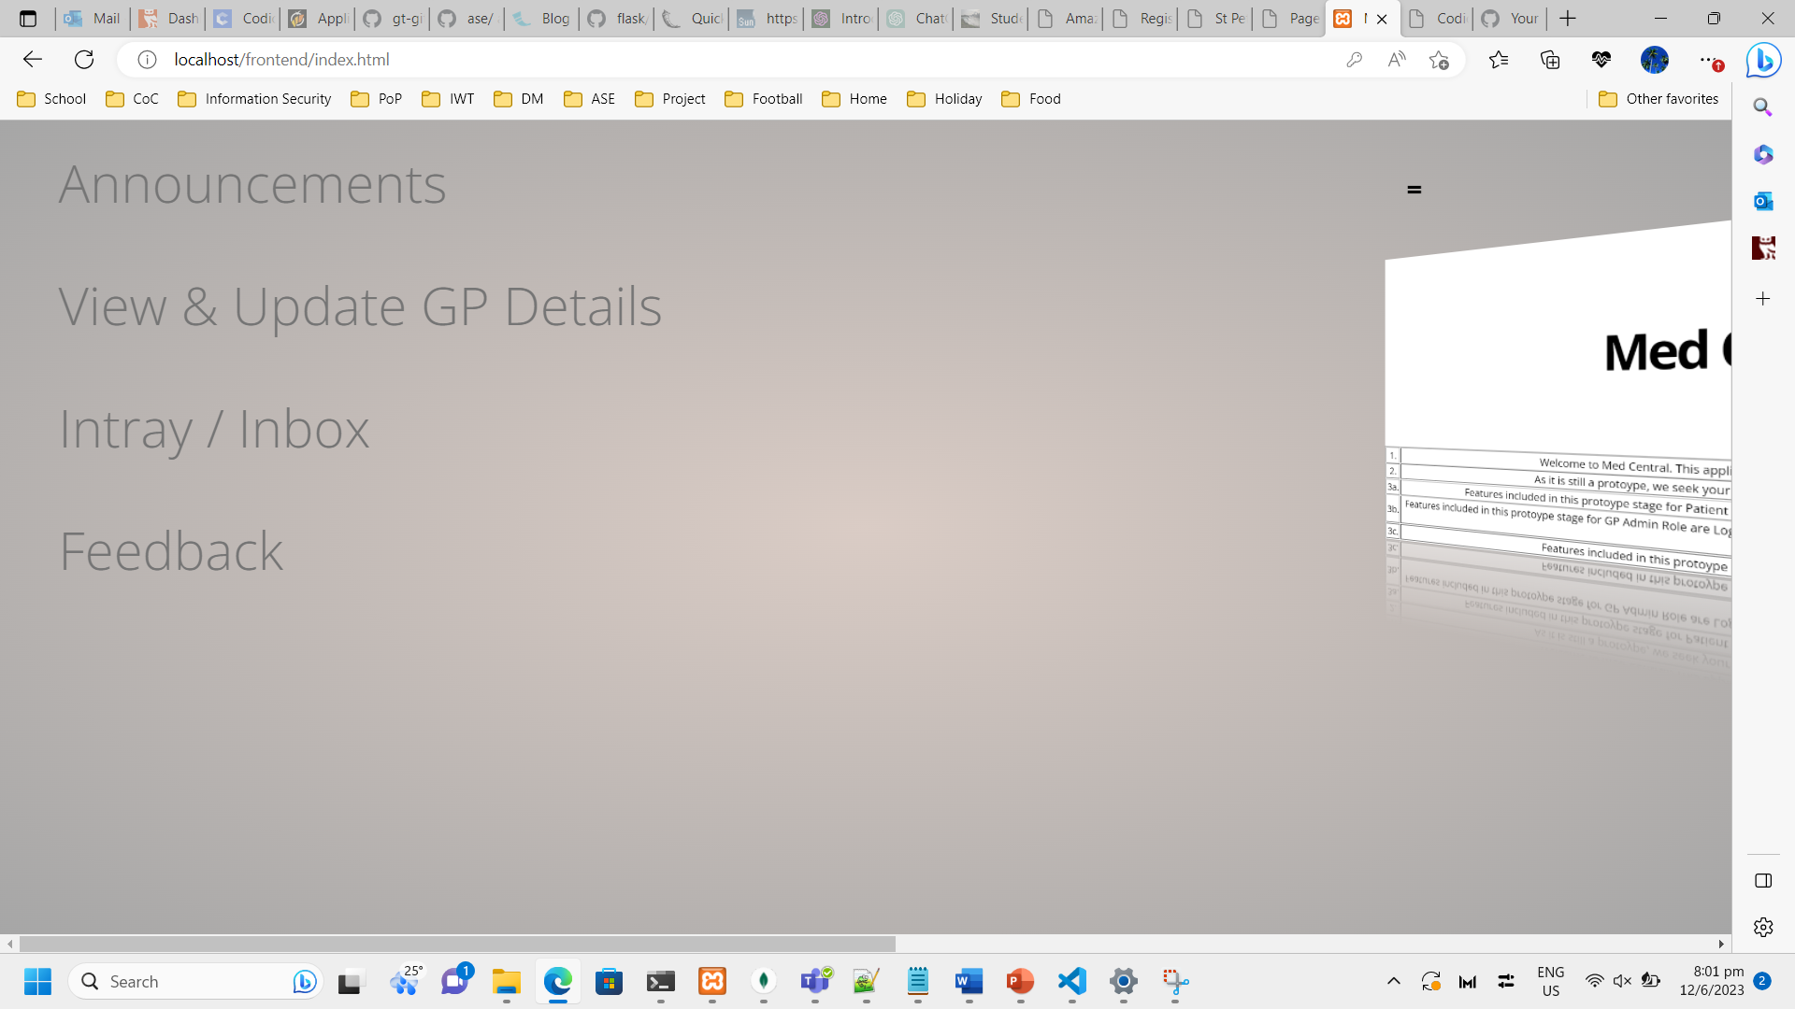  
*Figure 44. Screenshot showing GP Admin Role Navigation tab*

Description: The navigation tab links are different for each role due to them having specific functionalities. These are the ones available to GP Admins.

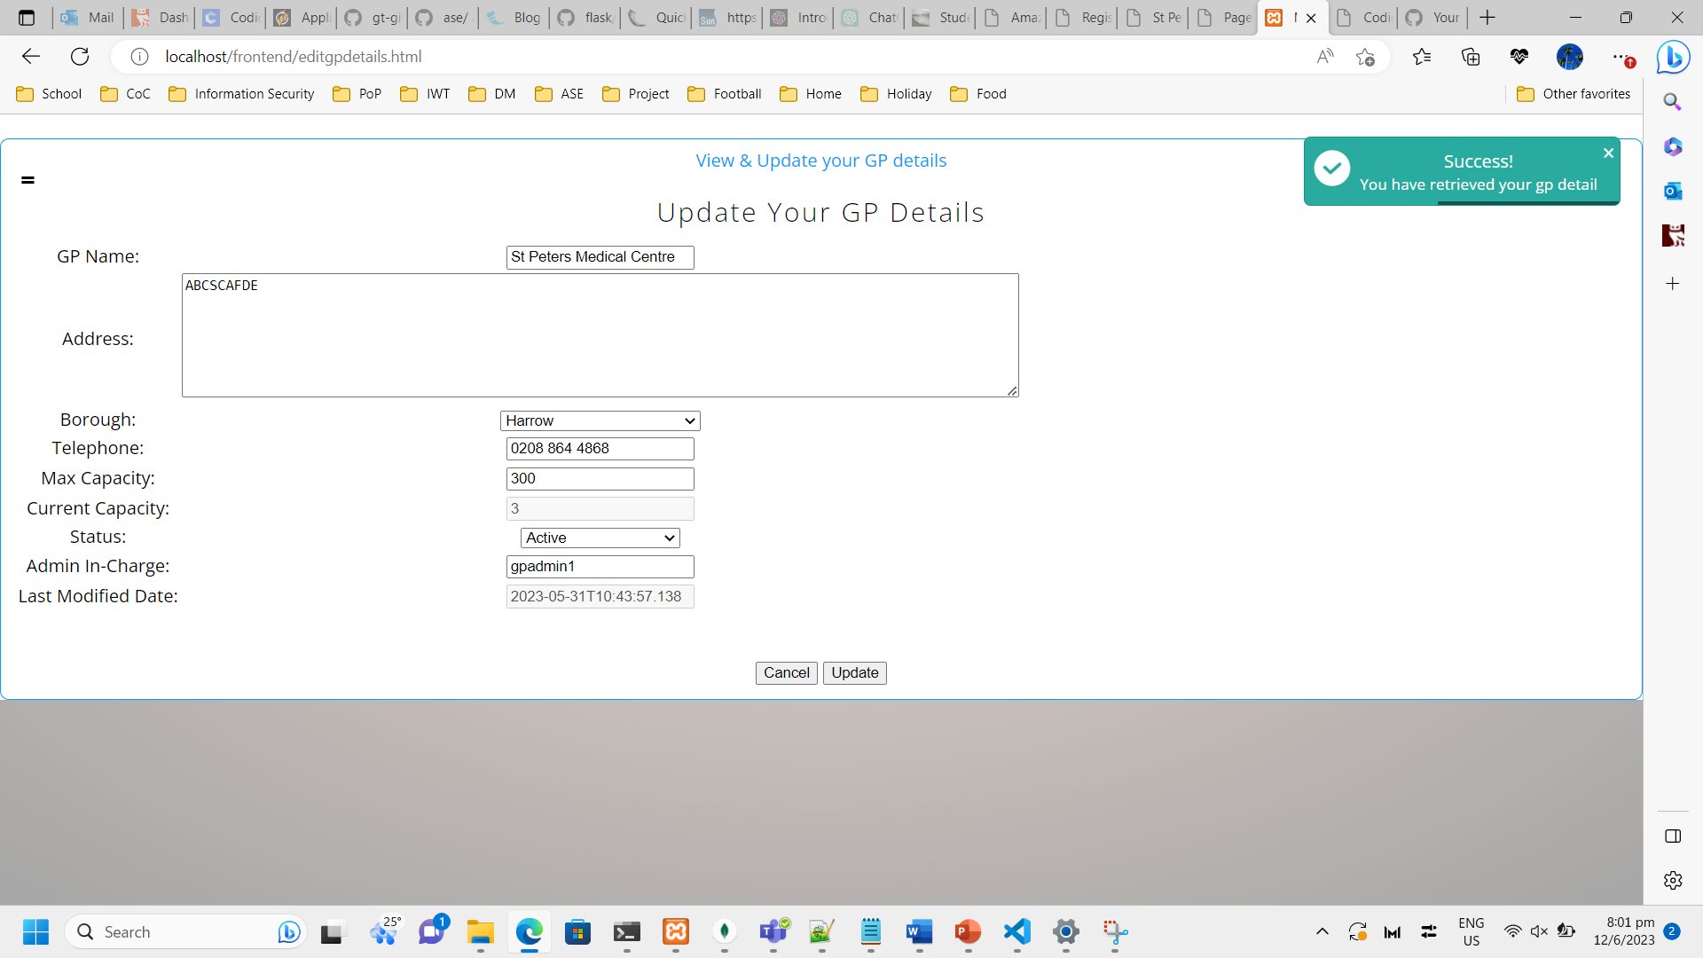  
*Figure 45. Screenshot showing GP Admin Role Update Your GP Details page*  
Description: Page for Updating your own GP details.

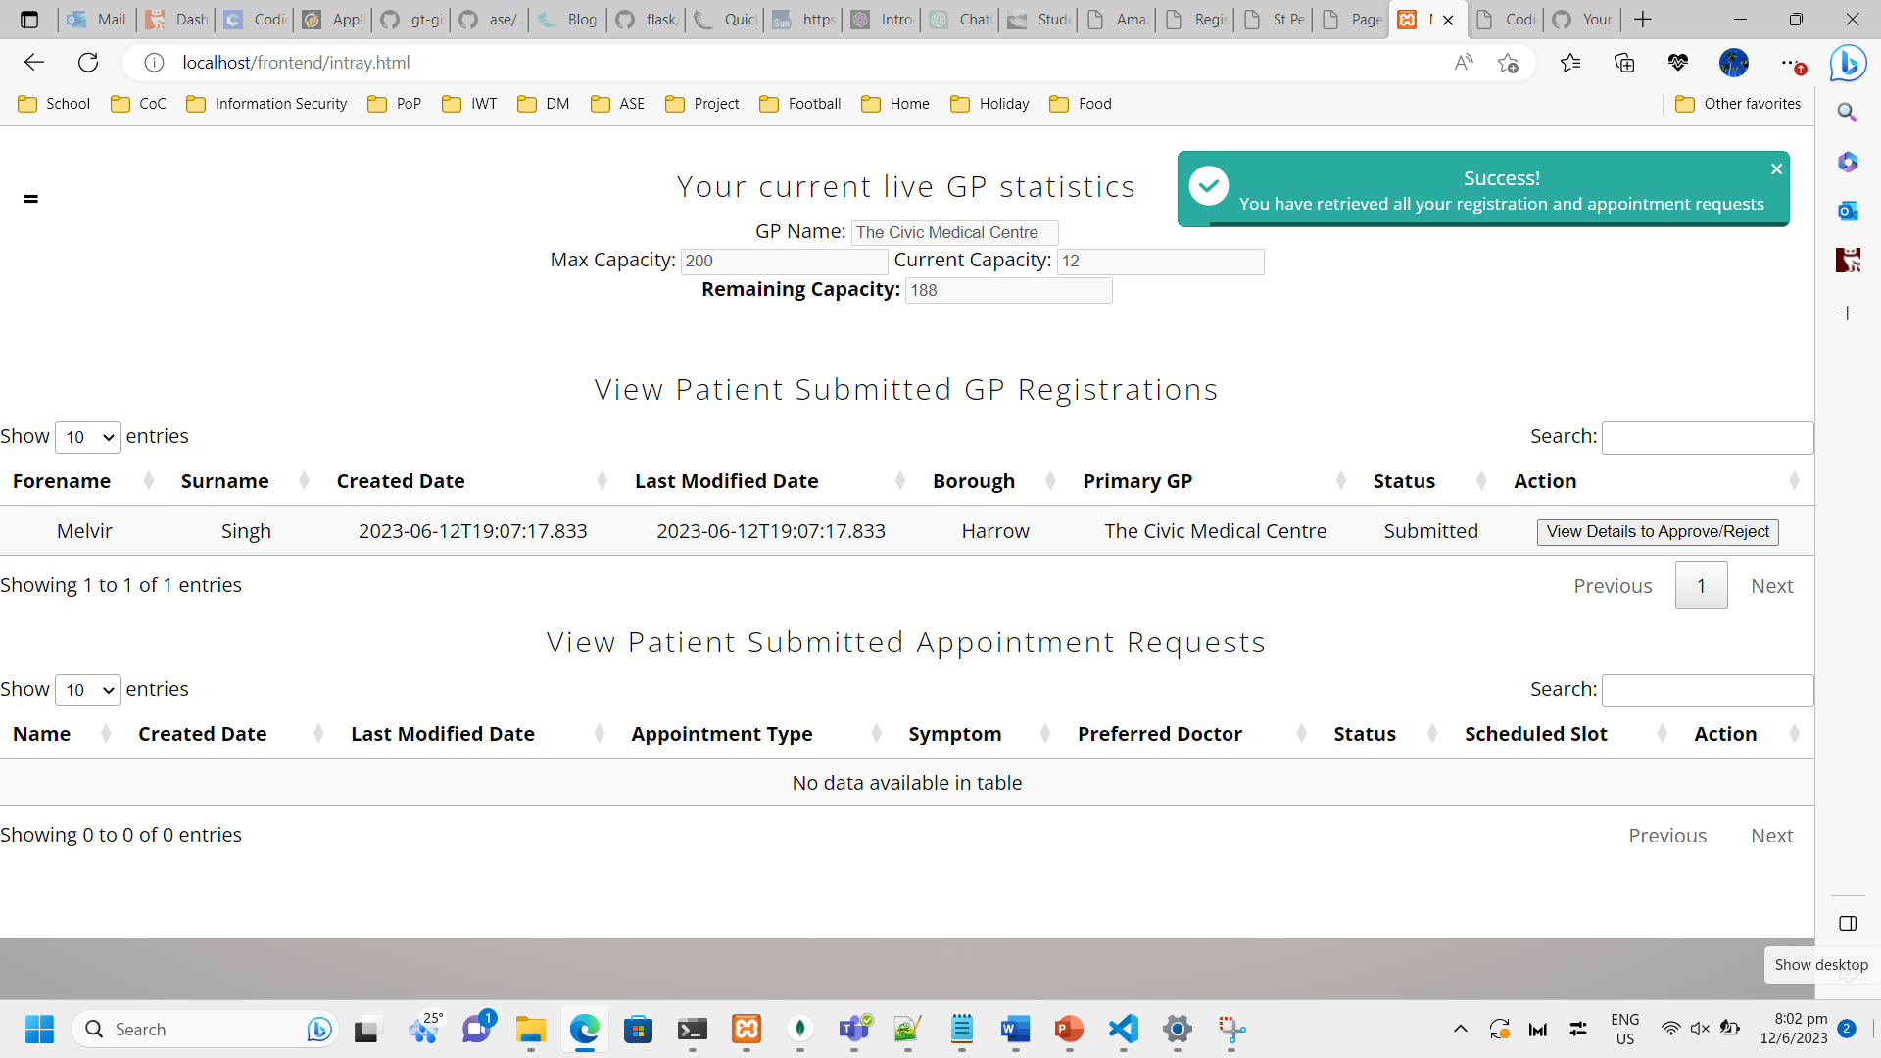  
*Figure 46. Screenshot showing GP Admin Role Inbox page*

Description: Inbox / Intray Page for GP Admins. This page provides a single overview for requests that require action to be taken by the GP Admins. The top part of the page provides a snippet of the current load and available capacity left in the GP. The middle table shows Patient’s GP Registration Requests and the bottom table shows Patient’s GP Appointment Requests. GP Admin can click on the ‘View Details to Approve/Reject’ button for each request.

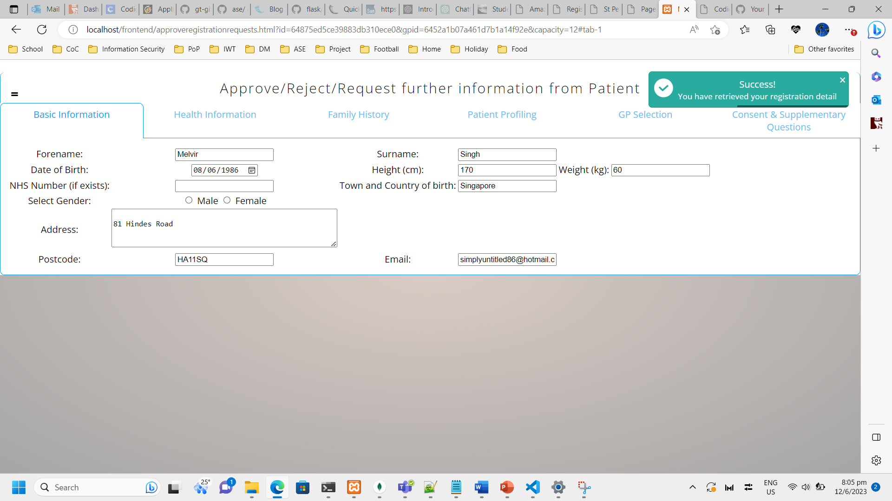  
*Figure 47. Screenshot showing GP Admin Role Inbox page continued*

Description: Upon clicking the button, the Registration form loads with the data input by the Patient.

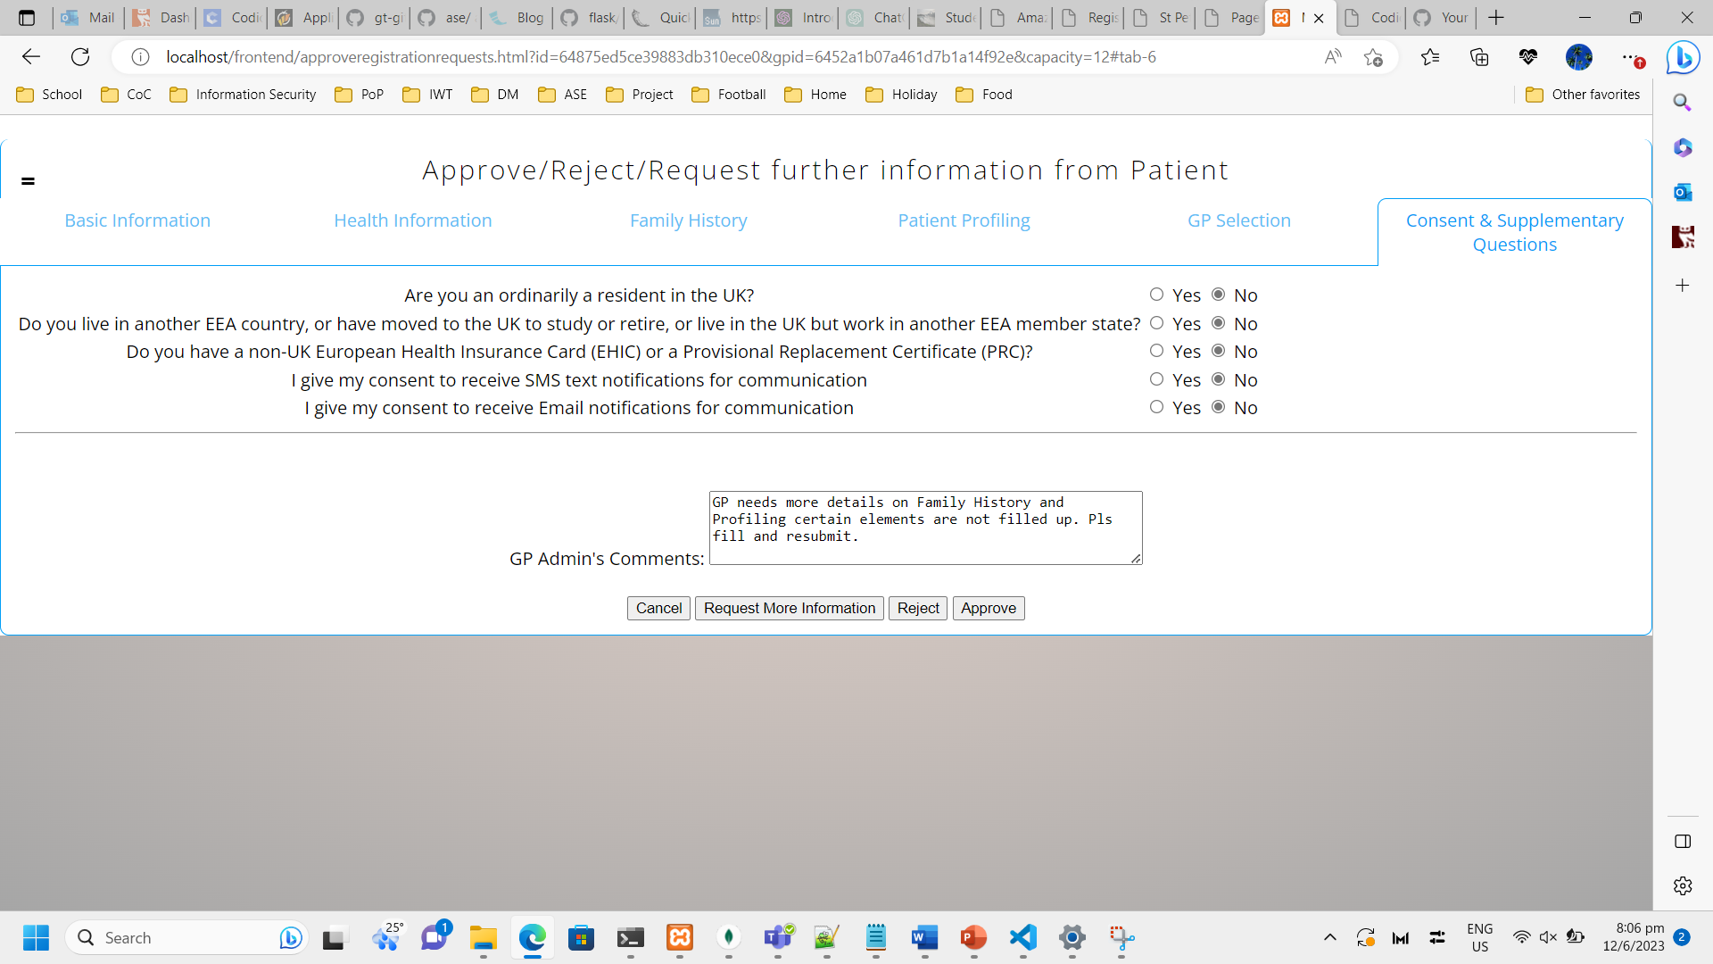  
*Figure 48. Screenshot showing GP Admin Role Approve action*

Description: The last tab allows the GP Admin to either Reject / Approve or request more information from the Patient. The GP Admin can fill up the reason and route the request back to the Patient.

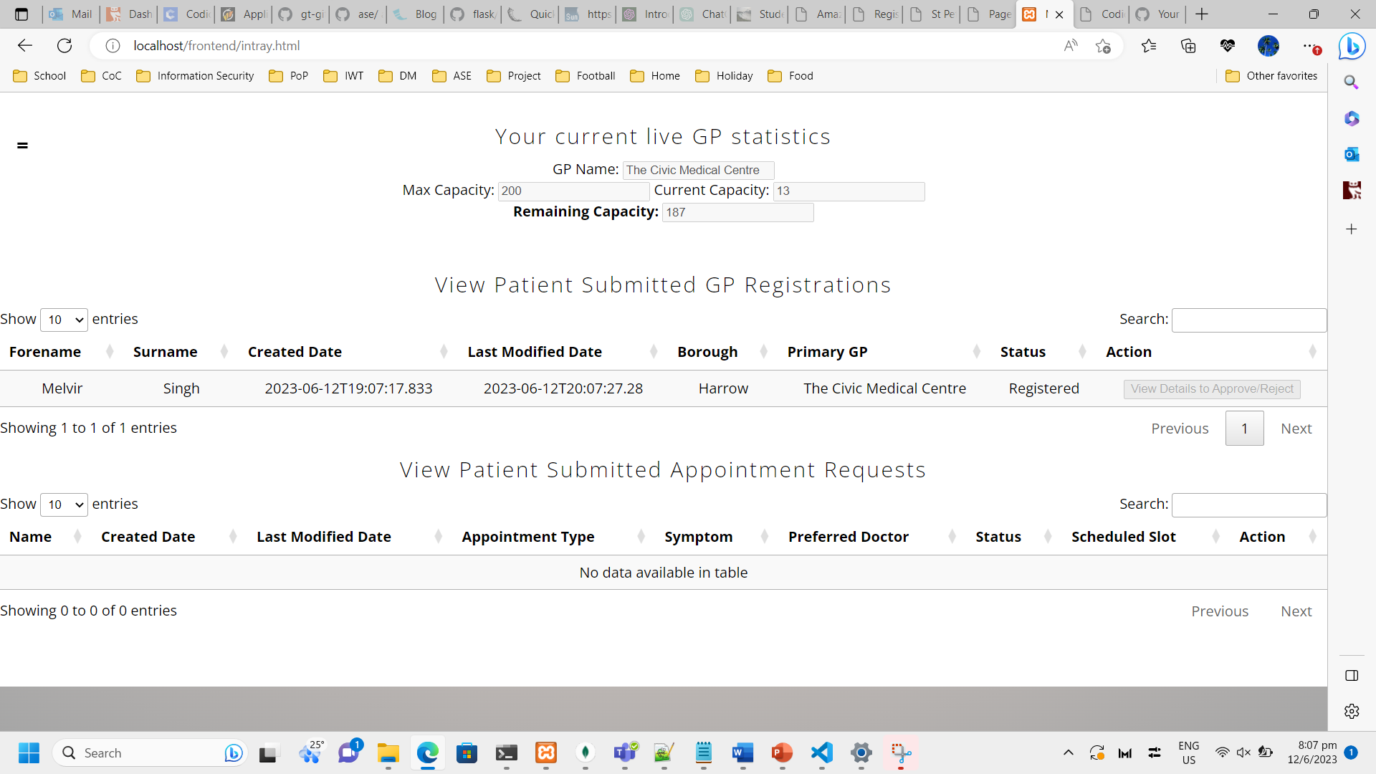  
*Figure 49. Screenshot showing GP Admin Inbox page with updated Status*

Description: If the GP Admin approved the request, the status will be updated to ‘Registered’ and the Patient will be able to view this from their own GP Registration page as shown earlier. The remaining capacity is also updated in real-time to provide latest statistics to the GP Admin.

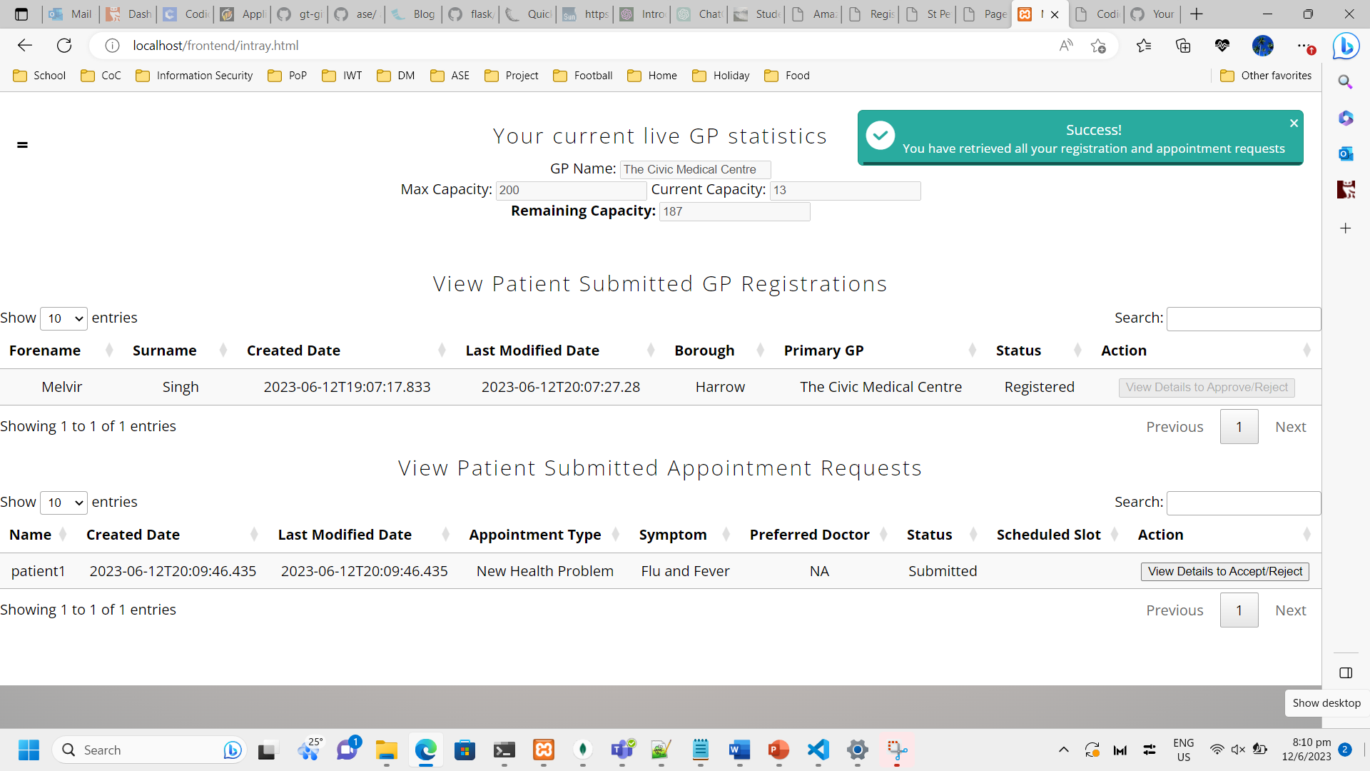  
*Figure 50. Screenshot showing GP Admin Inbox page with updated Status continued*

Description: To maintain consistency, the Patient Appointment Requests also works the same way.

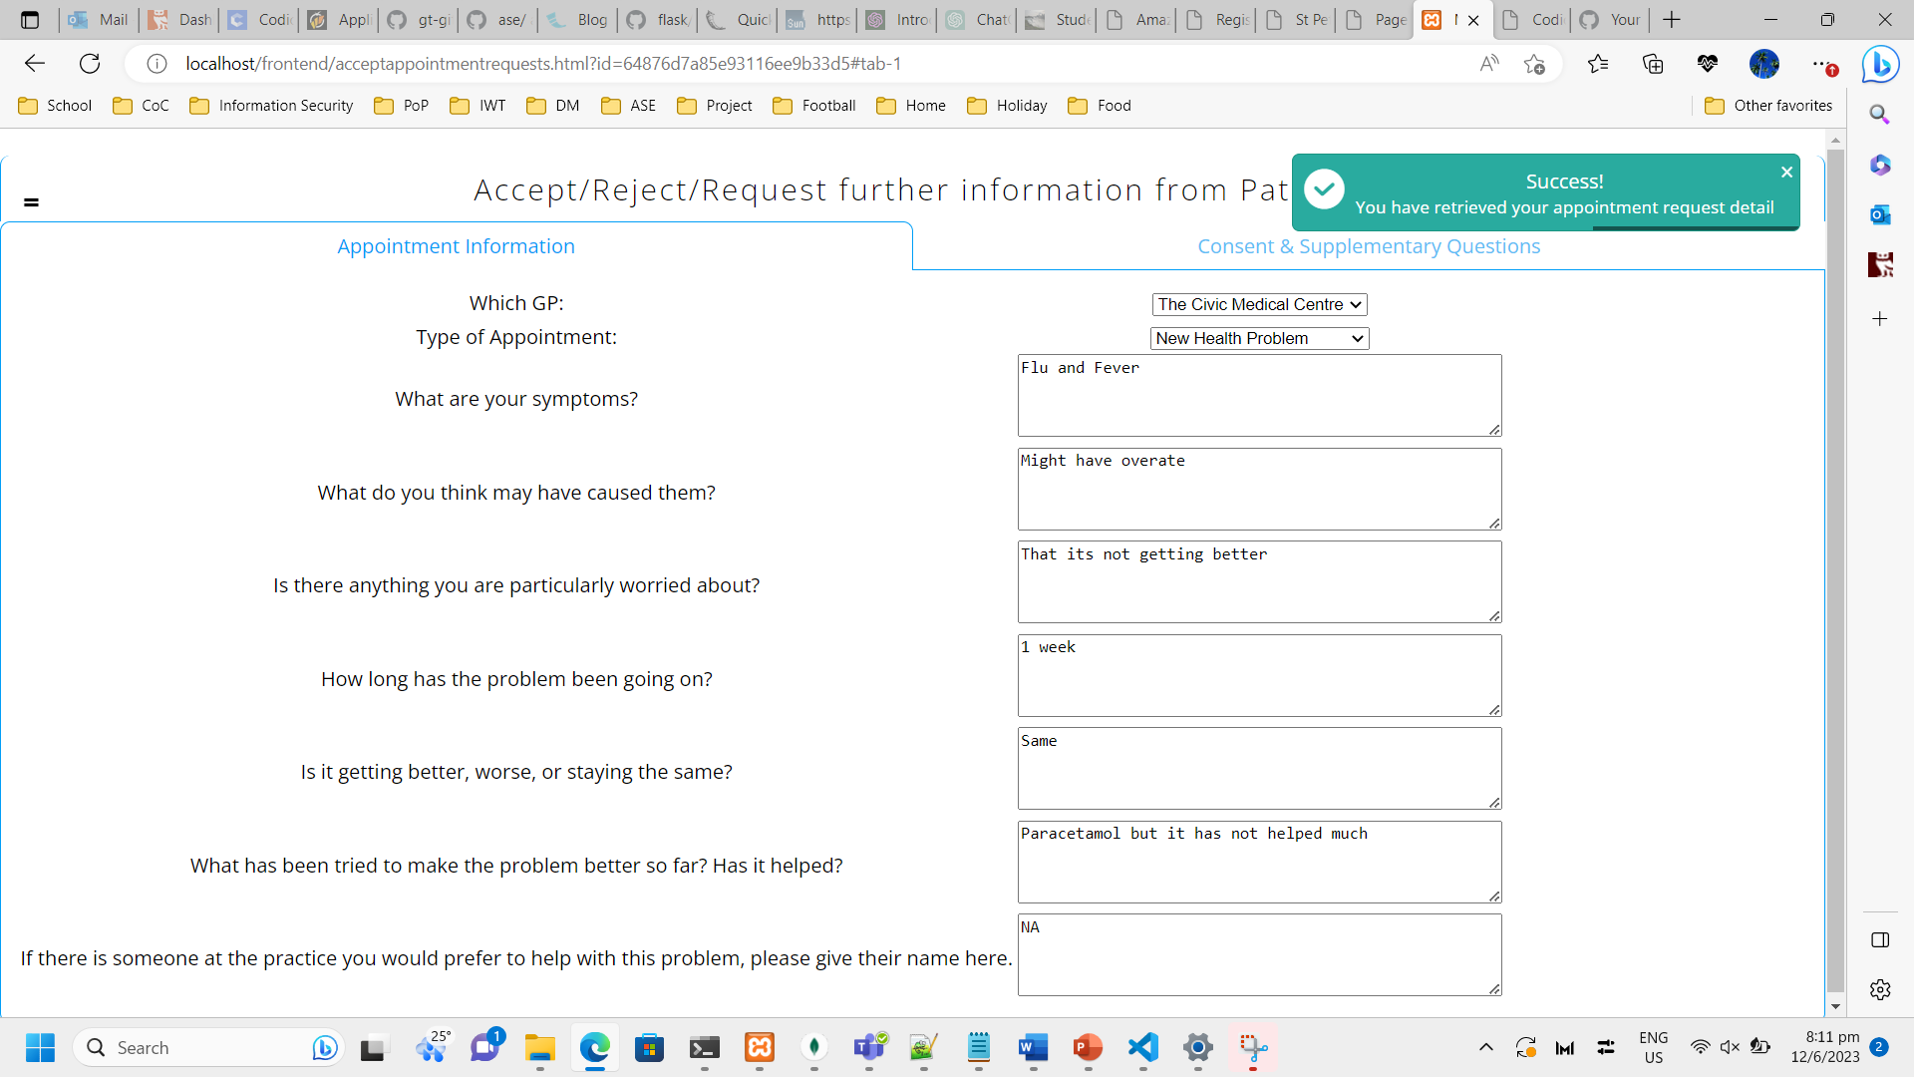  
*Figure 51. Screenshot showing GP Admin View detailed information of requests page*

Description: Upon clicking the ‘View Details to Approve/Reject’ button, the Appointment form loads with the data input by the Patient.

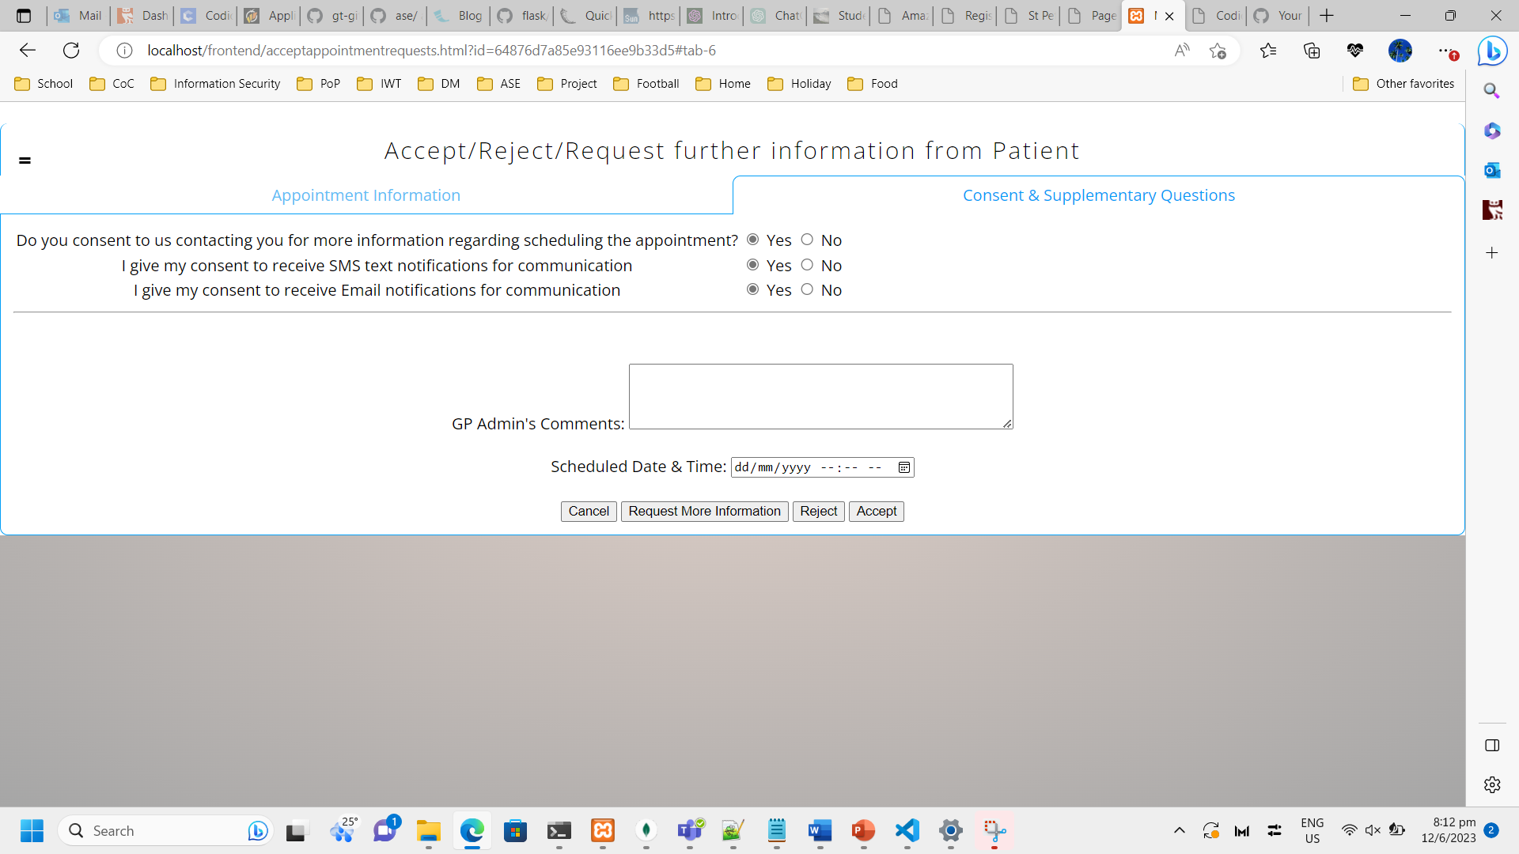  
*Figure 52. Screenshot showing GP Admin View detailed information of requests page continued*

Description: Similarly, the GP Admin has the same buttons available to take the appropriate action. If the GP Admin were to accept the request, he/she would need to schedule a date and time and click the ‘Accept’ button.

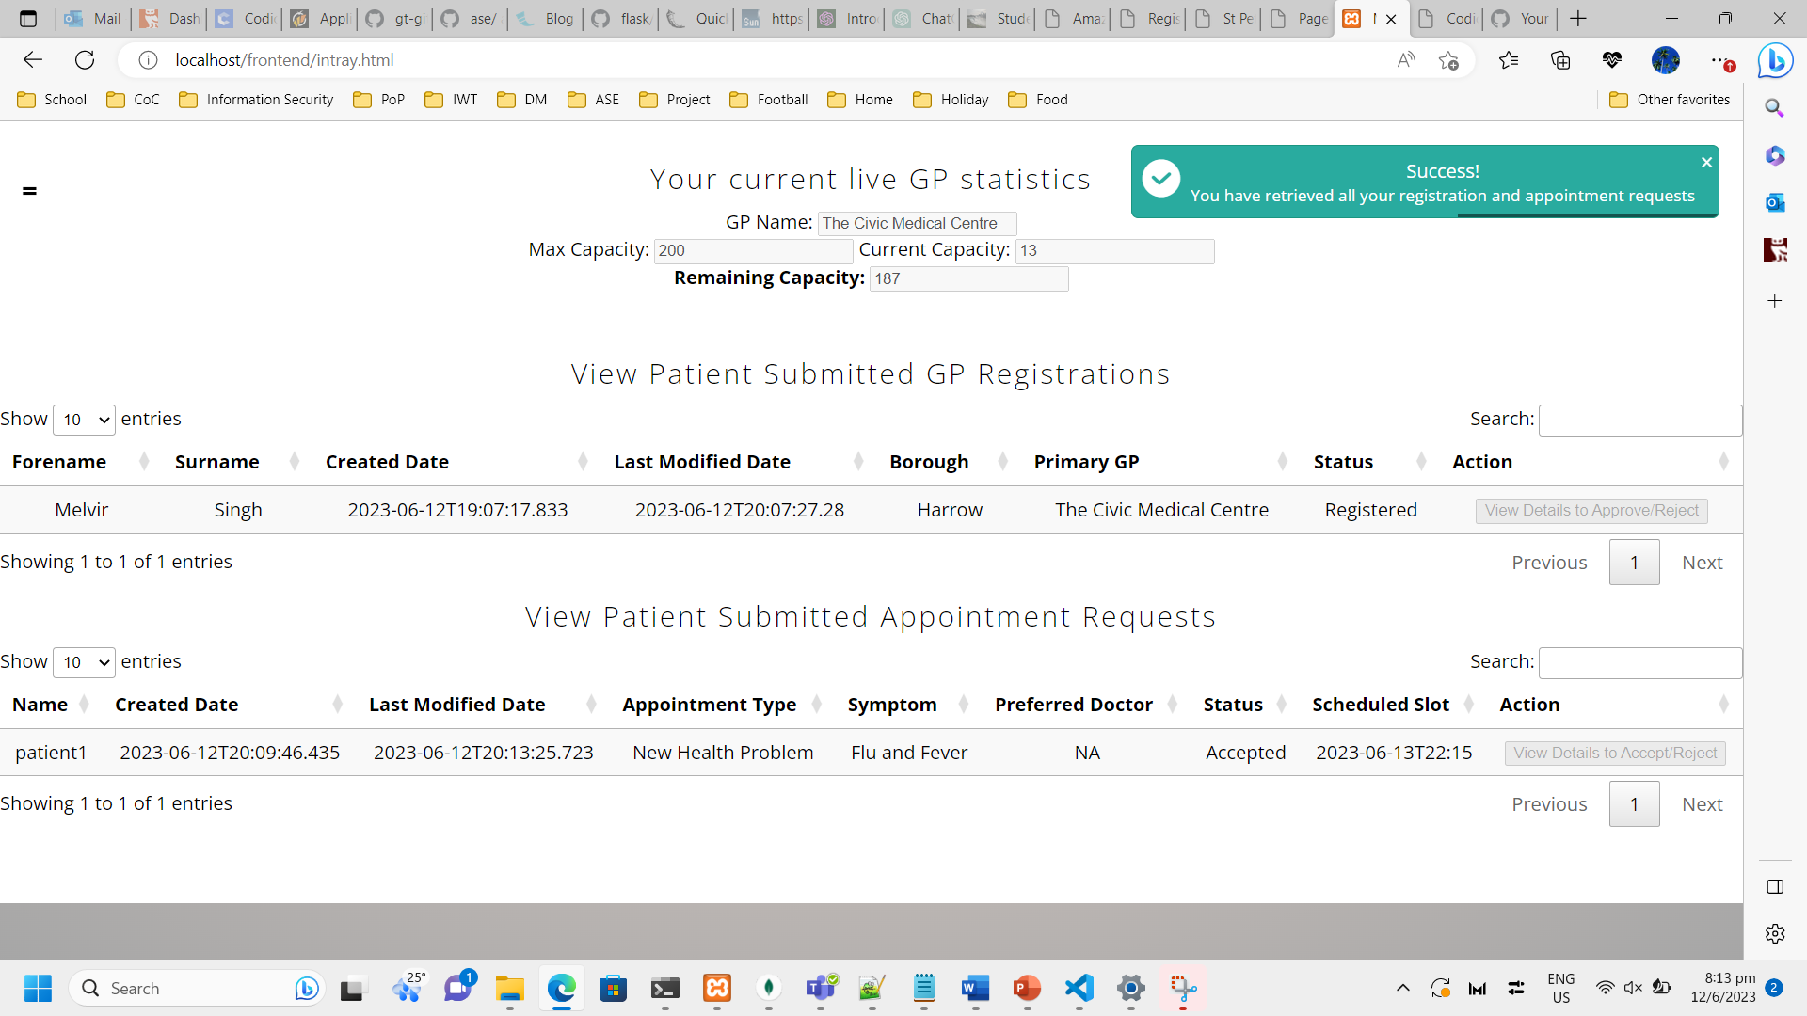  
*Figure 53. Screenshot showing GP Admin View Inbox page with updated status*

Description: If the GP Admin approved the request, the status will be updated to ‘Accepted’ and the Patient will be able to view this from their own GP Appointment page as shown earlier.

  
*Figure 54. Screenshot showing GP Admin View Feedback page*

Description: GP Admins are also able to provide Feedback similar to Patients as shown earlier.

6.3. NHS Admin Role’s Functionalities

  
*Figure 55. Screenshot showing NHS Admin Login page*

Description: Login page for all users of the application. Login for a test user (nhsadmin1 / Password123).

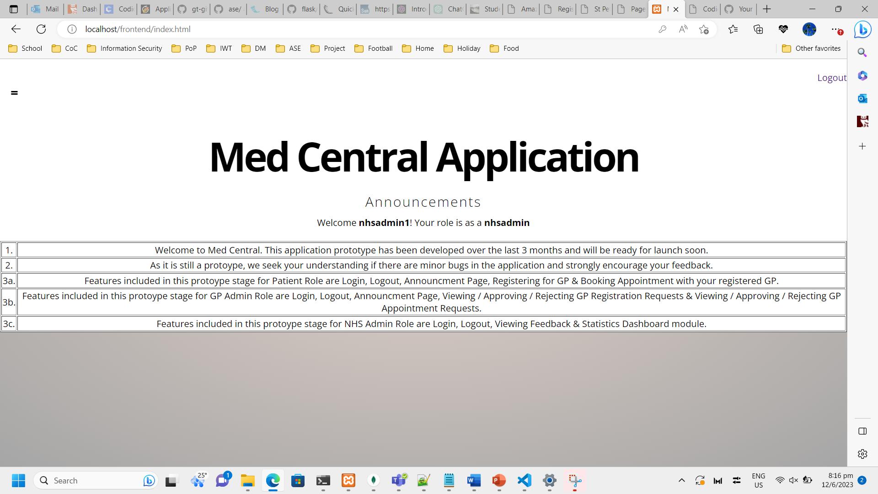  
*Figure 56. Screenshot showing NHS Admin Homepage*

Description: Default home/landing page for all users of the application. The name and role of the user is customized to the specific login. The announcements are standard and also allows user to logout his/her session on the top right.

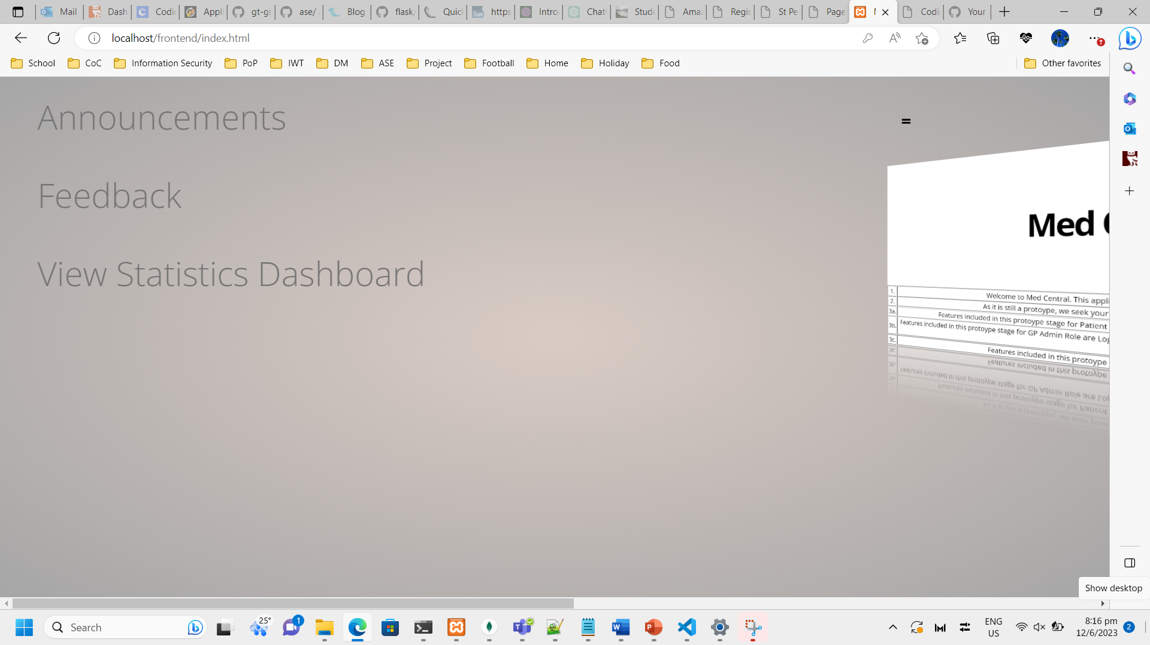  
*Figure 57. Screenshot showing NHS Admin Navigation tab*

Description: The navigation tab links are different for each role due to them having specific functionalities. These are the ones available to NHS Admins.

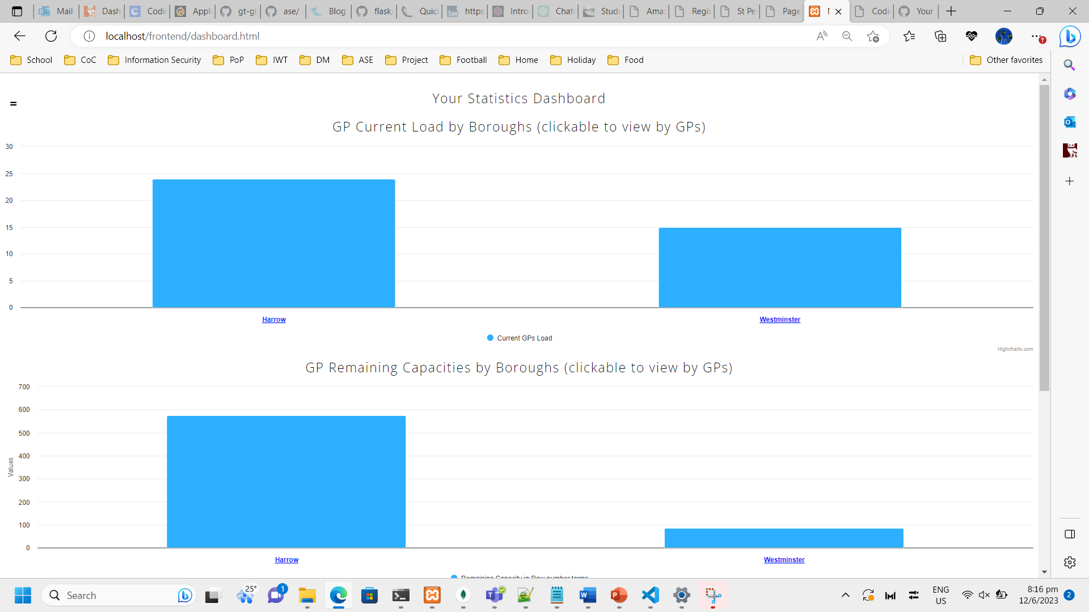  
*Figure 58. Screenshot showing NHS Admin Statistics Dashboard page*

Description: Page for viewing Statistics Dashboard. Currently there are 2 working statistics charts available for viewing/drilling for NHS Admins. The first is to view GP current load by boroughs. Only Harrow and Westminster are shown here as sample data has not been fully populated yet.

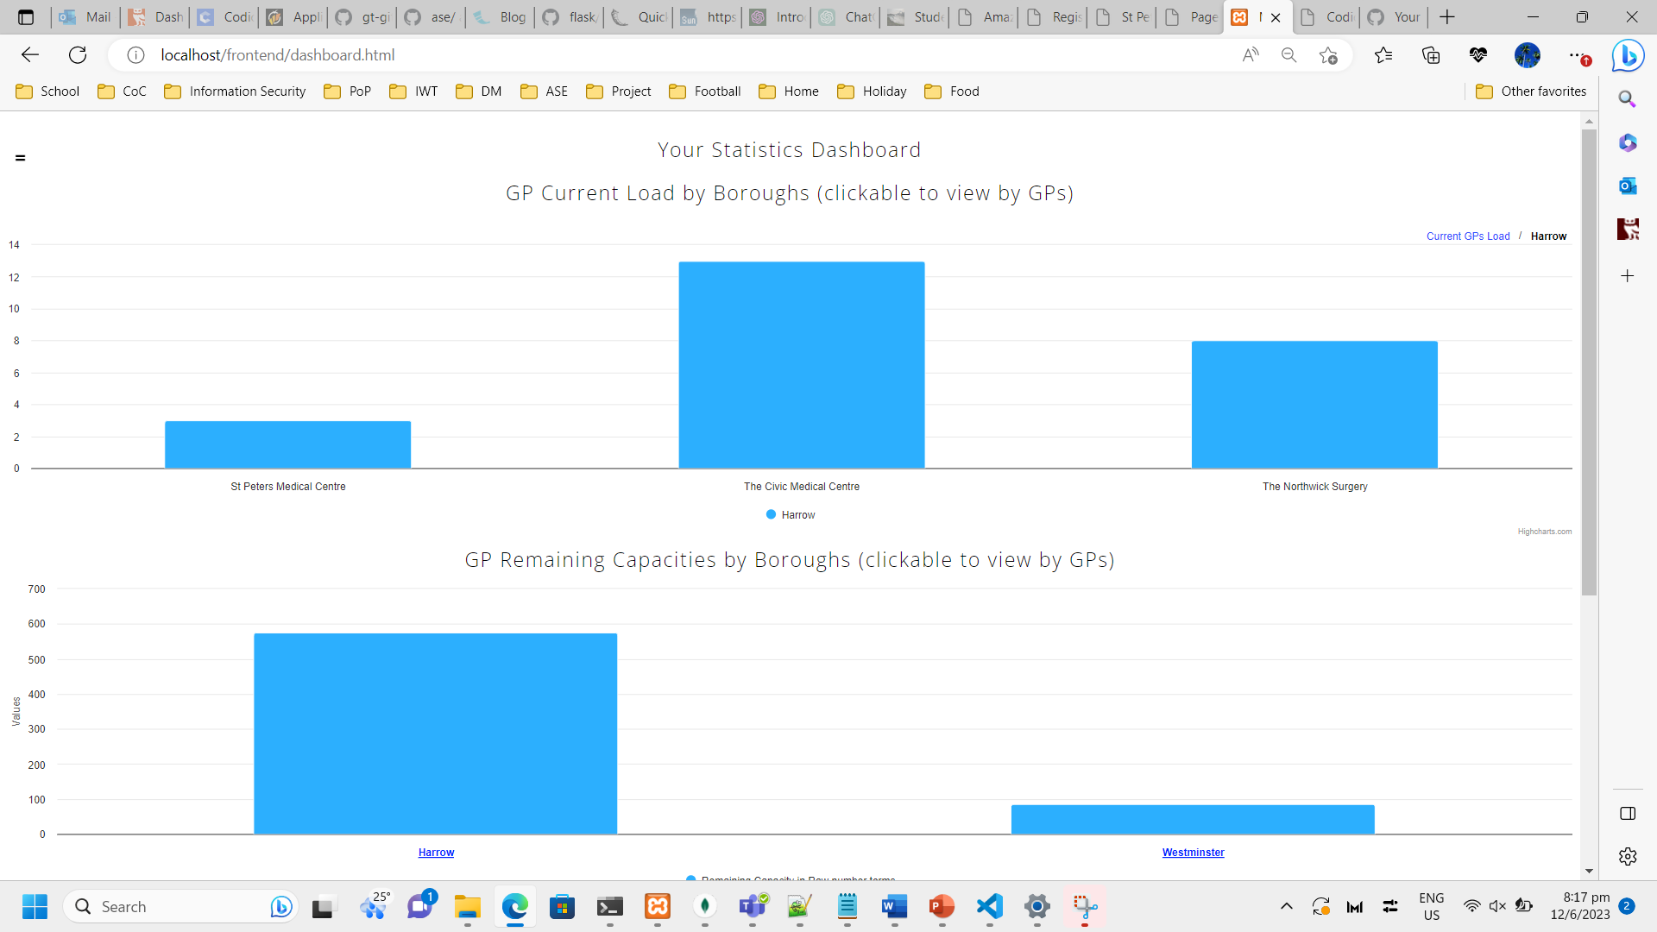  
*Figure 59. Screenshot showing NHS Admin Statistics Dashboard page with drilldown*

Description: Both charts are drillable. This means that if the NHS Admin wants more detailed data for ‘Harrow’, he/she only needs to click on the Harrow bar and a detailed GP view for the Harrow borough will be shown. It is really useful for them to gain an overview and sensing quickly using this.

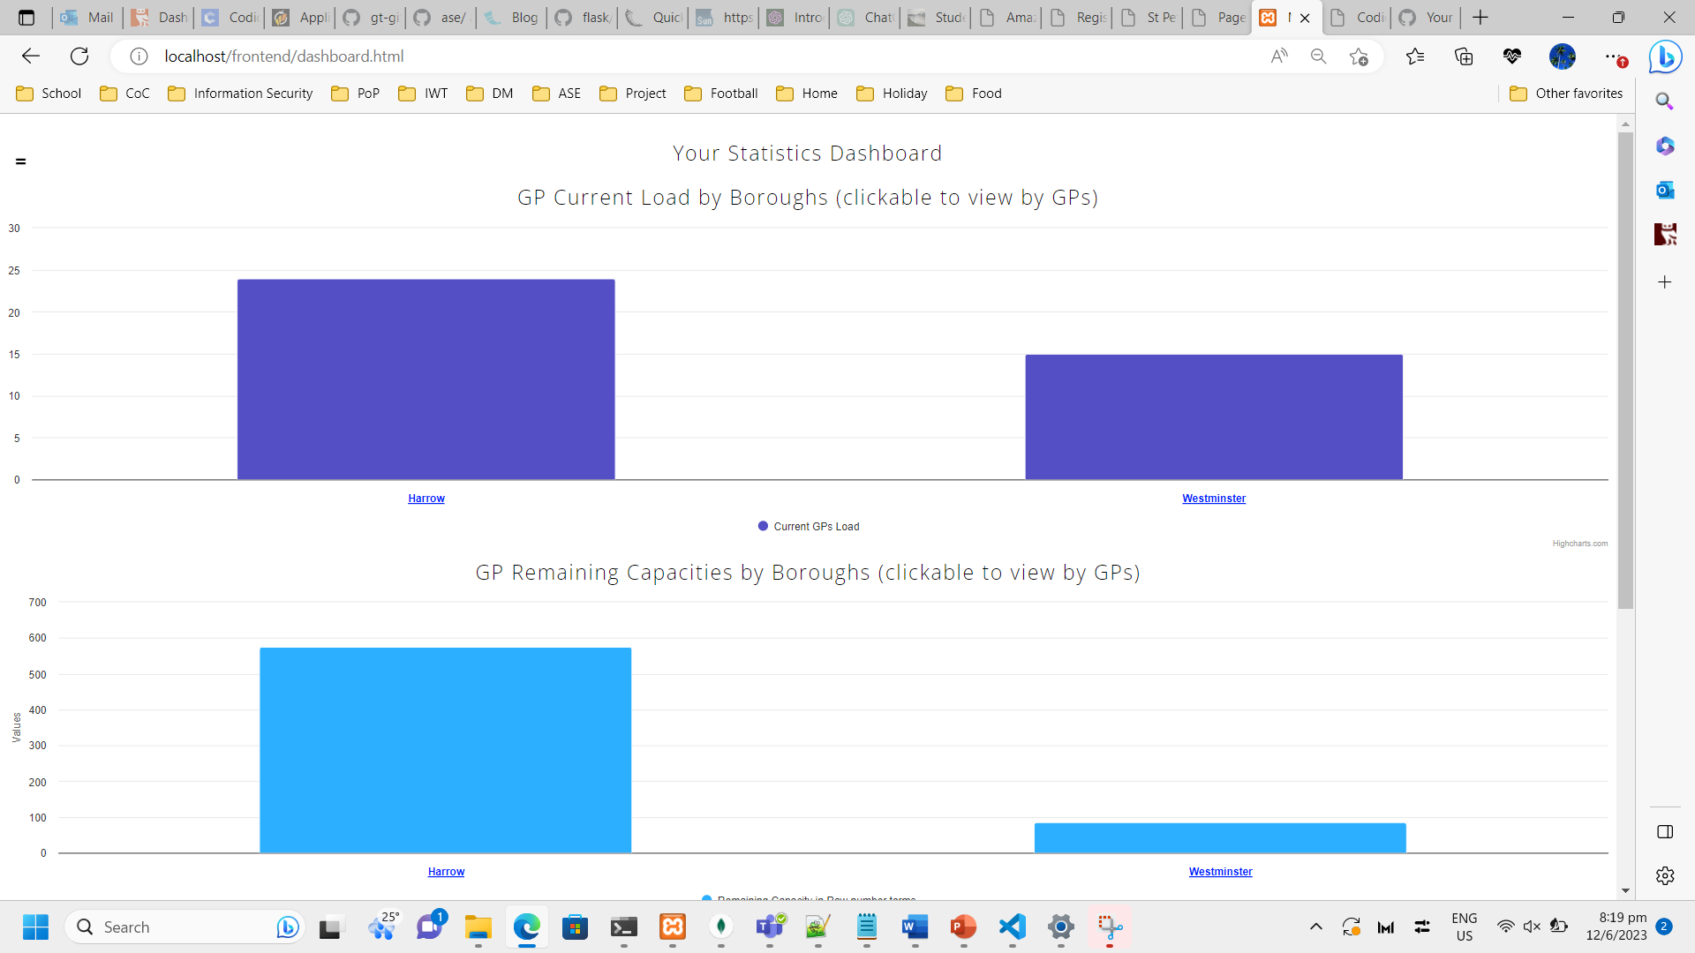  
*Figure 60. Screenshot showing NHS Admin Statistics Dashboard page of Remaining Capacity chart*

Description: The second chart shows Remaining Capacity of GPs by boroughs.

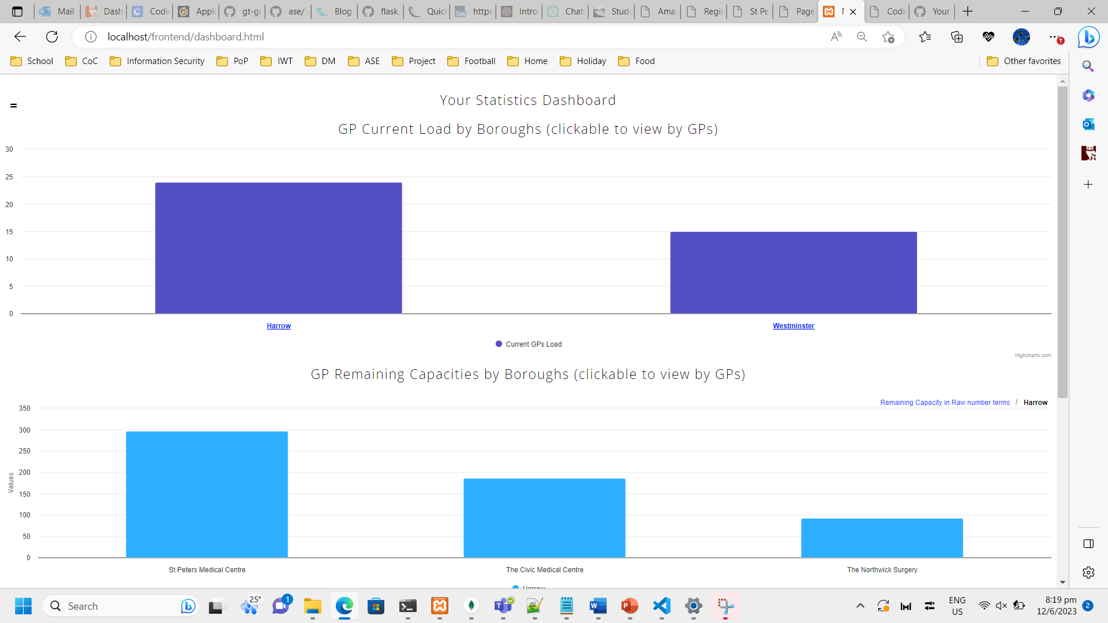  
*Figure 61. Screenshot showing NHS Admin Statistics Dashboard page Remaining Capacity drilldown*

Description: Similar to the first chart, it is drillable allowing for greater analysis by the NHS Admin.

7. Evaluation Findings

Below shows the summarized findings of the survey participants. As I could not obtain proper correspondences going with NHS as well as GPs (hardly got any replies back, could be because they are understaffed, etc), the 6 survey participants were either my classmates from the postgrad programme or from around the community that I know encountered similar problems as I did. I split the 6 participants into groups of 3, each group simulating a specific role of either a Patient, NHS Admin or GP Admin.

5 questions were asked. 4 being multiple choice ranging from 1 – 5 (5 being the best) and 1 being an open-ended question to welcome any remarks they might have. Actual survey results are available in the git repo under ‘Survey’ folder.

Question 1: How satisfied are you with the new application?

*Figure 62. Question 1 survey responses*

Summary: 5 out of the 6 participants responded with a full 5/5 satisfaction level with the new application The other participant responded with a 4/5 satisfaction level.

Question 2: Do you feel the application solves the 3 problems that it set out to do?

*Figure 63. Question 2 survey responses*

Summary: Responses were mixed for this question. Unsurprisingly, the lowest results came from the 2 participants holding the NHS Admin role. My sensing is that this could either be down to the NHS Admin having the least amount of features on the application or also that it is difficult for these respondents without tech or data analysis skillset to appreciate the value of centrally housed data for analytics purposes (the 3rd problem statement).

Question 3: Do you feel it is intuitive and easy to learn how to use the new application?

*Figure 64. Question 3 survey responses*

Summary: Responses were very positive for this. It is heartening to note this as I carefully followed good design principles for the application to ensure that it will be intuitive and easy to use, even with a wide age gap range of participants.

Question 4: Would you like to see this application improved further and subsequently launched for public to use?  
  
  
*Figure 65. Question 4 survey responses*

Summary: Another really positive response set. I think it is encouraging that all the participants would like to see the application continue to be developed so that it can subsequently be ready to be launched to the public to be used, and hopefully solve the 3 problem statements and many more in the future.

Question 5: What improvements would you like to see for the application?

Summary: As this was an open-ended question, all 6 participants gave really diverging and useful feedback. I would classify the responses into 3 categories really.

Firstly, those in the Patient role suggested a ‘Help’ or ‘FAQ’ section in the application so that they could utilize it to learn and master how to use the application. 1 of them asked for a ‘video walkthrough’ that I thought was really creative and insightful.

Secondly, those in the GP Admin role suggested a ‘Live Chat’ function so that GPs could have real-time chat with patients to understand issues better that might not be easy to come forth or present in the Booking GP form. That is again a creative suggestion and something that would add a good level of human based interaction within the application.

Lastly, those in the NHS Admin role suggested for a possible onboarding of new GP clinics via the application. Currently, the data is imported from the backend. They are suggesting a new function that allows GP clinics to submit their onboarding request in which NHS Admin can review and subsequently accept or reject. I did think of this feature while developing the application. I think this would be a good feature ensuring that more of the end to end processes are onboarded transparently into the system rather than from behind the scenes.

All the responses were useful and I would strongly suggest the possibility of them being added in a future iteration/release of the application.

8. Critical Evaluation & Conclusion

8.1. Recap & Success of solving Problem Statements

There were 3 problem statements highlighted which were the driving force behind this project and the eventual application that was developed.

As the application has not yet been deployed for NHS and public usage, it is imperative to note that it is only possible at this juncture to provide a rough sensing / testing of how the developed application and its features has solved the 3 problems.

Tedious manual processes for all parties (patient and GP)

For this problem, I propose there are 2 ways that we can assess whether MedCentral has completed solved or at least alleviated it.

Firstly, I have provided Before vs After timings on some key steps that typically happen with GP Registrations. The timings are estimated based on my own experience and using normal human timing speed.

|  |  |  |
| --- | --- | --- |
| Steps | Est Time Taken (Before MedCentral) | Est Time Taken (With MedCentral) |
| Patients - Filling up Registration Form | 30 mins | 10 mins |
| Patients - Making Trips down to/from GP (to collect & submit Registration Form) | 1 hour | - |
| Patients - Checking on Status | 15 mins | 5 min |
| GPs - Uploading Registration Form data to System | 30 mins | - |
| GPs – Modifying & Restitching Registration Form (with new Section or Fields) | 30 mins | 10 mins |
| GPs – Printing copies of updated Registration Form for new patients | 15 mins | - |
| **Total Time Taken** | **~ 3 hours** | **25 mins (84% quicker)** |

Table 7. Comparing estimated time taken of key Registration steps Before & With MedCentral

As shown in the table above, with MedCentral, it can lead to a 84% in time savings for the same Registration process that can happen manually in many GP clinics today. Although these are estimates, the numbers are realistic and based on actual human speed. The estimated savings alone shows good potential and rationale why MedCentral has value to at the very least be life tested in an actual environment, albeit with a small sample size to confirm these estimates.

Secondly, I’d like to highlight 2 key responses in the questionnaire. Noting the favourable response on Question 2 (Does the application solve the 3 Problem Statements?), where almost 70% selected 4 and 5 out of a highest of 5, that shows that the respondents were confident that the problem has actually been alleviated by MedCentral. In addition to Question 3 (Is it easy to learn the new application?), where 83% selected the maximum rating, it showed that my own estimates of the timings above with MedCentral should check out as respondents found the learning curve of MedCentral to be gentle.

Long waiting times for patients to visit their GPs

For this problem, we can also assess if it has been solved or improved partially via the same 2 ways.

Firstly, I have provided Before vs After timings on some key steps that happen with making appointments with your GP should you feel unwell. The timings are estimated based on my own experience and using normal human timing speed.

The assumption made is that the Secondary GP (with MedCentral) has a shorter waiting time compared to the Primary GP. I feel this is a safe assumption to state since the system is the one that selects the Secondary GP based on lowest current load during the patient’s GP Registration process in MedCentral.

|  |  |  |
| --- | --- | --- |
| Steps | Est Time Taken (Before MedCentral) | Est Time Taken (With MedCentral) |
| Patients - Filling up online appointment form | 15 mins | 15 mins |
| GPs - Responding to users on timing availabilities | 1 hour | 1 hour |
| Patients - Waiting to visit the Primary GP | 24 hours (assuming Primary GP only has slot the next day) | 24 hours (assuming Primary GP only has slot the next day) |
| Patients - Selecting SecondaryGP in MedCentral | - | 8 hours (assuming Secondary GP has slot at the end of the day) |
| **Total Time Taken to vist a GP** | **~ 25 hours** | **~ 9 hours (60% quicker)** |

Table 8. Comparing estimated time taken for patients to visit GPs Before & With MedCentral

As shown in the table above, with MedCentral, it can lead to a 60% in time savings for patients to be able to visit a GP to seek medical attention. Although these are based on the assumption that the SecondaryGP has an earlier timeslot, the numbers are realistic since the current load of GPs are taken into consideration when the SecondaryGP is selected by MedCentral. Thus, it is not only time savings for this problem. It is also hugely beneficial to patients as they are able to seek medical attention earlier and recover quicker to get back to their normal daily routine.

Secondly, on the questionnaire results, I’d like to point to Question 4 (Would you like to see the application improved further and subsequently launched for public to use?), where all respondents selected maximum rating of 5. I think it showed that they too realized on the potential benefit of being able to visit GPs with shorter waiting times with MedCentral.

However, my conclusion is that this problem cannot just be solved systematically. Although I have already added the ability of having a Secondary GP in MedCentral during the patient registering for their GP, it is not sufficient. Policy changes are also required at the NHS level to ensure or at least debate to the idea of Secondary GPs. I hope that they would be convinced to at least attempt to try it out as the Secondary GP is selected smartly by the system AI, and not the patient. The system AI ensures that the load will be better balanced out across the different GPs in the boroughs.

Information/Data is not being centrally available to be harnessed properly by data experts to bring better value-add and user experience for everyone

There are various ways to verify whether this problem has been rectified or improved on. A simple and trusted manner in industry is to verify and validate how easy it is to import data in commonly used tools by analysts for them to do data analysis work efficiently. 1 such tool that has taken the market by storm in recent years due to its simplicity is called Tableau. I signed up for a trial student account so I could show the benefits of having the data stored centrally together.

First step was to naturally export the data out from MongoDB as JSON files. This is demonstrated in the various screenshots below. It was achieved in just a few clicks.

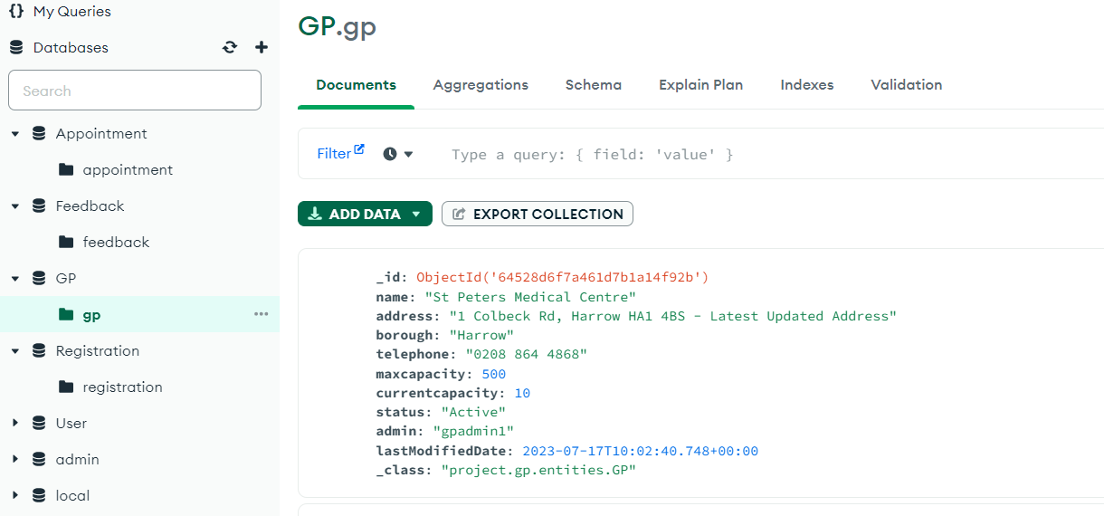  
*Figure 66. Showing the schema and data of GP Database prior to exporting*

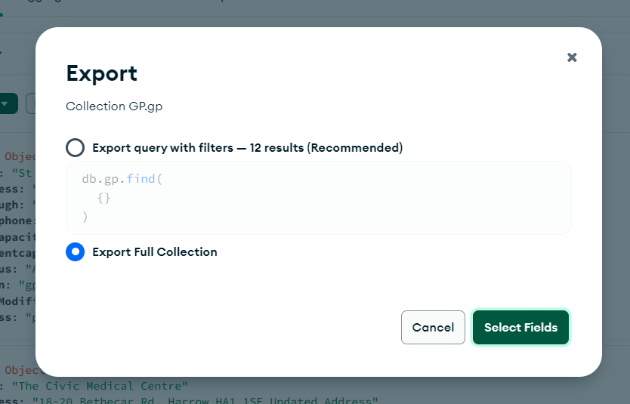  
*Figure 67. Option to export just some fields (if needed for confidentiality) or do a full export*

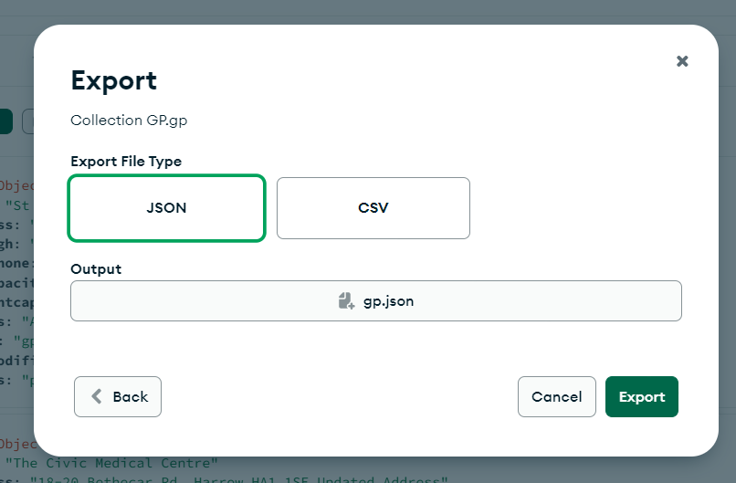  
*Figure 68. Tableau supports multiple ways to import data but via JSON file is one of the more common and secure ways of doing so (without impacting live data)*

Once all the data has been exported, it is now time to import it into Tableau. I utilized Tableau Desktop as I am familiar with it and there are many tutorials and guides online that show how to perform the common type of data import, manipulation and analysis.

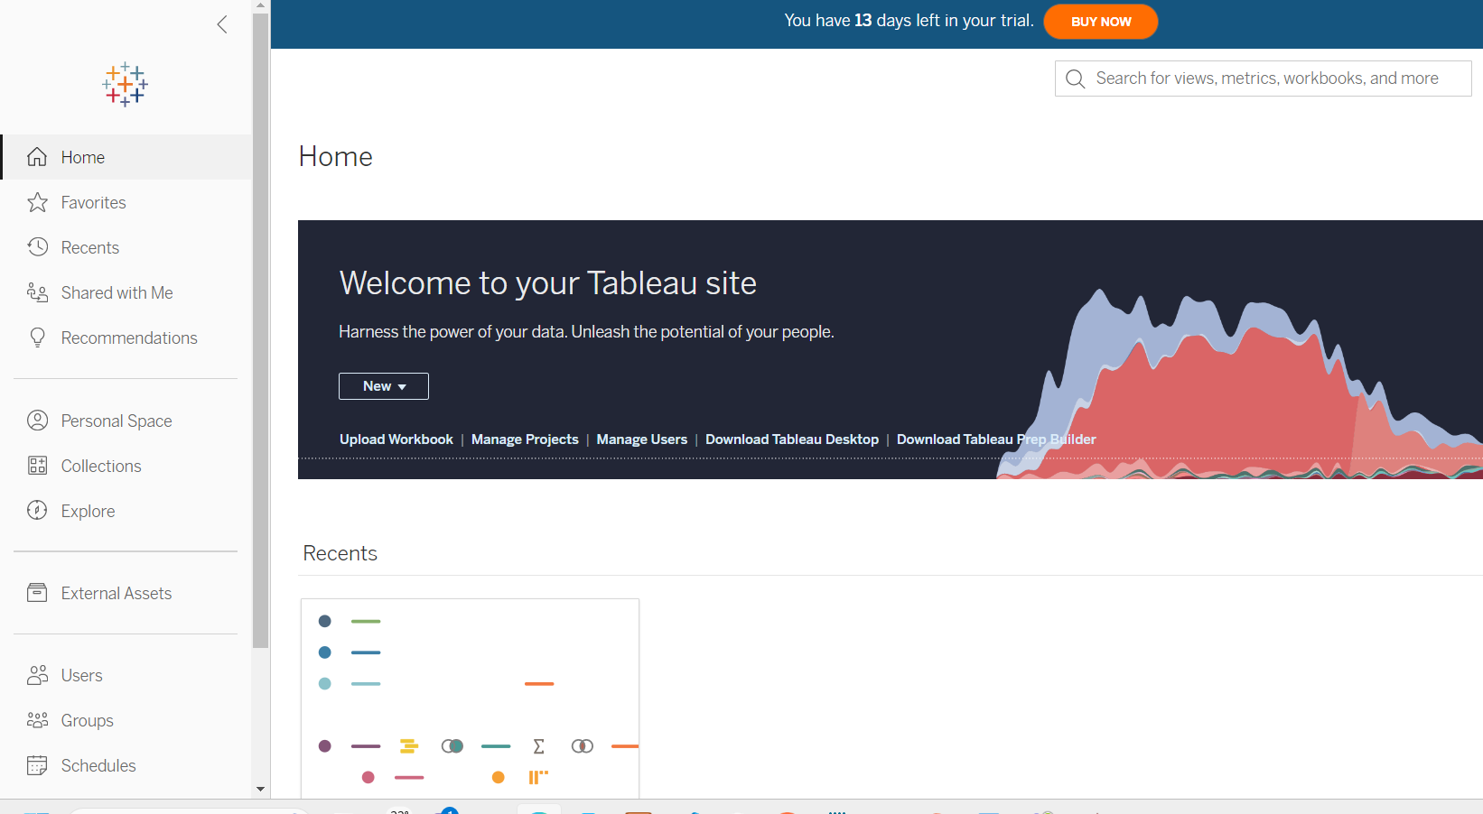  
*Figure 69. Creating a empty sample site for demonstration by MedCentral*

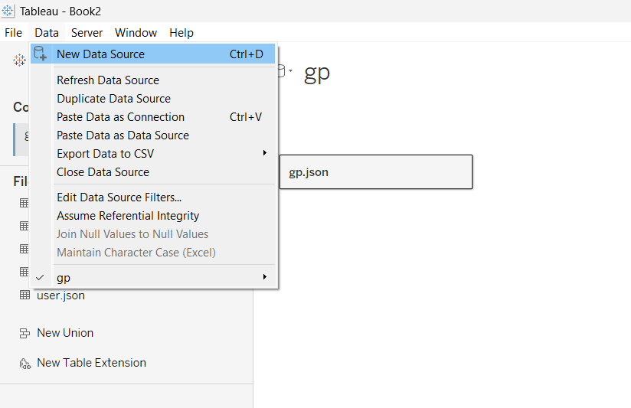  
*Figure 70. Adding a new Data Source that will import JSON files of MedCentral*

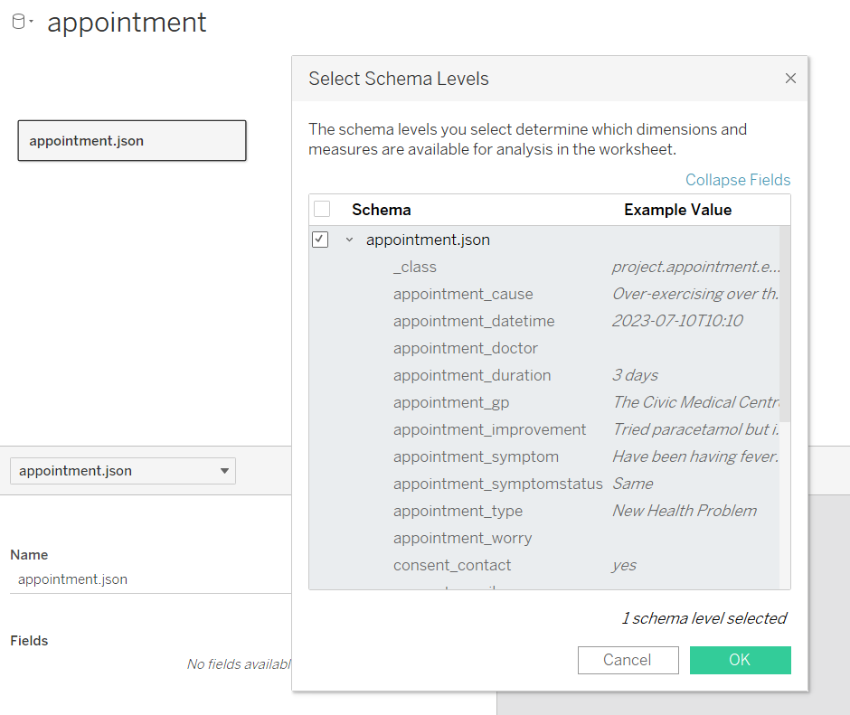  
*Figure 71. Example of Appointment JSON file being imported and noting that the schema and all its fields are automatically detected*

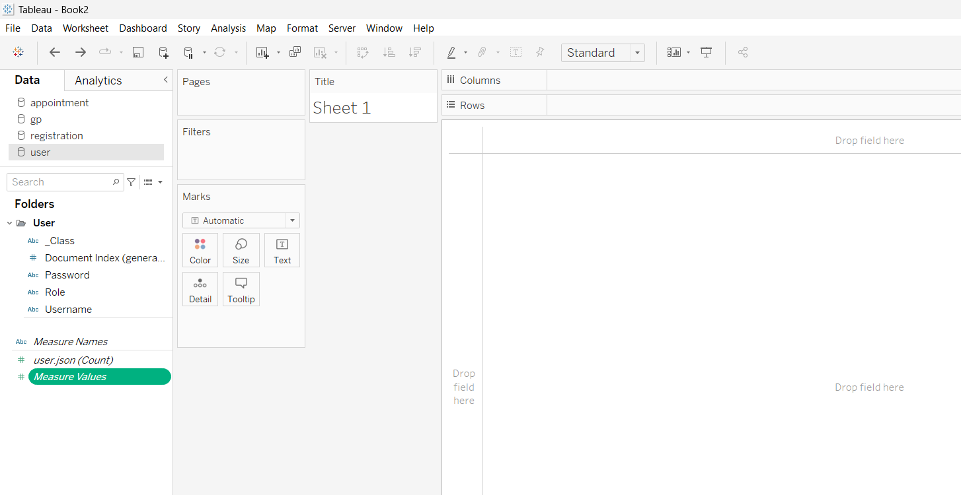  
*Figure 72. All MedCentral data successfully imported into Tableau as shown under the Data tab*

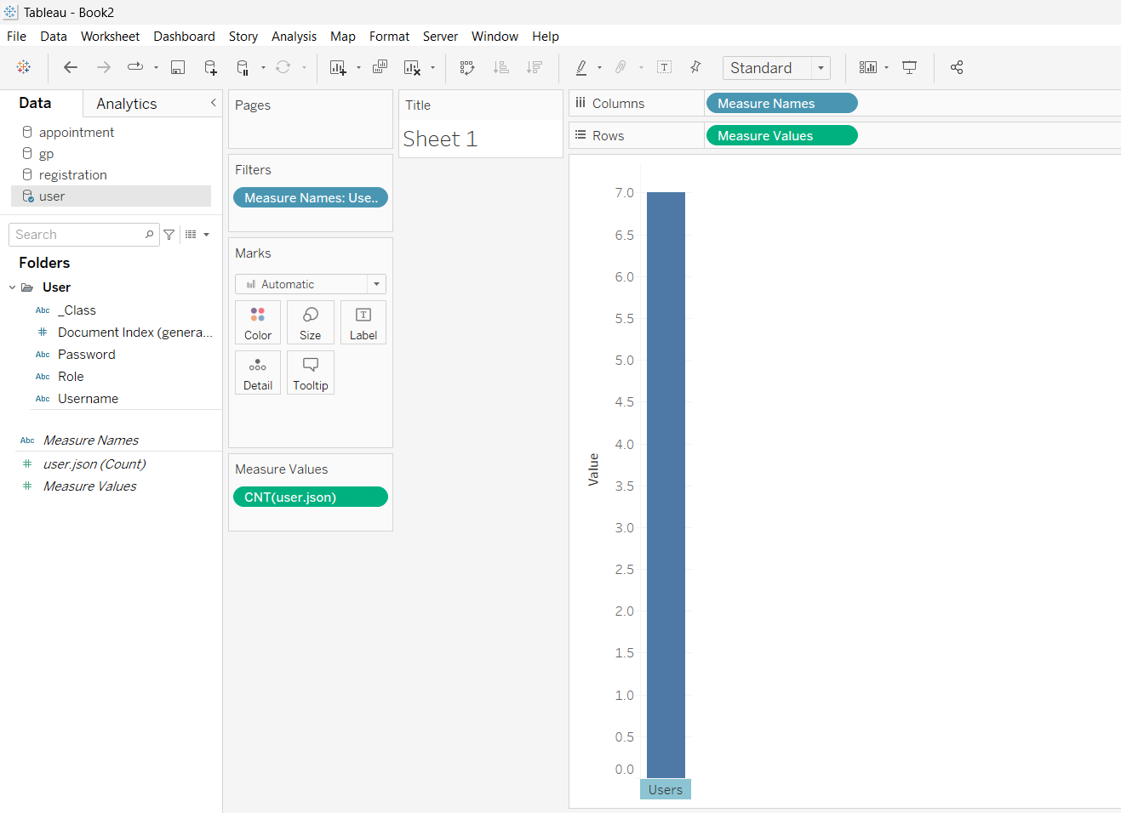  
*Figure 72. Statistics example showing User DB being visualized via a count of total user base of MedCentral which shows 7*

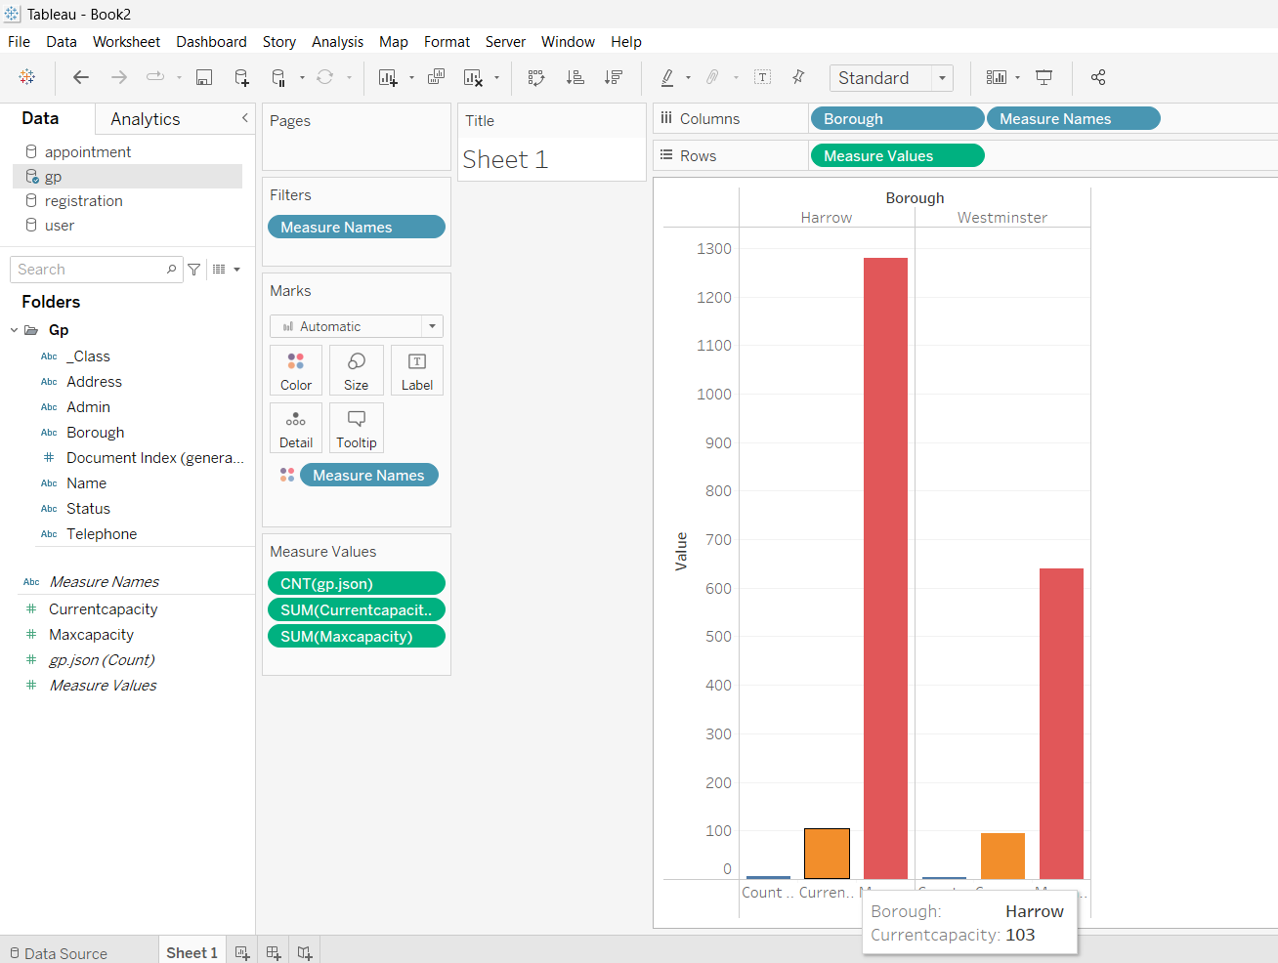  
*Figure 73. Statistics example showing Current and Max Capacity by Borough similar to what was coded under the Data Statistics module of MedCentral for NHS Admins (however this data is Static vs that one being live and real-time)*

As shown in the screenshots above, it is really convenient and straightforward to work, manipulate and visualize the data in Tableau. However, that is primarily so because the data was designed and stored well and that can only be the case if it is done centrally. If any of the GPs were handling their own data, it would have been much harder getting them to conform and agree on the reference design. It is also possible that even if they had agreed on a single design, further down the road, each of the GPs might add or modify certain columns which would then make it really difficult to continue doing data analysis well looking at all the data holistically.

By storing the data centrally, it is safe to say that data analysis can be performed at a much higher level by data analysts/scientists. And that has a high possibility to lead to a better user experience down the road for mainstream users which includes both Patients and GP Admins. The problems that the analysis/scientists solve with their analysis makes it worth it to spend more time upfront to do proper data design and storage, which has been the case in MedCentral.

8.2. Lessons Learnt

In every project we embark one, no matter how well it goes, there are always important lessons that can be learnt as a result of that enriching. It does not mean the project has been a failure but rather, it allows us to ensure that the next project we embark on would be even better. Thus, as part of my journey, I would like to touch on 3 lessons that I have learnt as a result of this experience.

.

Not carving sufficient bandwidth in project timeline for exploration   
  
Although I did specify 1 month for experimentation in the initial timeline, this proved insufficient due to the number of technologies that are new to me which I wanted to utilize for the project. These were namely ReactJs (frontend tech), SpringBoot (backend tech) and Docker Container (packing for deployment). During that period of experimentation, I realized that probably due to my personality of being a perfectionist, 1-2 weeks was not sufficient to learn and implement proper standards of those technologies for the application. 1-2 weeks per technology would have been sufficient if I did not bother about proper coding standards and quality. However, good code quality is paramount to me as I see this application possibly growing further or taken up by another student to improve in their Masters project.

Thus, if I could turn back time, I would carve out 2 months. Due to the tight project timeline for submission, I had to change ReactJs for a combination of HTML5 & JavaScript that I am more familiar to so that I am able to deliver an application that functions right. I was comfortable with that decision as TopNotch explains that more than 60% of developers have already used HTML5 to develop major applications, making it quite evident that HTML5 is becoming the developer platform to go to. (Top Notch, 2020)

By using JavaScript, it allowed me to ensure that I could develop MedCentral to be more interactive and user-friendly to users, which are some of the benefits Geek shares of utilizing JavaScript. (Geek, 2022)

I did however managed to explore SpringBoot and implemented it as the core technology for the application’s backend.

Not deploying the containerized application in Cloud   
  
Secondly, I would have liked to try out containerizing the application and deploying into Cloud.

I feel that this was too risky due to 2 factors. The first being that my focus was on completing all the functionalities of the application making sure that it was going to be useful to the stakeholders. Thus, I set aside majority of the timeline on development and the report, only setting aside a few days for deploying which was not sufficient for me to learn well about the different Cloud services and their deployment steps. The second being that I was aware of the need to do a demo to the supervisors. Thus, it would be another risk using a free Cloud account. It is well documented that free accounts are limited and these might cause hiccups such as locking accounts or limiting their usage after a certain period. If the school had provided a Cloud account for us during the project, it would have been much less riskier and I would have deployed onto the Cloud then. Nonetheless, the application works well and it could always be deployed onto any Cloud platform in the future as it was designed and developed to be stateless.

Leverage upon the school’s network to get user interviews to understand the problems better

A third lesson for me has to do with the project stakeholders portion. I started the project knowing it is a 1 man team project and due to my network, it has been impossible to get proper participation from NHS and GPs when it came down to user interviews. They are known to be busy and I accepted that they would not reply to any of my emails or calls to request for user interviews.

However, if I had involved the school or the school had been able to carve out those starting conversations, it would have been much easier to get proper user interviews with the stakeholders. That would then have been able to verify that the problem statements that I proposed are indeed the biggest pain points to be solved. However, having said that, I am still convinced that despite not getting active participation from NHS or GPs, I am solving the correct problems as they had affected me from the Patient role from my personal experience. And others new to the platform should have had the same issues.

8.3. Proposed Additional Features for future iteration of MedCentral

Although the application is in a ready enough state to be tested and deployed to a select group of stakeholders from public, it can always be improved on. Below are some of the features that I would have continued to embark on if I had more time and bandwidth.

Leverage on Single-sign on (SSO) authentication for Registration/Login  
  
There are so many applications out there these days. And with email having become prevalent to everyone in society, instead of doing a manual user registration/login form, I would prefer the application to leverage onto SSO using a Google account for example. This will make it easier for the user (there is no need to remember another username/password) and also for the application administrator (there is no need to handle and manage security for holding/storing passwords).

System recommending timeslots to GPs when they schedule patient’s GP booking requests

Currently the system allows the GP Admin to select a timeslot to schedule the patient if they plan on accepting the booking request. Although that puts the GP Admin in control of the situation fully, it would undoubtedly be easier and more convenient for the GP Admin if the system could recommend which timeslots are available in the system. Better still, if it could automatically select an available timeslot for the GP Admin. However, the consequence of that is that it becomes harder for the GP Admin to then be able to cater for individual patient’s specific timeslot requests. However, I feel that is a willing trade-off to accept since priority should be to clear as many patient requests instead of catering to individual ones for the medical system to perform up to standard for all residents.

Email/SMS notifications whenever requests are updated

Currently, there are no notifications built into the system yet. It is not difficult to build in an email/SMS notification such that whenever a patient request is updated (approved/rejected/request for more information), patients can get notified instead of having to login to the system to check for the latest status. However, in order to achieve this, there will be a need for the application admin to sign up for a paid account with any of the Cloud service providers. Then, it could be configurable in the system. Once that is settled, the code can be easily added into the application via a few lines or library plugin.

9. References

BMA (no date) *NHS backlog data analysis.* [online] Available at: <https://www.bma.org.uk/advice-and-support/nhs-delivery-and-workforce/pressures/nhs-backlog-data-analysis> [Accessed: 6 Mar 2023]

Tim, S (2019) *The Advantages of Data-Driven Decision Making Code.* [online] Available at: <https://online.hbs.edu/blog/post/data-driven-decision-making> [Accessed: 10 Feb 2023]

Hexacta (no date) *How Good UI Design benefits your business.* [online] Available at: <https://www.hexacta.com/how-ui-design-benefits-your-business/> [Accessed: 12 Feb 2023]

Mike, S (no date) *Top 5 benefits to centralized data.* [online] Available at: <https://www.dataideology.com/top-5-benefits-to-centralized-data/> [Accessed: 15 Feb 2023]

Top Notch, D (2020) *Reasons why HTML5 is the future.* [online] Available at:  [https://www.topnotchdezigns.com/reasons-html5-future/](https://www.digitaltrends.com/computing/best-browser-chrome-vs-firefox-vs-safari-vs-edge/) [Accessed: 18 Mar 2023]

Geek, B (2022) *Importance of JavaScript in Web Development.* [online] Available at: <https://www.geekboots.com/story/importance-of-javascript-in-web-development> [Accessed: 18 Mar 2023]

Gitlab (2022) *What are the benefits of a microservices architecture.* [online] Available at: <https://about.gitlab.com/blog/2022/09/29/what-are-the-benefits-of-a-microservices-architecture/> [Accessed: 25 Feb 2023]

MongoDB (2022) *What Is a Non-Relational Database.* [online] Available at: <https://www.mongodb.com/databases/non-relational> [Accessed: 25 Feb 2023]

DB-Engines (2023) *Popularity ranking of database management systems.* [online] Available at: <https://db-engines.com/en/ranking> [Accessed: 27 Feb 2023]

Docclocker (no date) *Find a doctor. Avoid the wait.* [online] Available at: <https://docclocker.com/> [Accessed: 10 Mar 2023]

NHS (2020) *New health app aims to help people ‘Wait Less’ for minor injury treatment.* [online] Available at: <https://hertsvalleysccg.nhs.uk/about-us/news-archive/2020/new-health-app-aims-help-people-wait-less-minor-injury-treatment> [Accessed: 14 July 2023]

Spring (no date) *An overview of Spring Boot and its features.* [online] Available at: <https://spring.io/projects/spring-boot> [Accessed: 14 July 2023]

GeeksforGeeks (no date) *MVC Design Pattern.* [online] Available at: <https://www.geeksforgeeks.org/mvc-design-pattern/> [Accessed: 15 July 2023]

Fortegrp (2020) *8 reasons why you should use unit testing.* [online] Available at:  [https://fortegrp.com/the-importance-of-unit-testing/](https://www.geeksforgeeks.org/mvc-design-pattern/) [Accessed: 18 July 2023]

Fortegrp (2017) *How to Estimate Quality Assurance Testing Time.* [online] Available at: <https://fortegrp.com/how-to-estimate-testing-time/> [Accessed: 18 July 2023]

Alexandre, O (2021) *What Should I Use GitHub for?* [online] Available at: <https://careerfoundry.com/en/blog/web-development/what-do-developers-use-github-for-heres-why-its-vital/> [Accessed: 19 July 2023]

Javatpoint (no date) *XAMPP Tutorial.* [online] Available at: <https://www.javatpoint.com/xampp> [Accessed: 20 July 2023]

Catarina, G (2022) *Coding standards: what are they, and why do you need them.* [online] Available at: <https://blog.codacy.com/coding-standards-what-are-they-and-why-do-you-need-them/> [Accessed: 20 Jul 2023]

Project.co (2023) *Stretch Goals – What They Are, How to Set Them.* [online] Available at: <https://www.project.co/stretch-goals/> [Accessed: 27 July 2023]

Sonya, S (2017) *5 Team Benefits of Project Status Tracking.* [online] Available at: <https://getnave.com/blog/project-status-tracking-team-benefits/> [Accessed: 29 Jul 2023]

Google (no date) *DevOps tech: Code maintainability.* [online] Available at: <https://cloud.google.com/architecture/devops/devops-tech-code-maintainability> [Accessed: 29 July 2023]

Marwen, A (2018) *Four REST API Versioning Strategies.* [online] Available at:  [https://www.xmatters.com/blog/blog-four-rest-api-versioning-strategies/](%20https://www.xmatters.com/blog/blog-four-rest-api-versioning-strategies/) [Accessed: 29 Jul 2023]